

SELLING DIGITAL DEVICES WEBSITE USER MANUAL (ZENTRIX)

|  |  |
| --- | --- |
| Class Admin: Trần Thị Thanh Ngân  Mentor: Hồ Ngọc Đăng Khoa | Group: 3  Group Members: Lê Nhựt Anh  Đặng Công Khanh  Huỳnh Hoàng Tỹ  Nguyên Nguyễn  Võ Lâm Thúy Vi  Nguyễn Lê Khắc Vũ  Nguyễn Thanh Bình |

**Cantho, April 2025**

# INTRODUCTION

## Group Members:

|  |  |  |  |
| --- | --- | --- | --- |
| **No** | **Full Name** | **Role** | **Note** |
| 1 | Lê Nhựt Anh | Team Leader, Developer |  |
| 2 | Đặng Công Khanh | Developer |  |
| 3 | Võ Lâm Thúy Vi | Developer |  |
| 4 | Nguyễn Lê Khắc Vũ | Developer |  |
| 5 | Nguyễn Thanh Bình | Developer |  |
| 6 | Nguyễn Việt Nguyên | Tester |  |
| 7 | Huỳnh Hoàng Tỹ | Developer |  |

## Project Introduction:

Zentrix is an e-commerce web application specializing in selling electronic devices such as laptops, smartphones, tablets, accessories, and more. The platform is designed to provide a fast, secure, and user-friendly shopping experience for customers while enabling administrators to efficiently manage products, orders, and customer interactions. With Zentrix, customers can easily browse, compare, and purchase electronic products from a well-organized and responsive website. Meanwhile, the admin panel offers powerful tools to manage inventory, track orders, and analyze sales data, making it an ideal solution for businesses in the electronics retail industry.

## Technologies Used:

* + Backend: Java, Spring Boot
  + Frontend: React.js
  + Database: PostgreSQL
  + Version Control: Git
  + Testing Tools: Katalon, Swagger, Postman.

## Project Purpose and Role:

Zentrix is an e-commerce web application specializing in selling electronic devices such as laptops, smartphones, tablets, accessories, and more. The project aims to provide a modern, fast, and secure shopping experience for customers while enabling administrators to manage products and orders efficiently.

## Project Purposes:

* + Seamless Shopping Experience: Customers can browse, search, and purchase electronic products easily.
  + Product & Order Management: Admins can add, update, and remove products while tracking orders and customer interactions.
  + Secure Transactions: Integrating secure payment gateways to ensure safe and reliable transactions.
  + Customer Engagement: Providing customer reviews, ratings, and a support system to enhance user trust.
  + Scalability & Performance: Designed to handle a large number of users and product listings efficiently.

Table of Contents

INTRODUCTION 1

Group Members: 1

Project Introduction: 1

Technologies Used: 1

Project Purpose and Role: 1

Project Purposes: 2

FEATURES 7

1. REGISTER 7

2. LOGIN 9

a) Login by username 9

b) Login by Google 13

3. LOGOUT 13

a) Logout from Dashboard 13

b) Logout from Homepage 14

4. FORGOT PASSWORD 15

5. MANAGE PROFILE 19

a) Manage profile in dashboard 19

b) Manage profile in homepage 22

6. MANAGE CUSTOMERS 26

a) Add customer 26

b) View customer detail 28

c) Edit customer 29

d) Delete customer 31

e) Lock/Unlock customer 32

f) Search customer 33

g) View customer list 34

7. MANAGE STAFFS 35

a) Add staff 35

b) View staff detail 37

c) Edit staff 38

d) Delete staff 40

e) Lock/Unlock staff 41

f) Search staff 42

g) View staffs list 43

8. MANAGE MEMBERSHIPS 44

a) Add membership 44

b) View memebership detail 45

c) Edit membership 46

d) Delete membership 47

e) View memberships list 48

f) Search membership 48

9. MANAGE PRODUCTS IN HOMEPAGE 49

a) View product detail 50

b) Search product 51

c) View products list 52

d) Sort product 52

e) Filter product 53

10. MANAGE PRODUCTS IN DASHBOARD 54

a) Add product 54

b) View product detail 57

c) Edit product 58

d) Delete product 60

e) Search product 61

f) View products list 61

11. MANAGE ORDERS 62

a) Add order 62

b) View order detail 62

c) Search order 63

d) View orders list 63

e) Export order pdf file 64

12. MANAGE PAYMENTS 65

a) Payment by VNPay 65

b) Payment by Momo 65

13. MANAGE CARTS 65

a) Add product to cart 65

b) View cart 66

c) Edit quantity product in cart 67

d) Delete product from cart 68

14. MANAGE PROMOTIONS 68

a) Add promotion 69

b) View promotion detail 70

c) Edit promotion 71

d) Delete promotion 71

e) Search promotion 71

f) View promotions list 72

g) Filter promotion 72

h) Collect promotion 73

15. MANAGE WARRANTIES 73

a) Add warranty 74

b) View warranty detail 76

c) Edit warranty 77

d) Search warranty 77

e) View warranties list 77

f) Export warranty file 78

16. MANAGE STOCKS 80

a) Import stock 80

b) Import stock by using Excel 82

c) View import stock detail 84

d) View export stock detail 84

e) Export stock to Excel 85

f) Export stock to PDF 86

g) View import products list 87

h) View export products list 87

17. MANAGE NOTIFICATIONS 88

a) Add notification 88

b) View notification detail 89

c) Delete notification 90

d) Search notification 90

e) View notifications list 91

18. MANAGE REVIEWS 91

a) Add review 91

b) View review detail 93

c) Edit review 93

d) Delete review 95

e) Search review 96

f) View reviews list 97

19. MANAGE POSTS 98

a) Add post 98

b) View post detail 99

c) Edit post 101

d) Delete post 102

e) Search post 103

f) View posts list 104

20. MANAGE CATEGORIES 105

a) Add category 105

b) View category detail 106

c) Edit category 107

d) Delete category 108

e) Search category 110

f) View categories list 110

21. MANAGE SUPPILERS 111

a) Add supplier 111

b) View supplier detail 112

c) Edit supplier 113

d) Delete supplier 114

e) Search supplier 115

f) View suppliers list 115

22. MANAGE BRANCHES 116

a) Add branch 116

b) View branch detail 117

c) View products detail in branch 117

d) Edit branch 118

e) Delete branch 119

f) Search branch 120

g) View branches list 121

23. COMPARE PRICE 122

24. INCOME STATISTIC 123

# FEATURES

## REGISTER

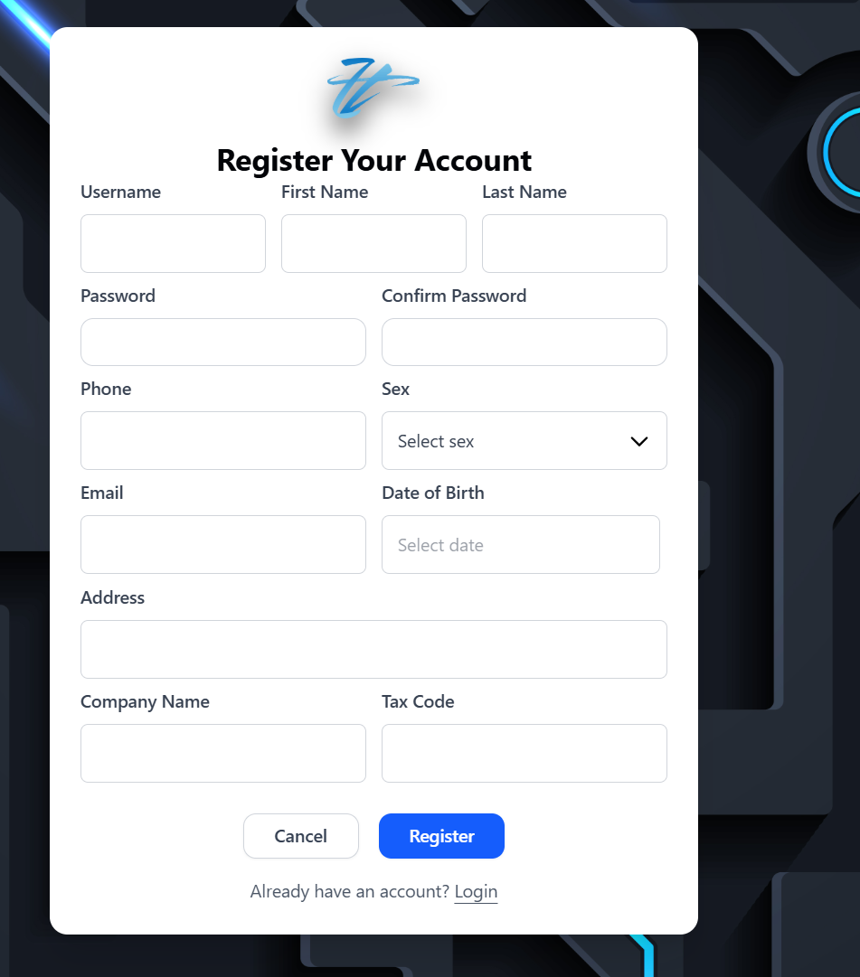

**VALIDATION FIELD REGISTER TABLE**

|  |  |  |
| --- | --- | --- |
| **No.** | **Field** | **Validation** |
|  | Username | * Must be not blank * Must be at least 3 characters |
|  | First name | * Must be not blank * Only allow letters, Vietnamese letters, “-“, and “_” character |
|  | Last name | * Must be not blank * Only allow letters, Vietnamese letters, “-“, and “_” character |
|  | Password | * Must be not blank * Must be at least 8 characters * Must be at least 1 lowercase character * Must be at least 1 uppercase character * Must be at least an integer * Must be at least 1 symbol |
|  | Confirm password | * Must be not blank * Must be matched with password field |
|  | Phone | * Must be not blank * Must be integers between 9 and 15 digits |
|  | Sex | * Must be not blank |
|  | Email | * Must be not blank * Must be at least “@” character * Must be at least 1 character before “@” character without space * Must be at least 1 character after “@” character without space |
|  | Date of birth | * Must be not blank * Max date is today |
|  | Address | * Must be not blank |
|  | Company name | * Only allow letters, Vietnamese letters, “-“, and “_” character |
|  | Tax code | * Must be integers between 10 and 13 digits |

**REGISTER FUNCTION FIELDS TABLES**

|  |  |  |  |
| --- | --- | --- | --- |
| **No.** | **Field** | **Type** | **Function** |
|  | Cancel | Button | Clear all field |
|  | Register | Button | Sign up a new account and status of account is verifying. User must be verify email during login |
|  | Login | Link | Navigate to login page |
|  | Zentrix logo | Link | Navigate to home page |

## LOGIN

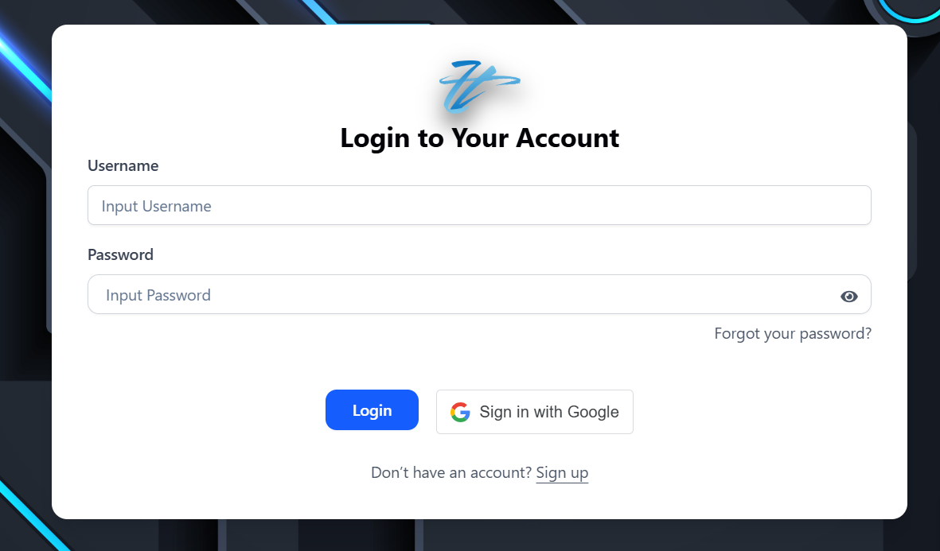

### Login by username

Input username and password. Then, click login to sign in. If username and password is correct. Website will navigate to home page if role is Customer. Otherwise, it will navigate to dashboard. However, if status of account is VERIFYING. Website will sent email to verify account. After verified account successfully. It will navigate to Homepage if role of account is customer, and navigate to dashboard if account is staff.



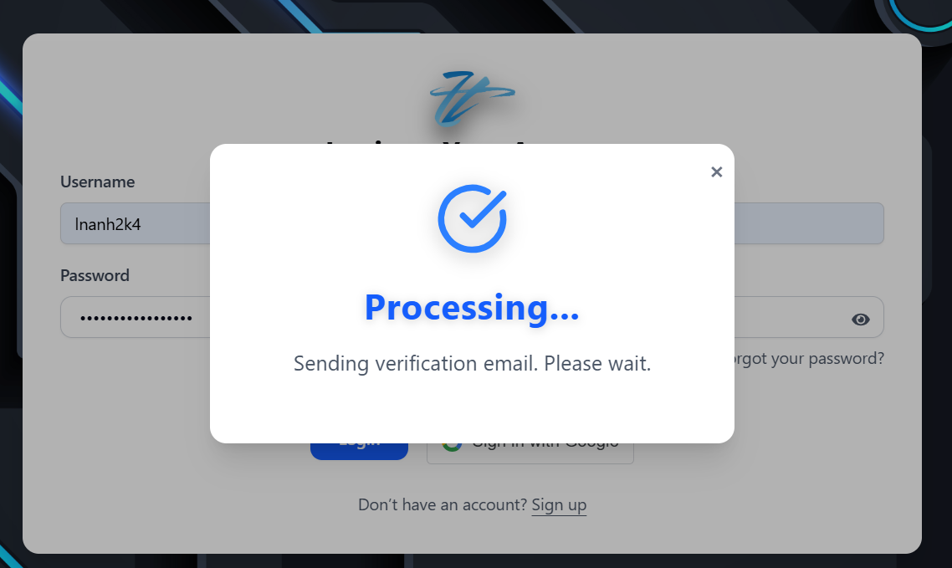

User can click resend email if gmail of user does not received email from system

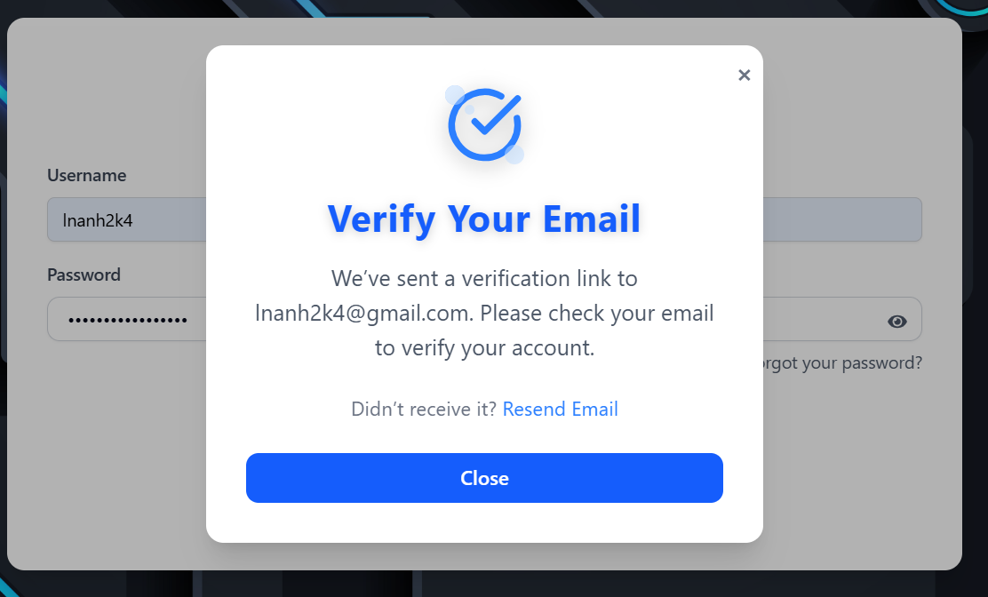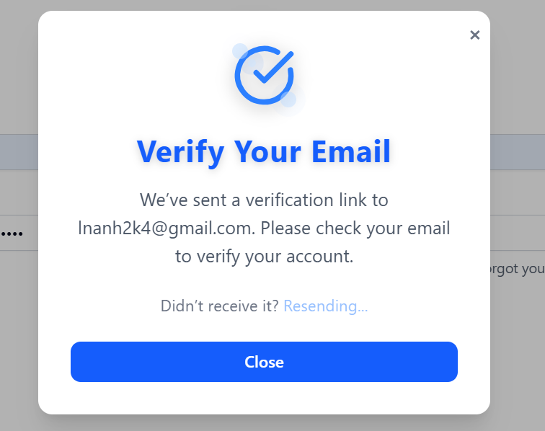



Click VERIFY ACCOUNT button to verify

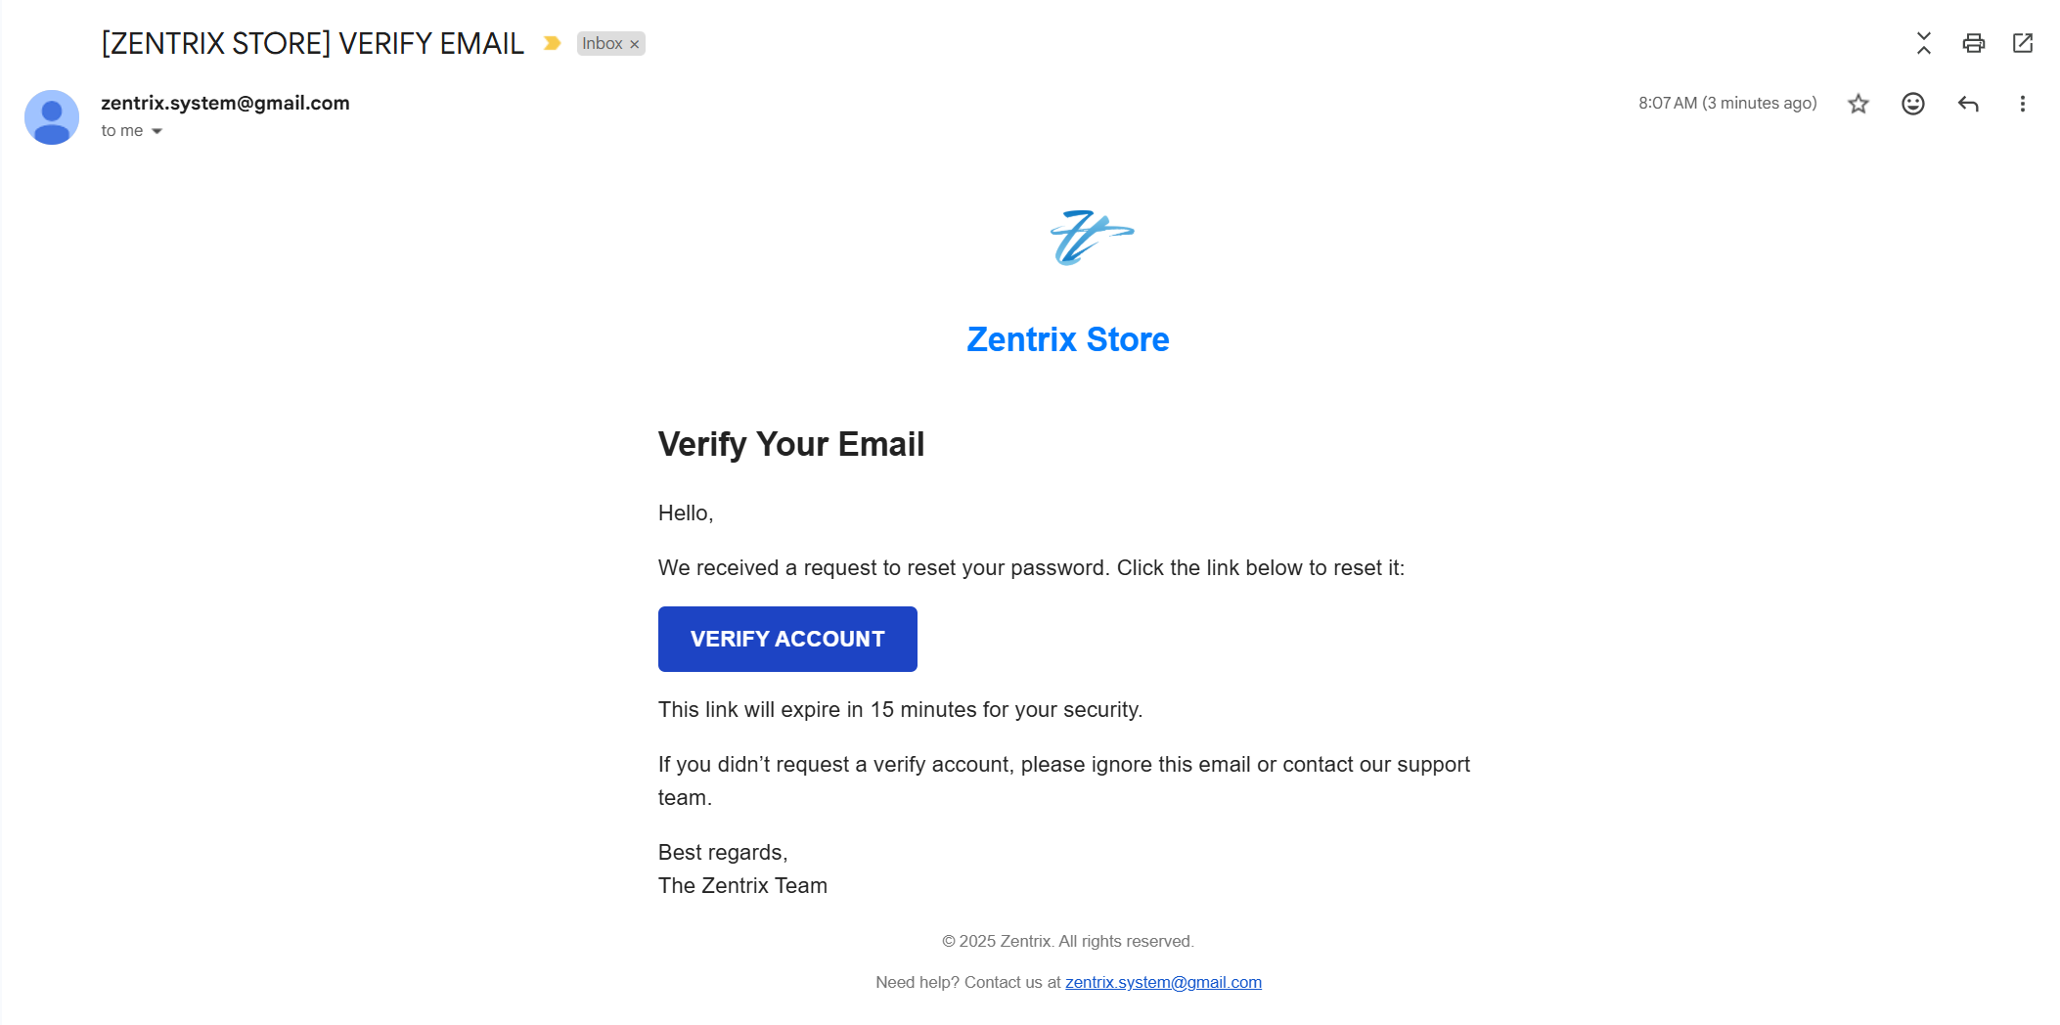

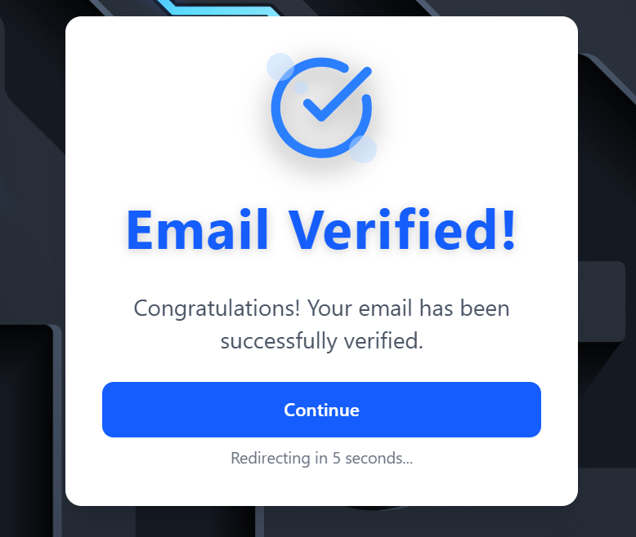

Beside that, if account is admin locked. It will show notification as below:

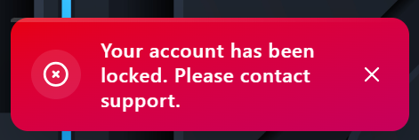

### Login by Google

Click “Sign in with Google” to sign in. Website will navigate to home page if role is Customer. Otherwise, it will navigate to dashboard. Beside that, if account is admin locked. It will show notification as below:





## LOGOUT

### Logout from Dashboard

Click Logout icon to sign out account. After sign out account, system will navigate to home page

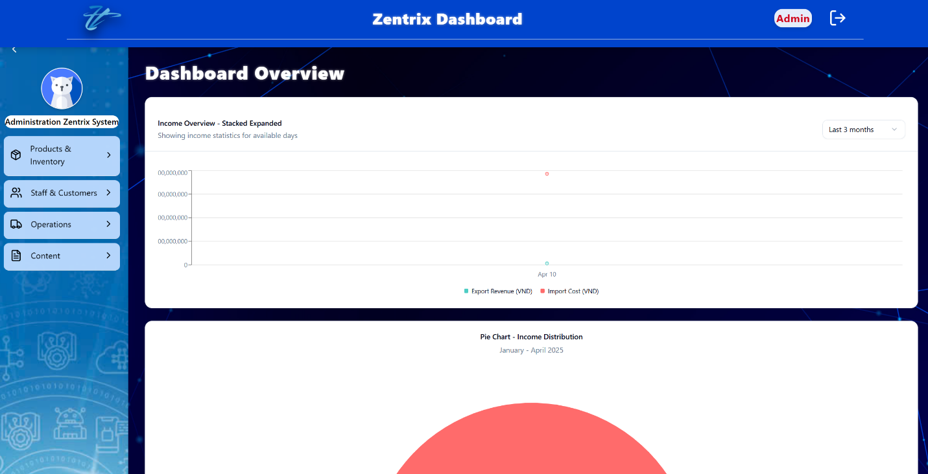

### Logout from Homepage

Click icon with username at next to icon in navigation bar. The system will navigate to profile of user. Click logout icon to sign out account

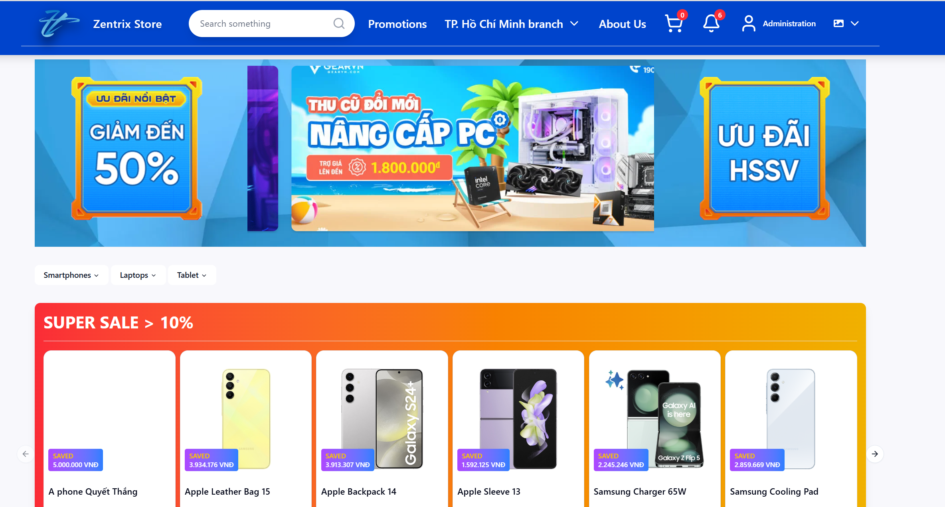

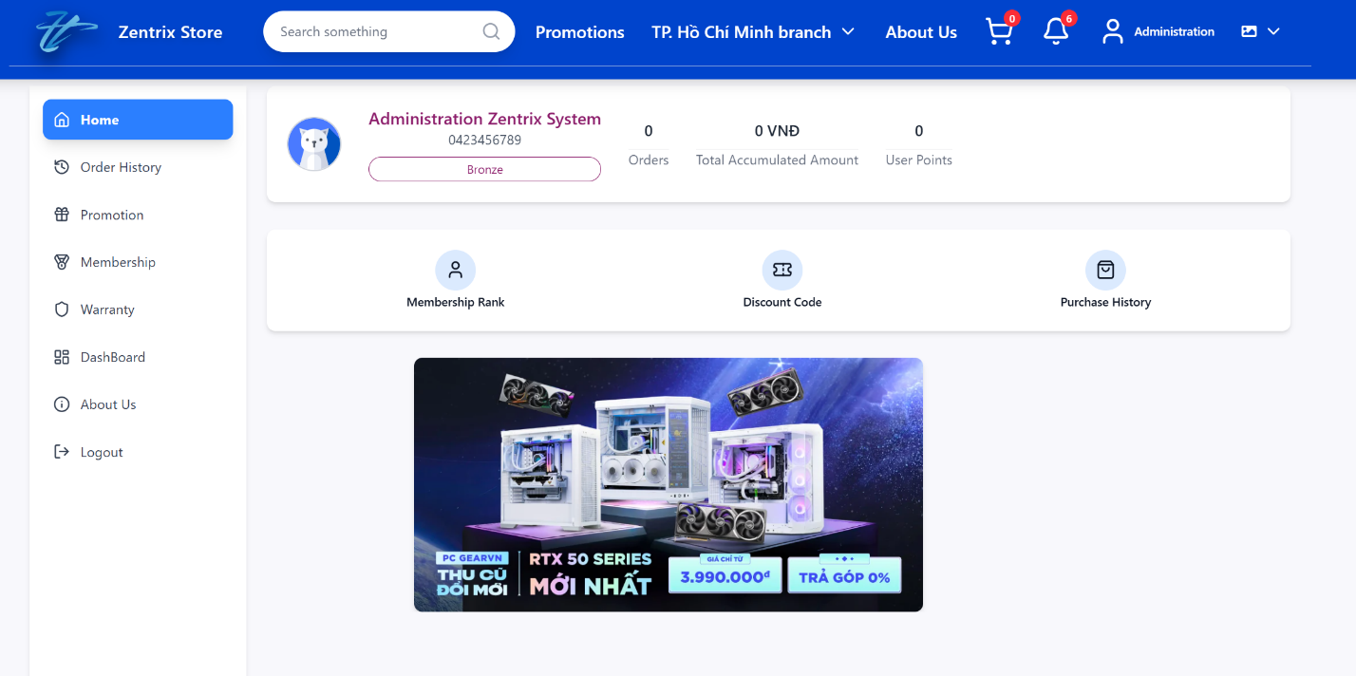

## FORGOT PASSWORD

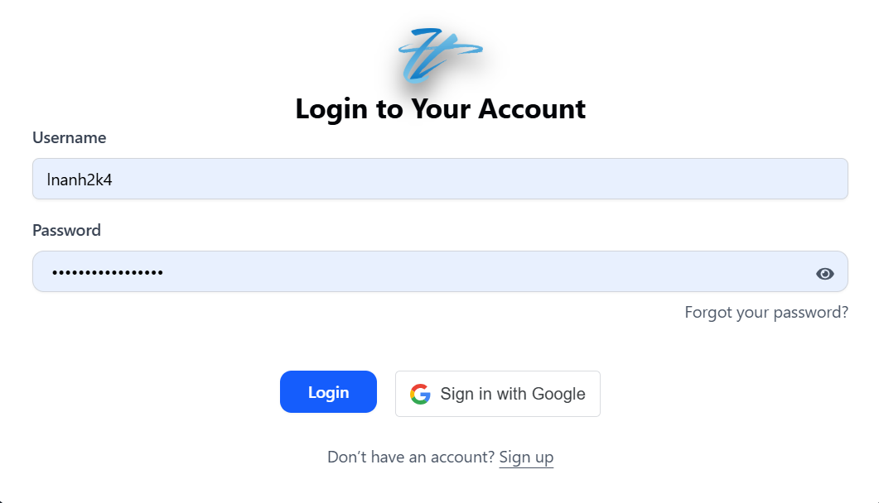

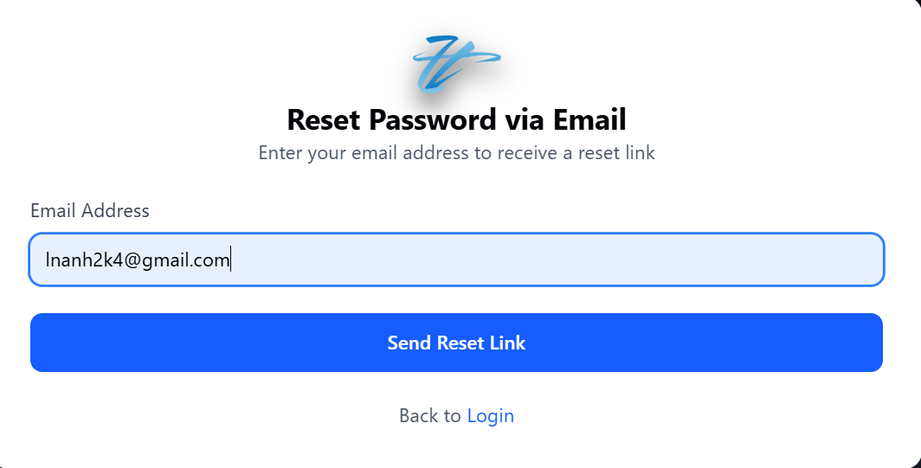

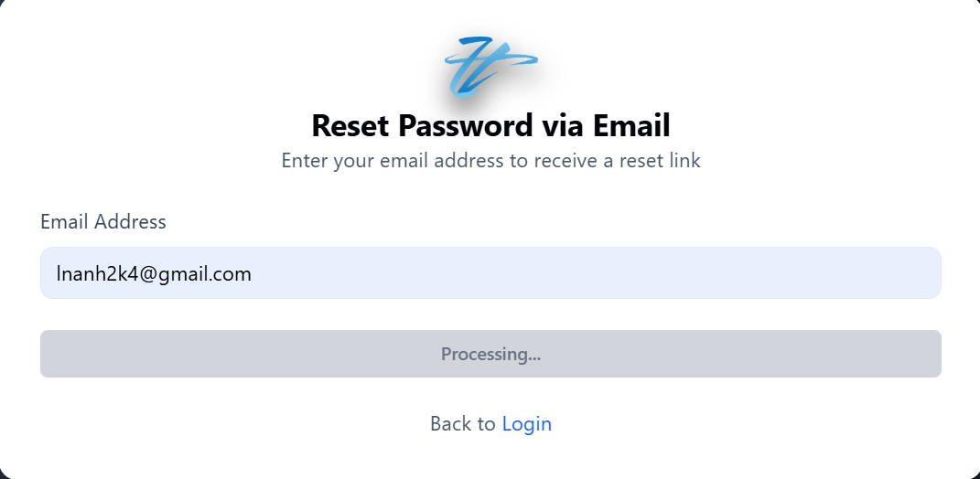

User can click resend email link so that system resend email again if gmail of user does not received email from system

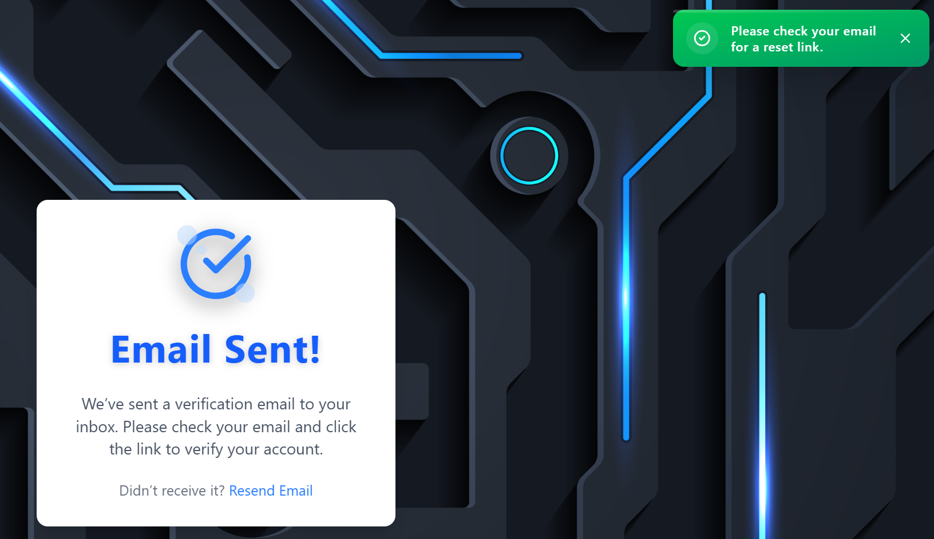



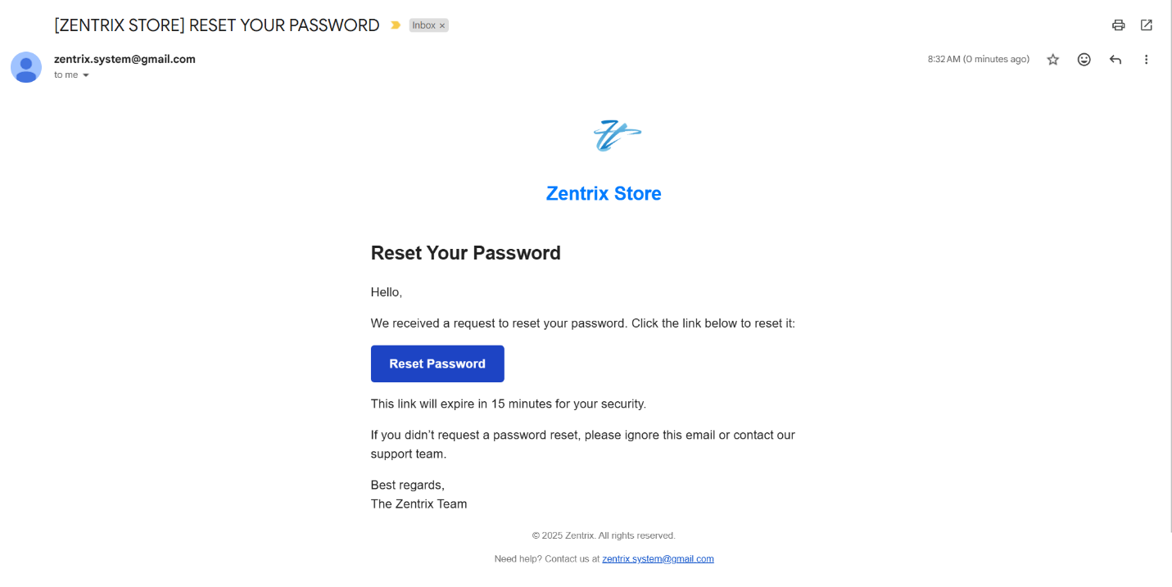

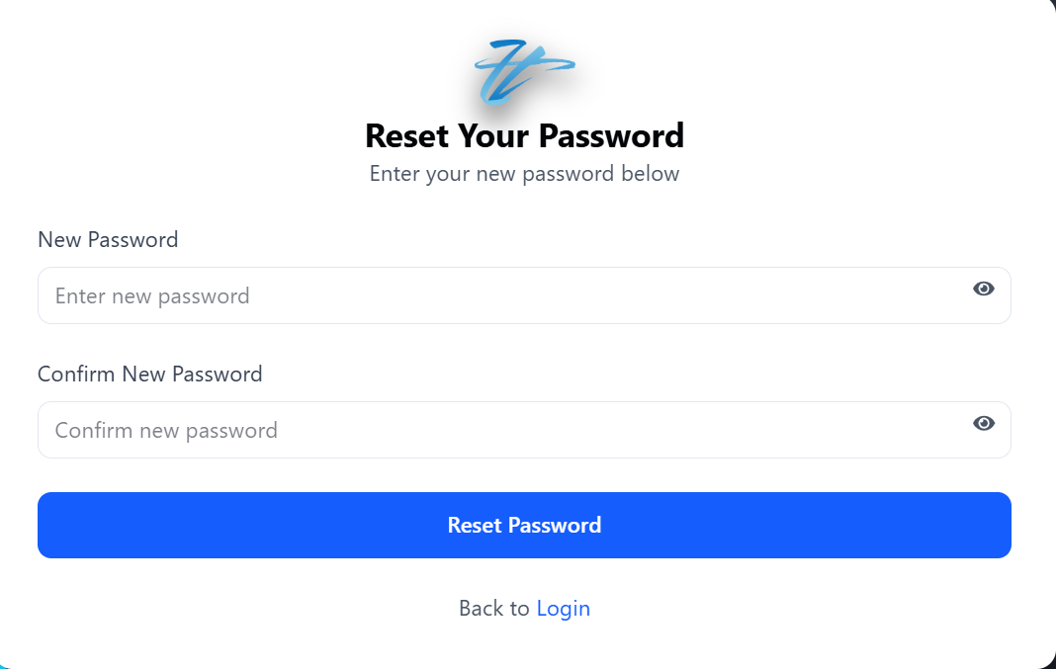

**VALIDATION FIELDS OF RESET PASSWORD TABLE**

|  |  |  |
| --- | --- | --- |
| **No.** | **Field** | **Validation** |
|  | Password | * Must be not blank * Must be at least 8 characters * Must be at least 1 lowercase character * Must be at least 1 uppercase character * Must be at least an integer * Must be at least 1 symbol |
|  | Confirm password | * Must be not blank * Must be matched with password field |

After fill in information into all field. Click reset password button. If reset password successfully, system will show notification and navigate to login page

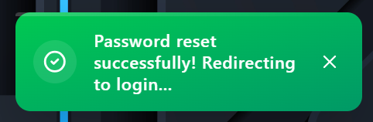

## MANAGE PROFILE

### Manage profile in dashboard

#### View profile

Click icon in menu bar on the left side to navigate to profile

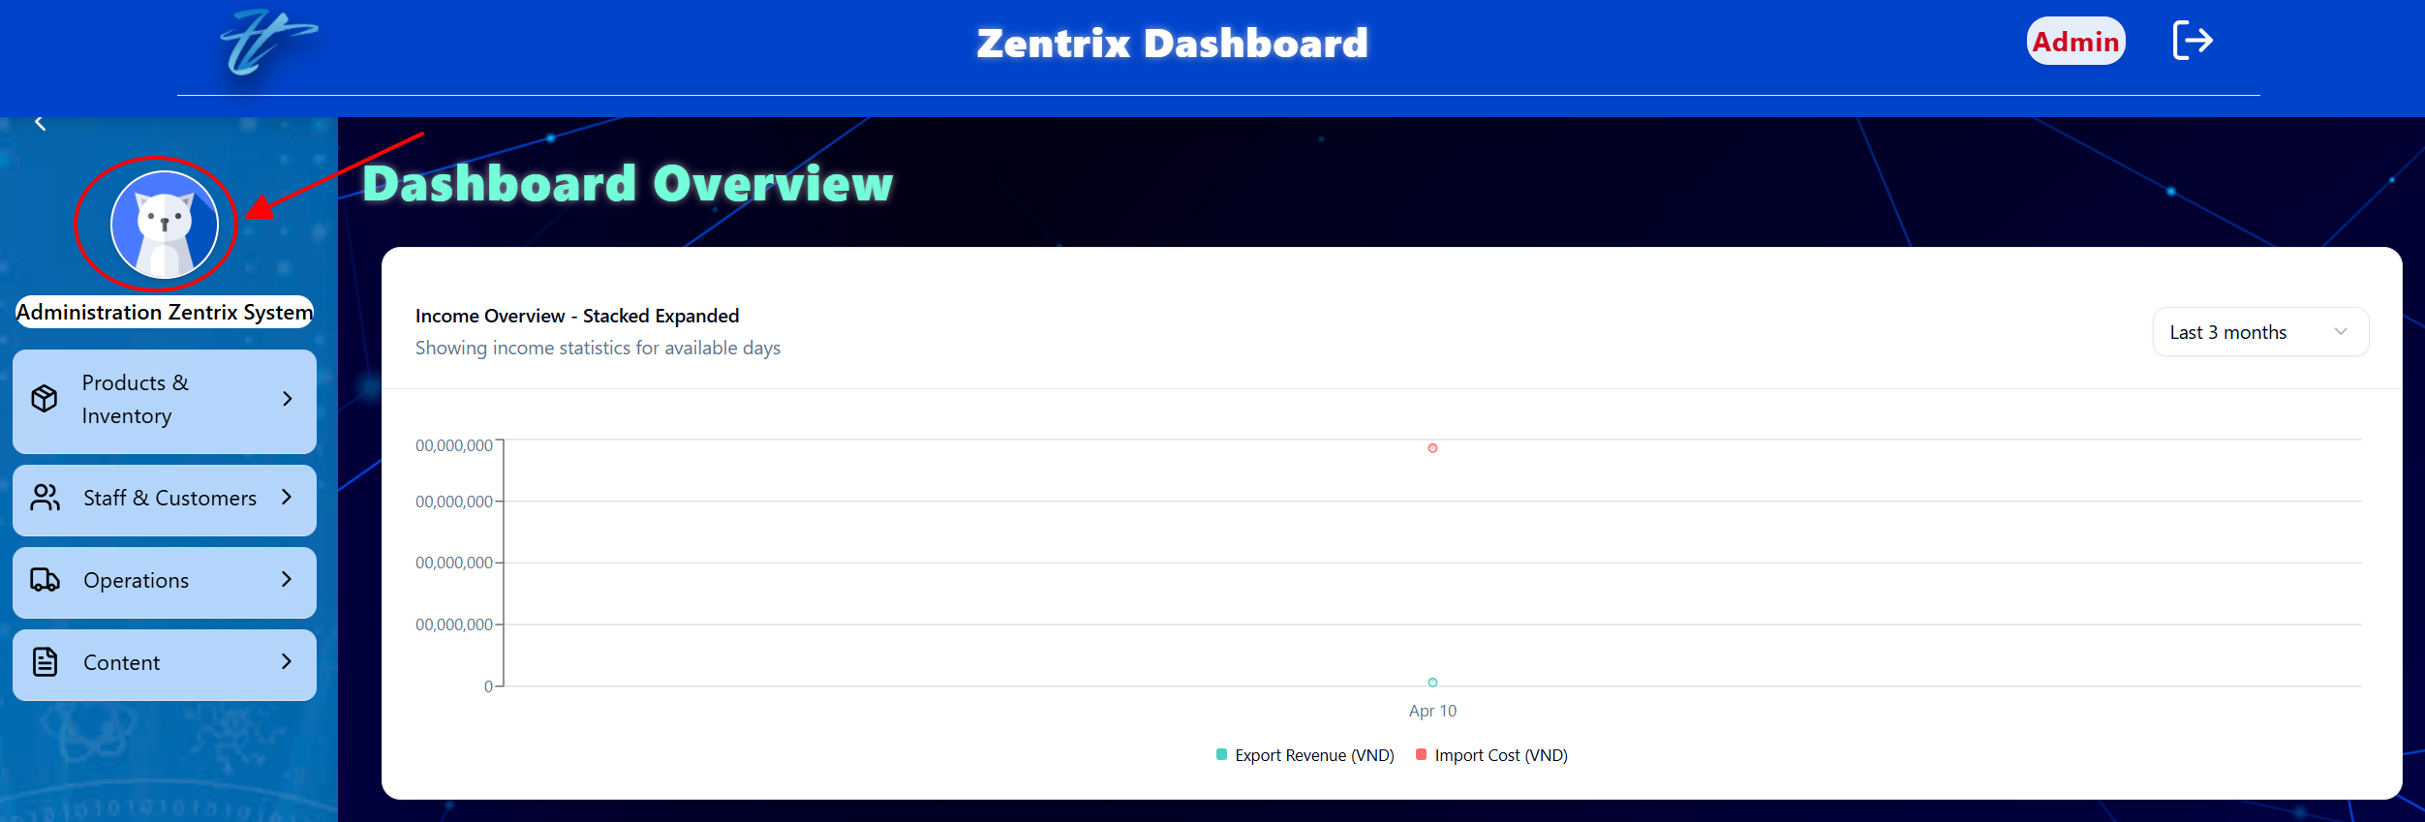

#### Edit profile

Click edit to change information

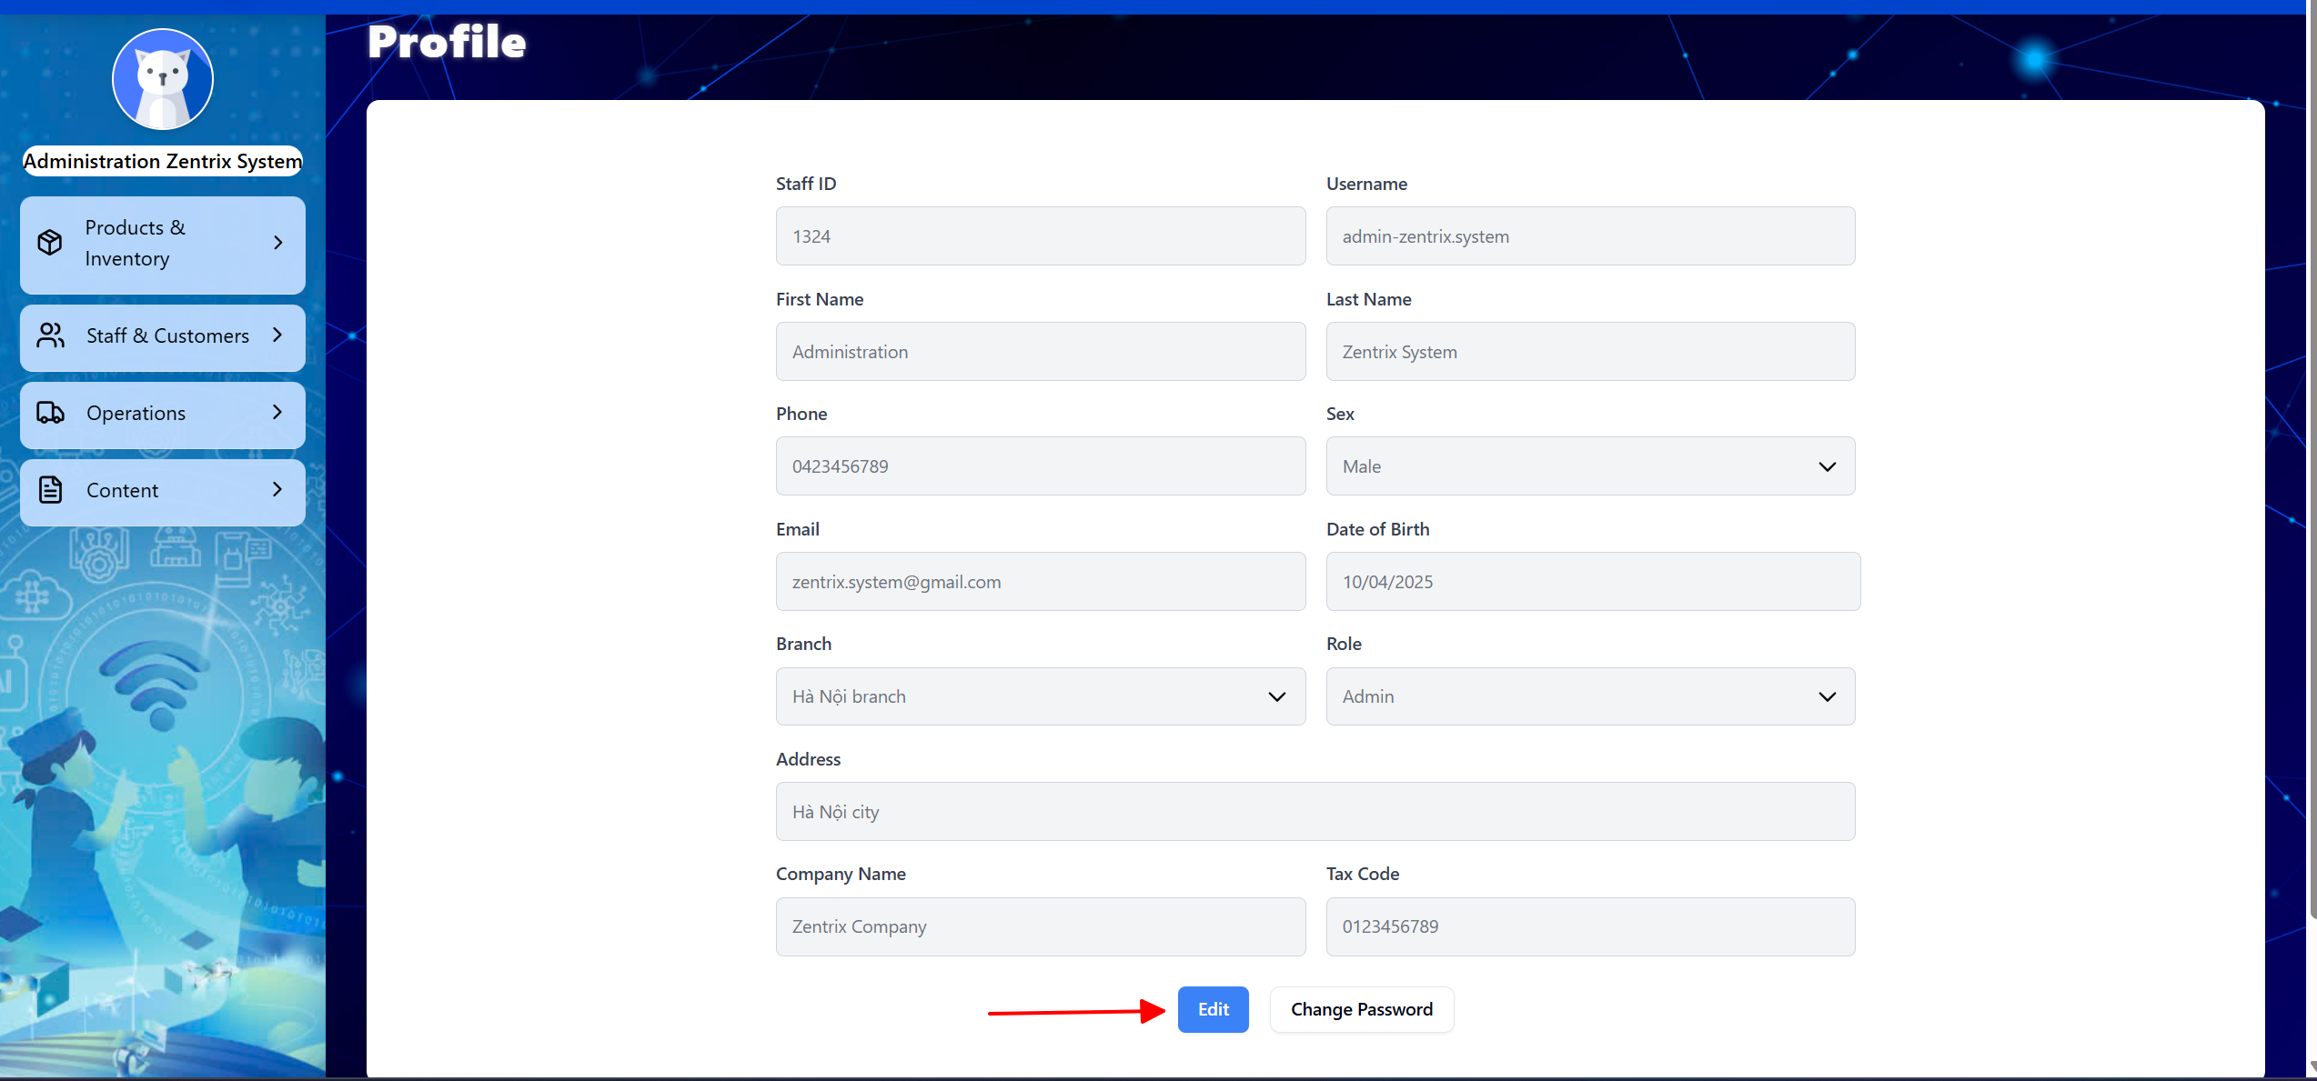

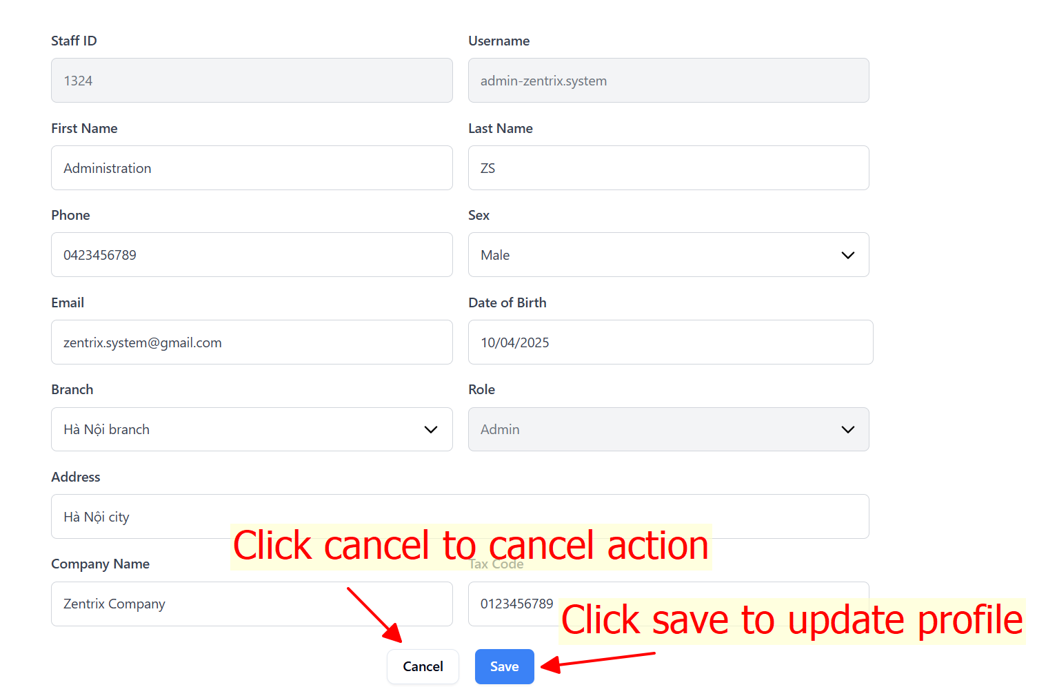

If edit profile successfully. System will show notification

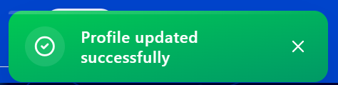

#### Change password

Click change password button to change password

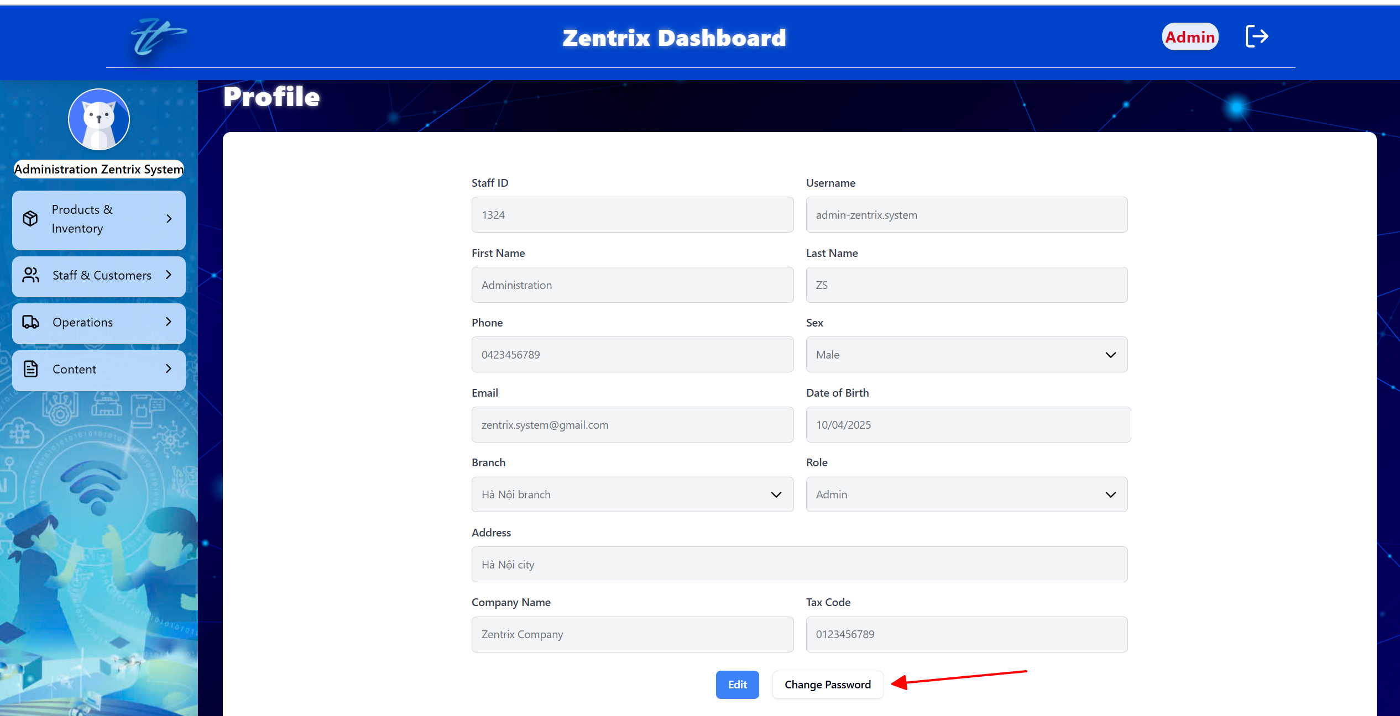

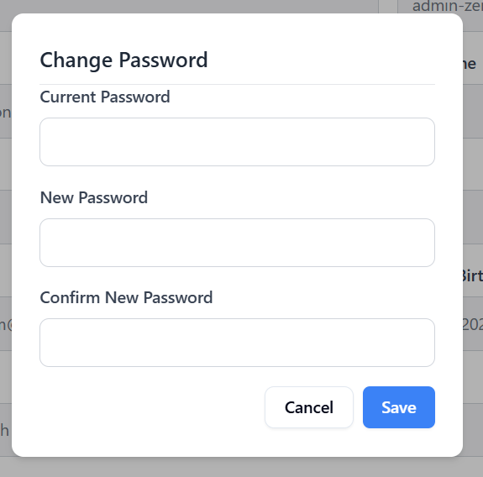

**VALIDATION FIELDS OF CHANGE PASSWORD TABLE**

|  |  |  |
| --- | --- | --- |
| **No.** | **Field** | **Validation** |
|  | Password | * Must be not blank * Must be at least 8 characters * Must be at least 1 lowercase character * Must be at least 1 uppercase character * Must be at least an integer * Must be at least 1 symbol |
|  | Confirm password | * Must be not blank * Must be matched with password field |
|  | Current password | * Must be not blank |

After fill in all fields in change password form. Click save button to change password. If change password successfully. System will show notification below



### Manage profile in homepage

#### View profile

Click profile on the left menu bar to navigate profile page

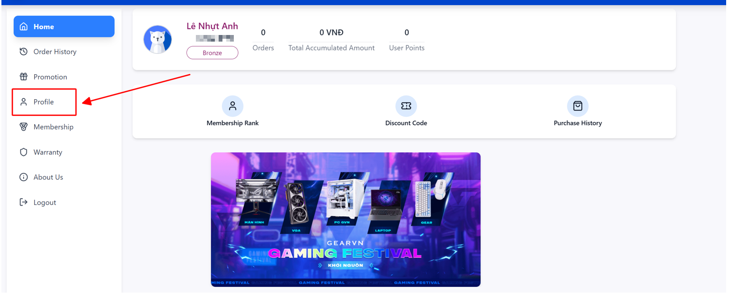

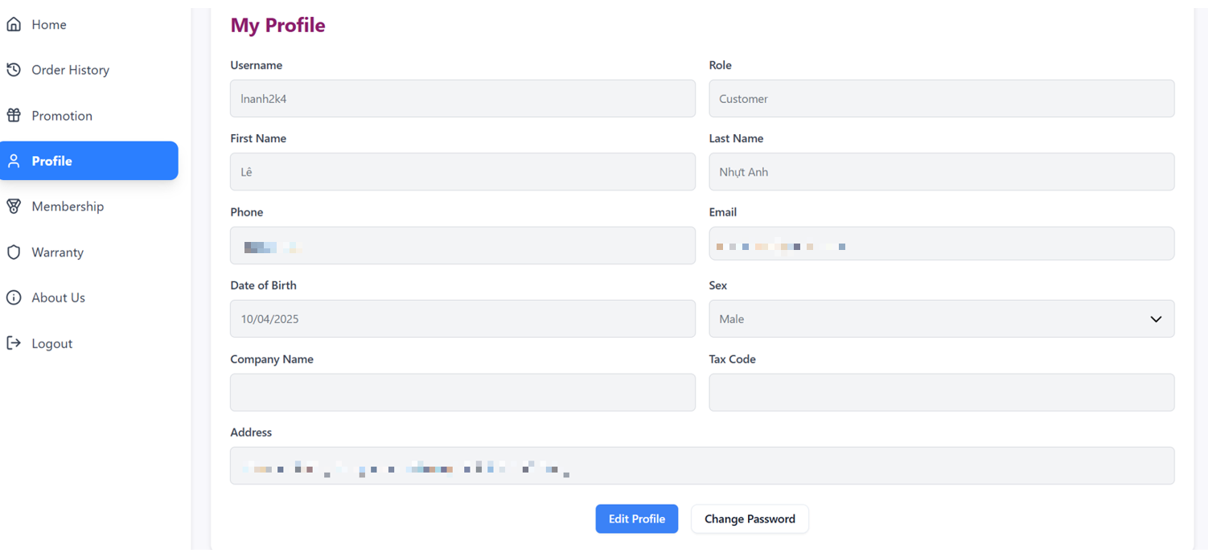

#### Edit profile

Click edit profile button to edit profile

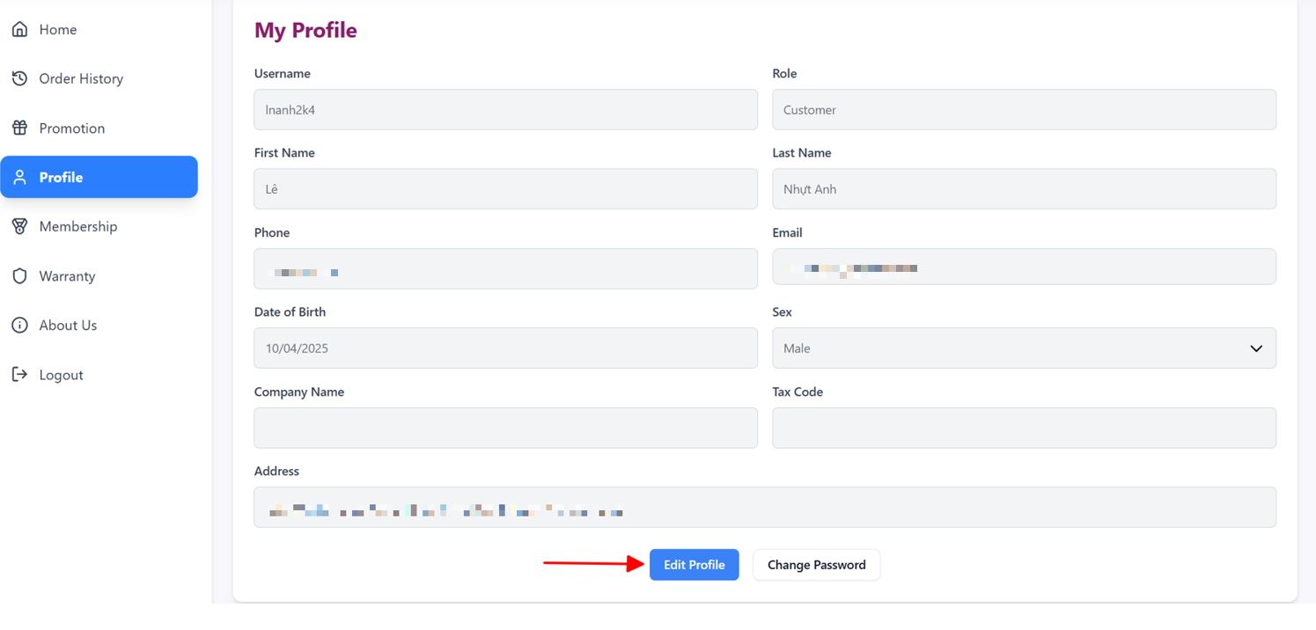

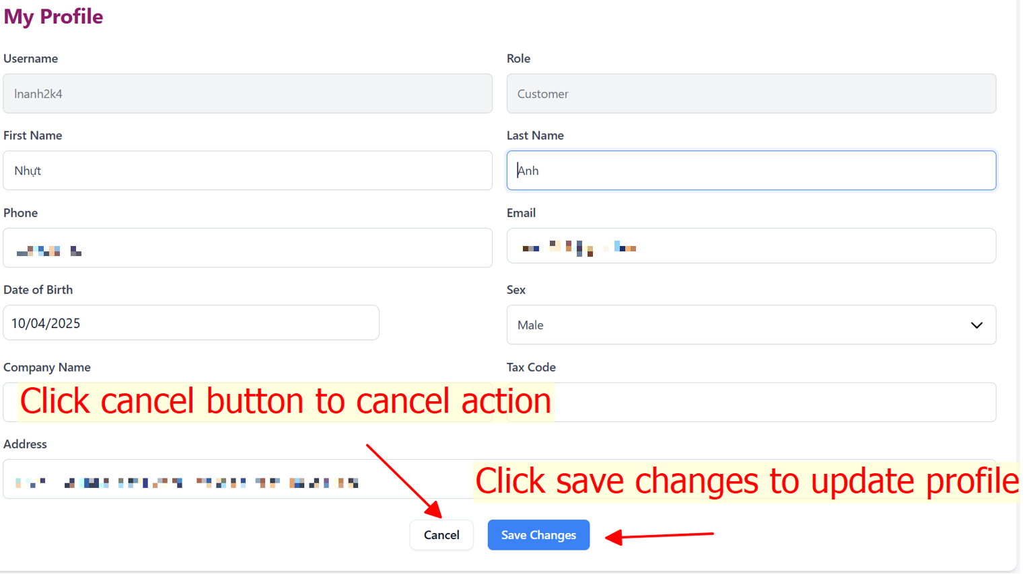

If edit profile successfully, system will show notification as below

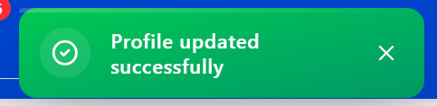

#### Change password

Click change password button to change password

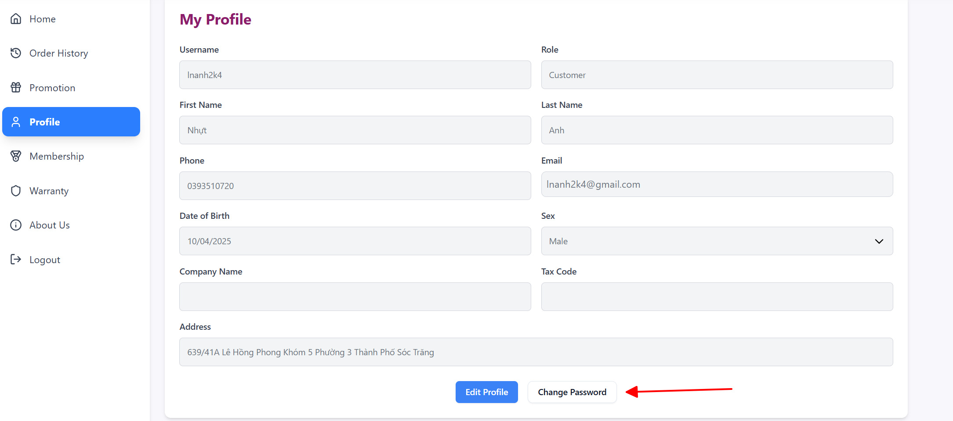

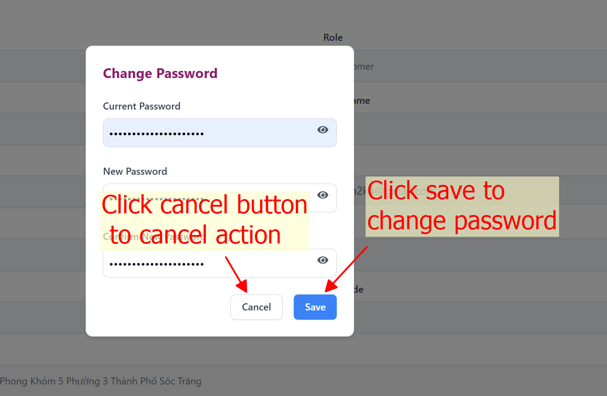

**VALIDATION FIELDS OF CHANGE PASSWORD TABLE**

|  |  |  |
| --- | --- | --- |
| **No.** | **Field** | **Validation** |
|  | Password | * Must be not blank * Must be at least 8 characters * Must be at least 1 lowercase character * Must be at least 1 uppercase character * Must be at least an integer * Must be at least 1 symbol |
|  | Confirm password | * Must be not blank * Must be matched with password field |
|  | Current password | * Must be not blank |

After fill in all fields in change password form. Click save button to change password. If change password successfully. System will show notification below



## MANAGE CUSTOMERS

### Add customer

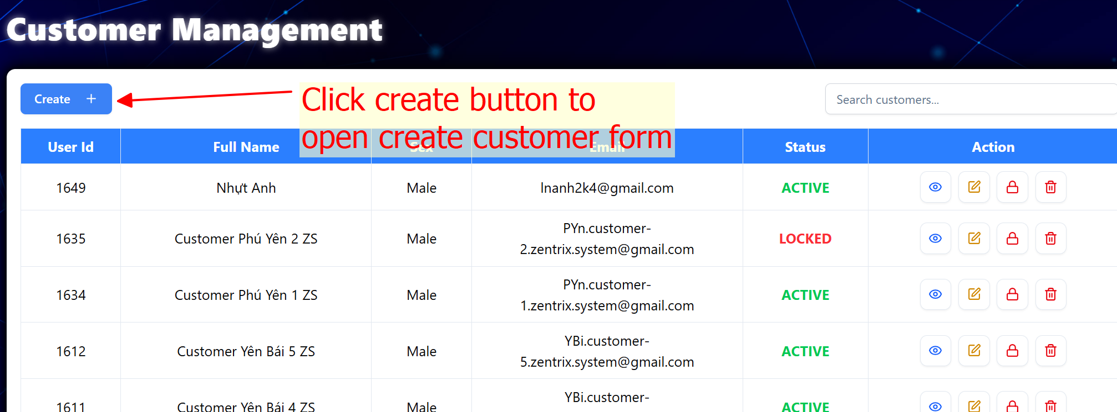

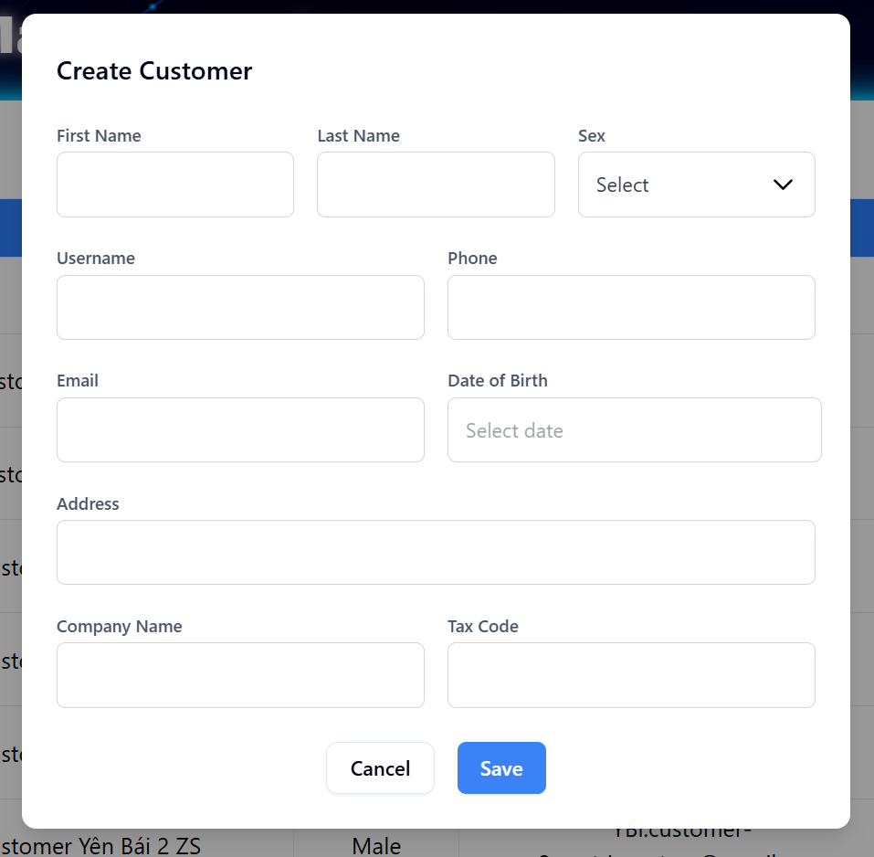

Fill in and click save to create a new customer with VERYFYING status. 

Figure . Create customer successfully

**VALIDATION FIELD ADD CUSTOMER TABLE**

|  |  |  |
| --- | --- | --- |
| **No.** | **Field** | **Validation** |
|  | Username | * Must be not blank * Must be at least 3 characters |
|  | First name | * Must be not blank * Only allow letters, Vietnamese letters, “-“, and “_” character |
|  | Last name | * Must be not blank * Only allow letters, Vietnamese letters, “-“, and “_” character |
|  | Phone | * Must be not blank * Must be integers between 9 and 15 digits |
|  | Sex | * Must be not blank |
|  | Email | * Must be not blank * Must be at least “@” character * Must be at least 1 character before “@” character without space * Must be at least 1 character after “@” character without space |
|  | Date of birth | * Must be not blank * Max date is today |
|  | Address | * Must be not blank |
|  | Company name | * Only allow letters, Vietnamese letters, “-“, and “_” character |
|  | Tax code | * Must be integers between 10 and 13 digits |

### View customer detail

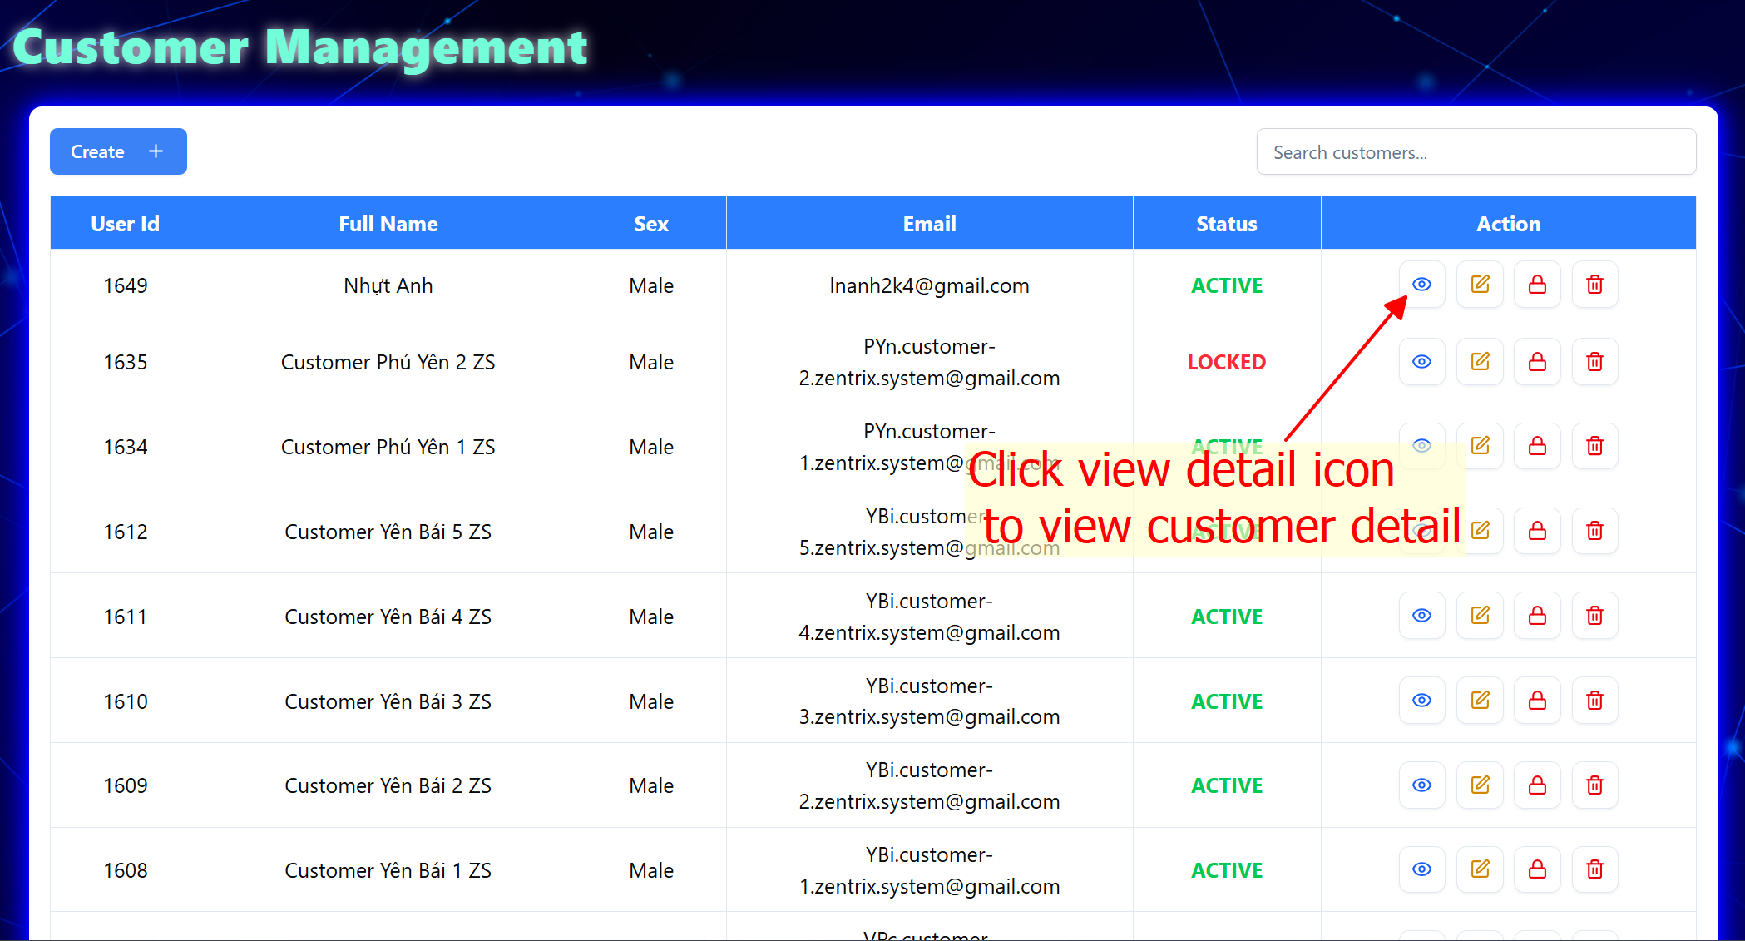

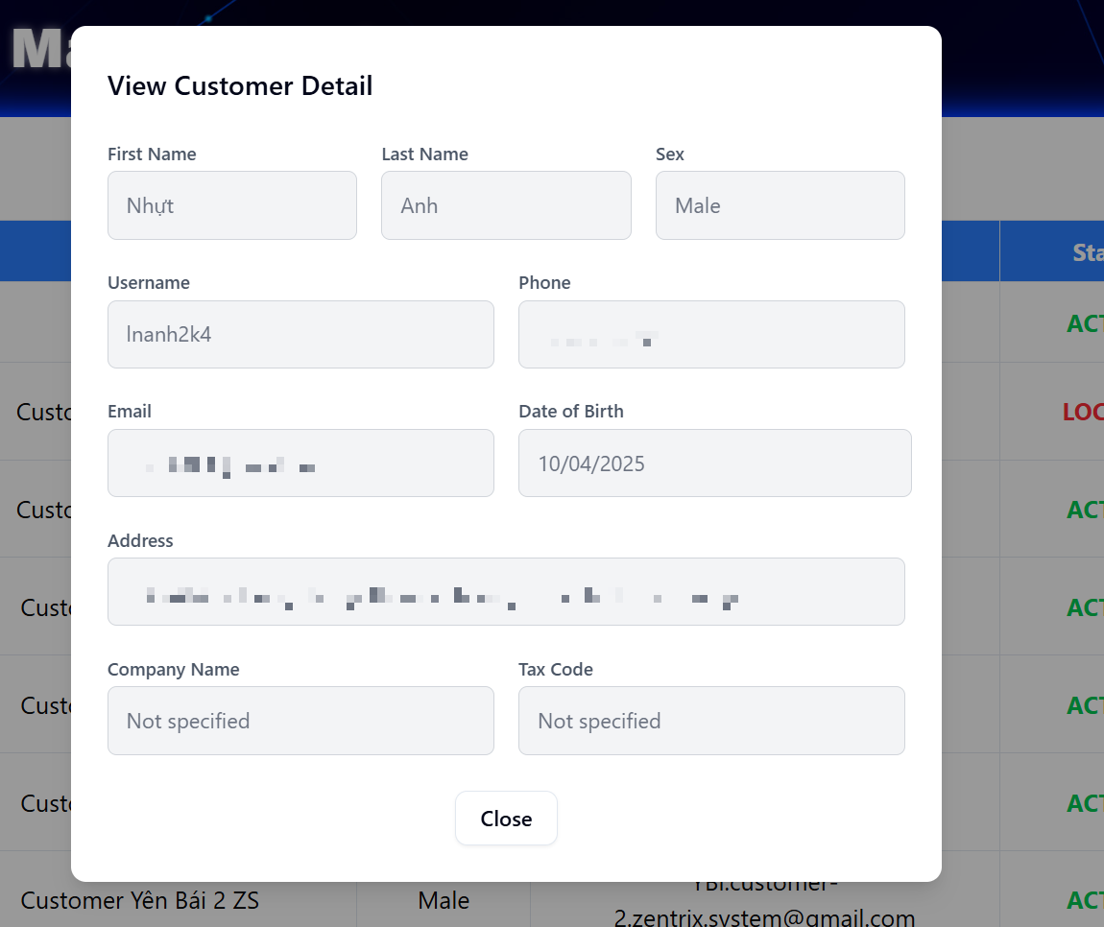

Figure . View customer detail

### Edit customer

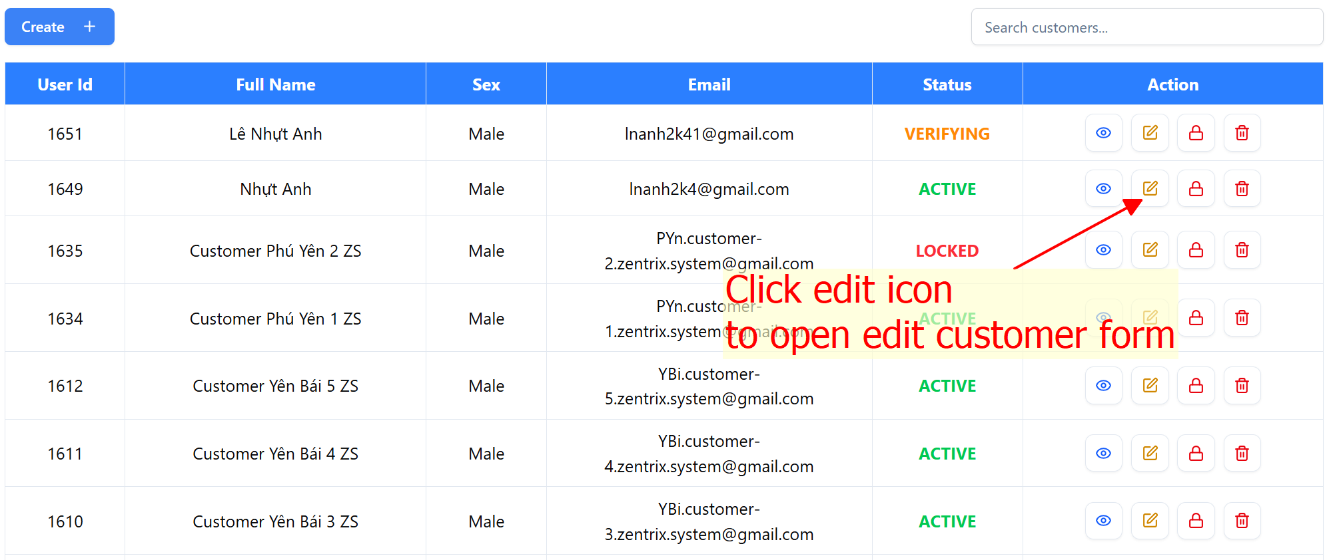

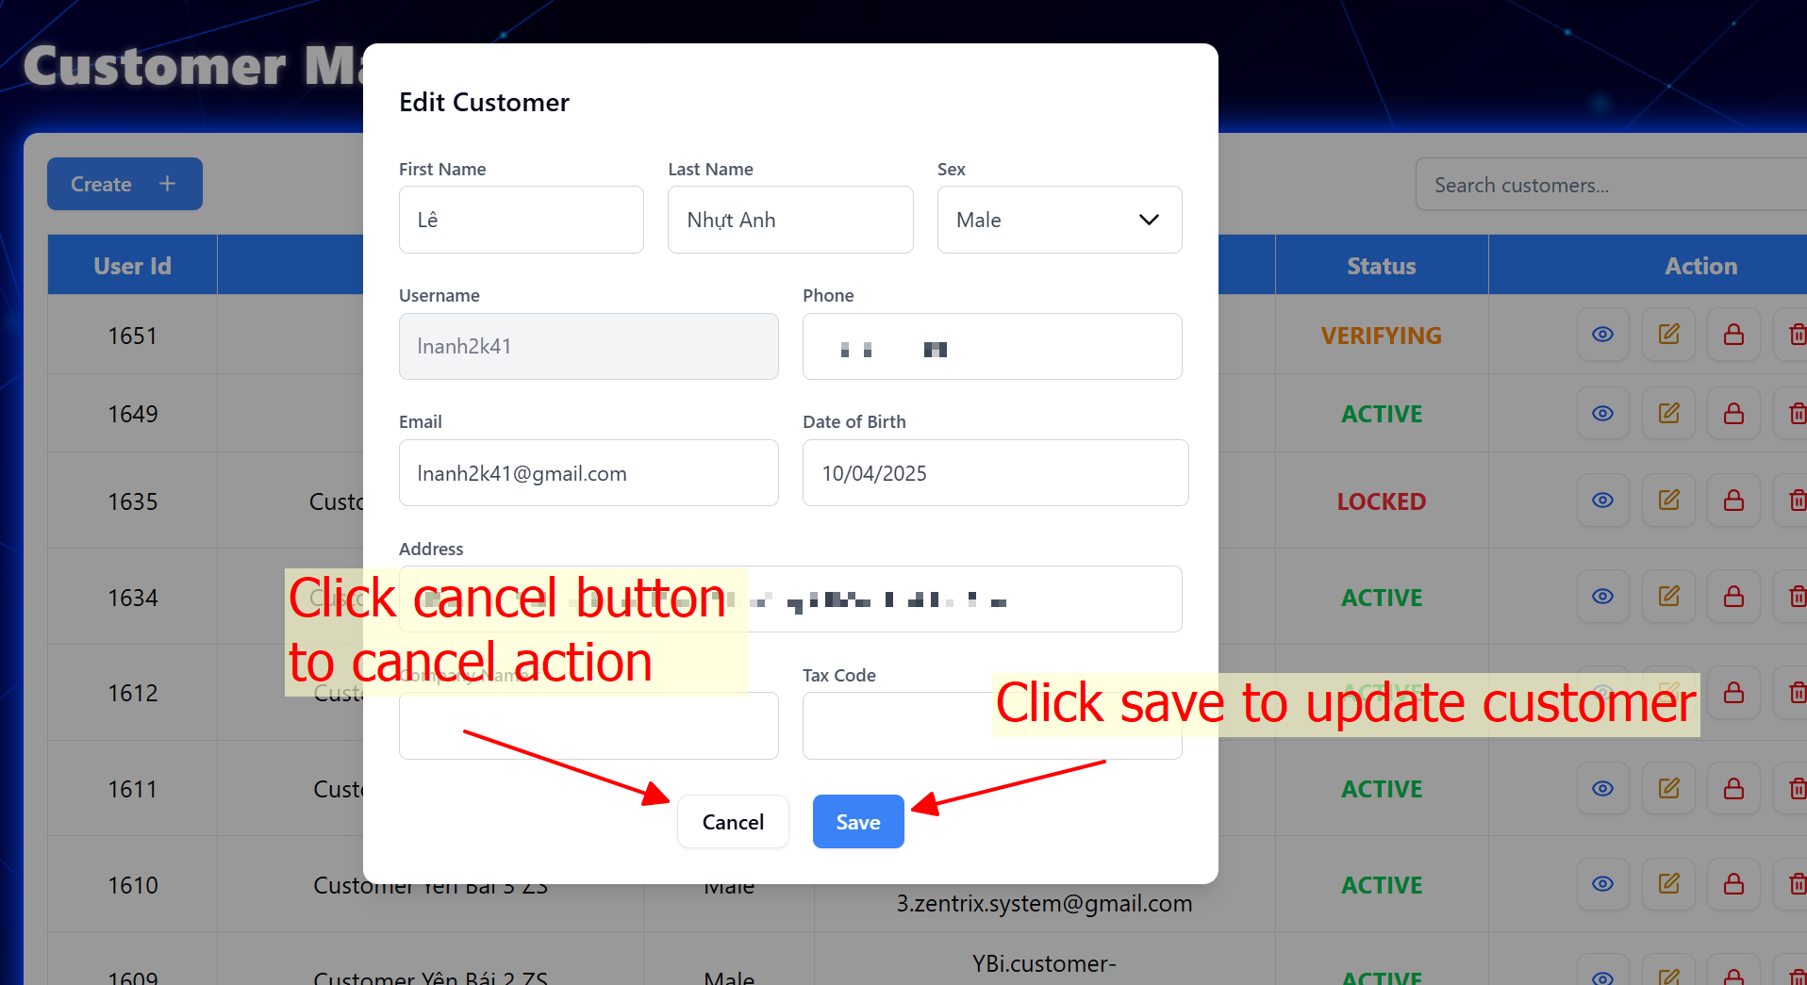

Attention: If email is changed, the status of user will change to verifying although status of user is active.

**VALIDATION FIELD EDIT CUSTOMER TABLE**

|  |  |  |
| --- | --- | --- |
| **No.** | **Field** | **Validation** |
|  | Username | * Must be not blank * Must be at least 3 characters |
|  | First name | * Must be not blank * Only allow letters, Vietnamese letters, “-“, and “_” character |
|  | Last name | * Must be not blank * Only allow letters, Vietnamese letters, “-“, and “_” character |
|  | Phone | * Must be not blank * Must be integers between 9 and 15 digits |
|  | Sex | * Must be not blank |
|  | Email | * Must be not blank * Must be at least “@” character * Must be at least 1 character before “@” character without space * Must be at least 1 character after “@” character without space |
|  | Date of birth | * Must be not blank * Max date is today |
|  | Address | * Must be not blank |
|  | Company name | * Only allow letters, Vietnamese letters, “-“, and “_” character |
|  | Tax code | * Must be integers between 10 and 13 digits |

### Delete customer

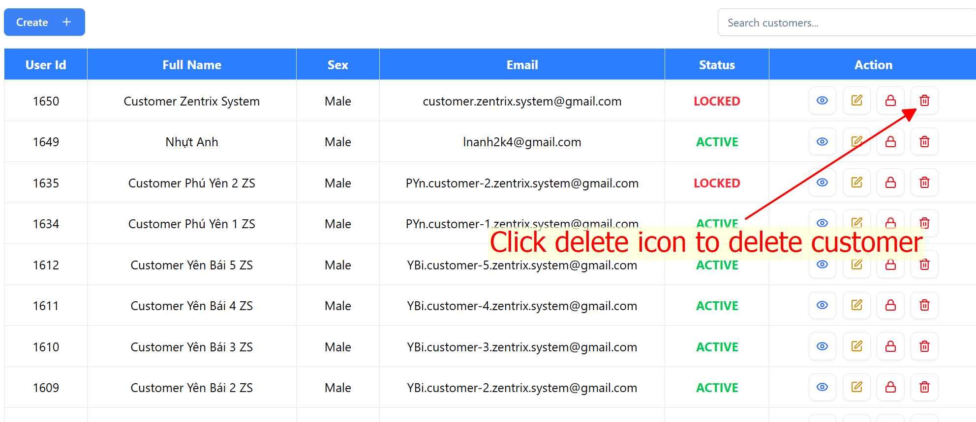

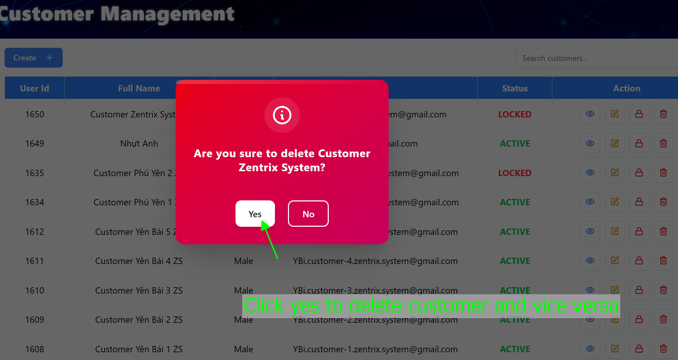

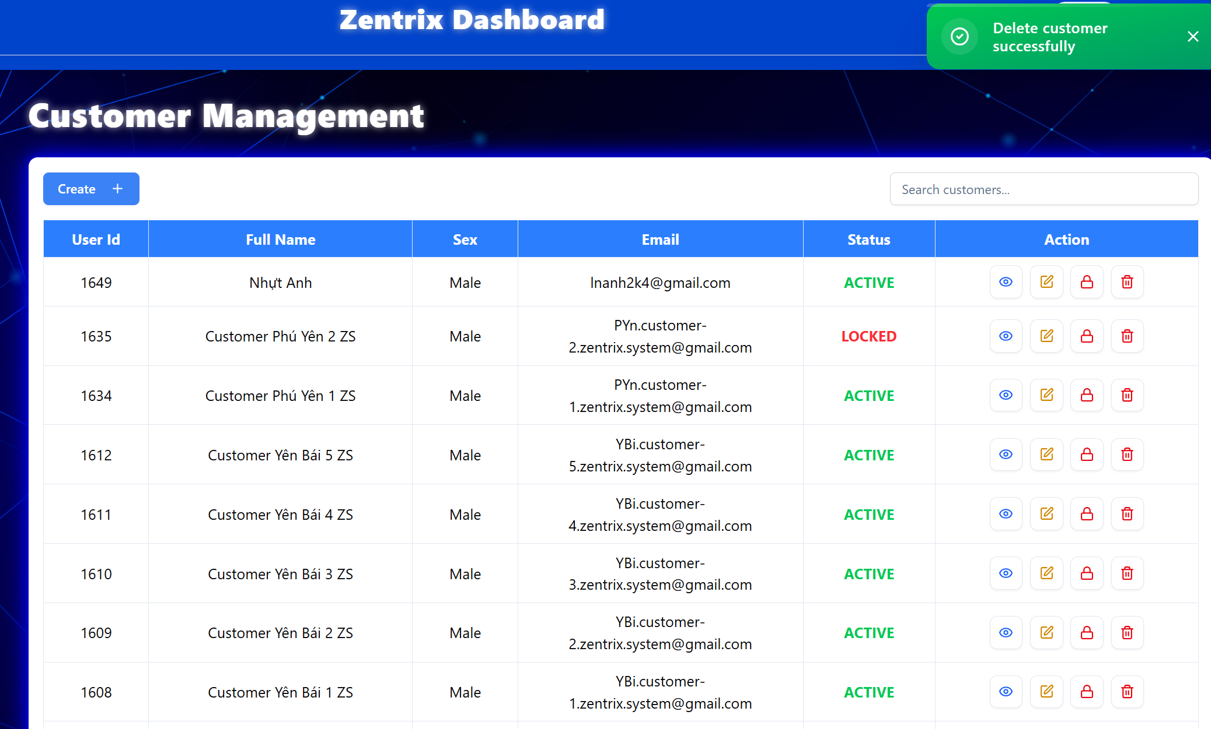

Figure . Delete customer successfully

### Lock/Unlock customer

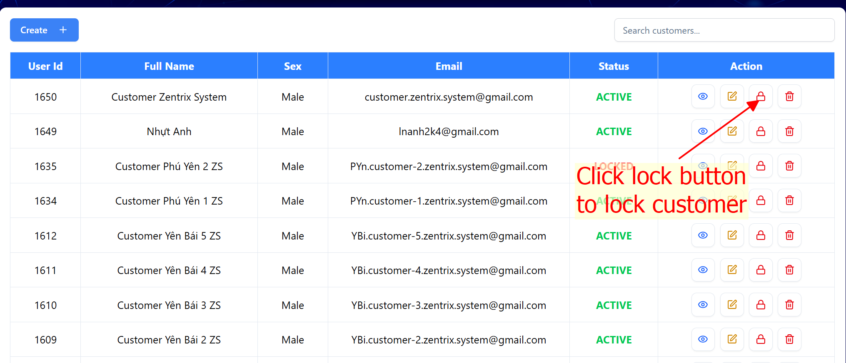

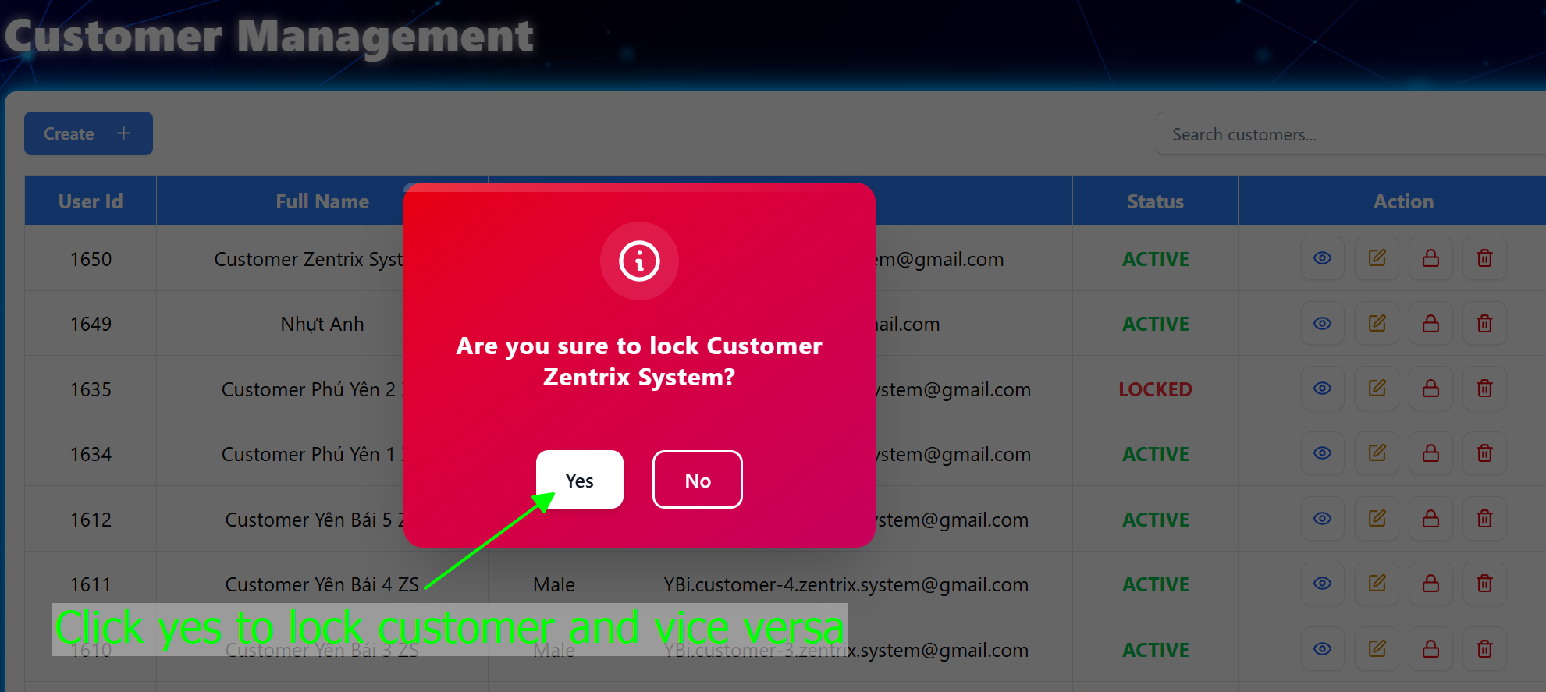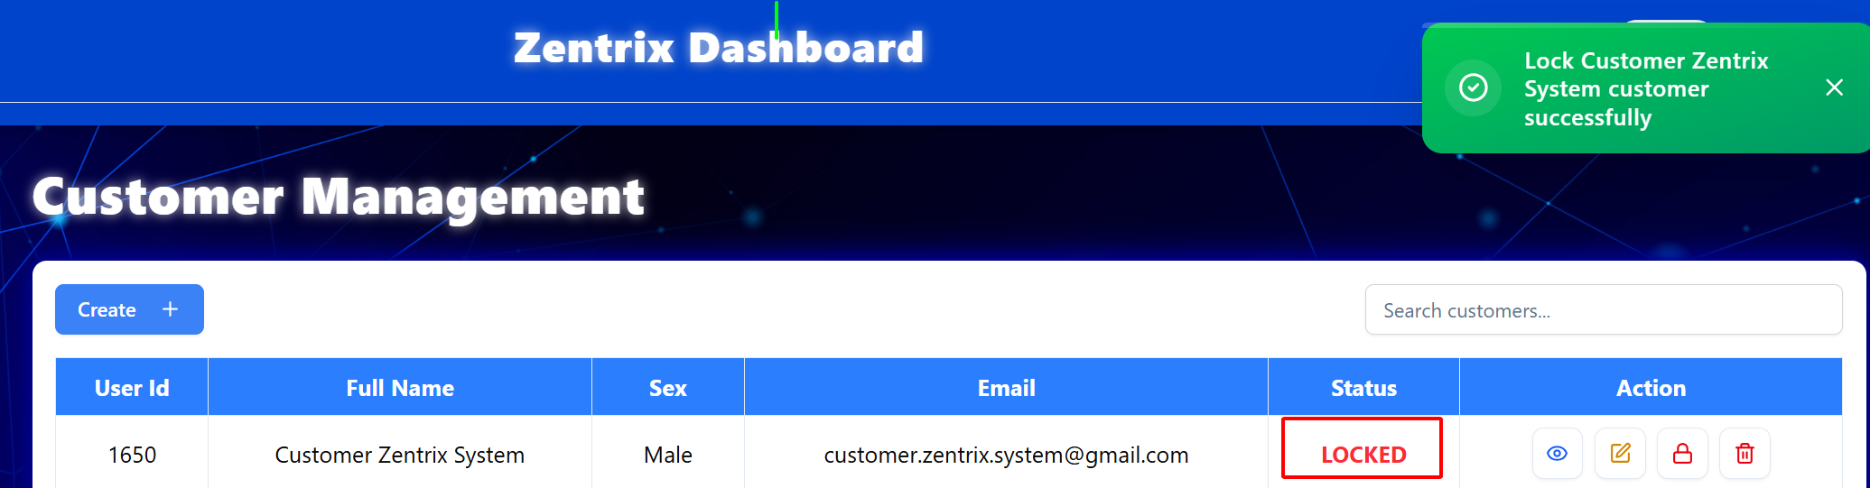

Figure . Lock customer successfully

### Search customer

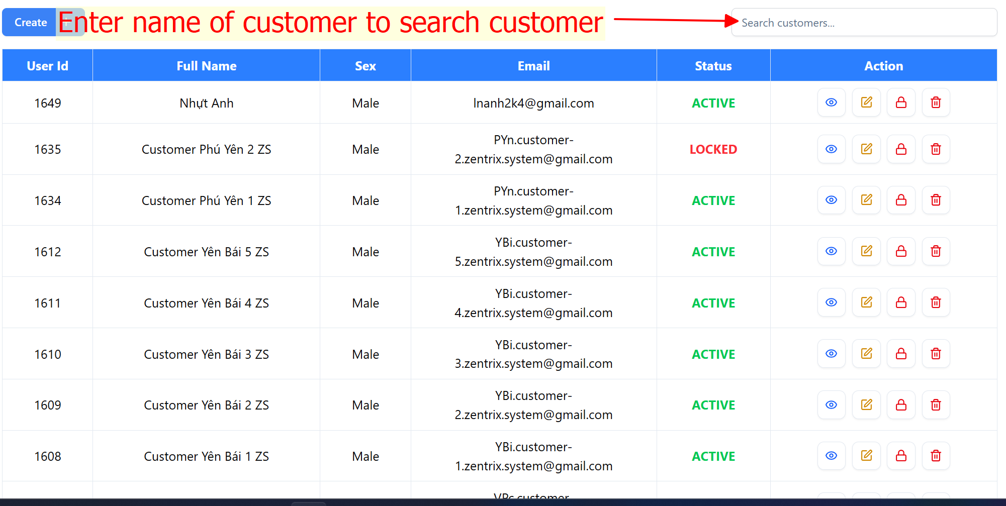

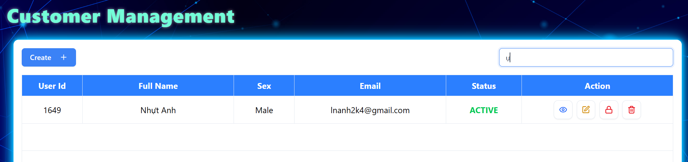

### View customer list

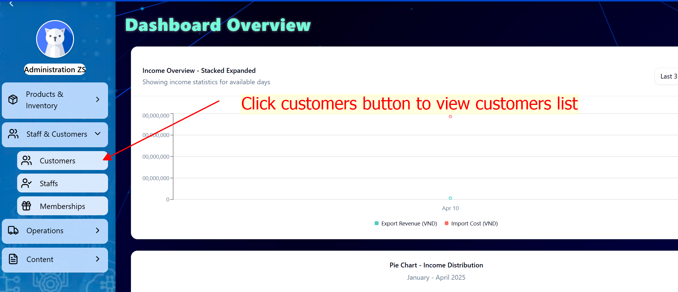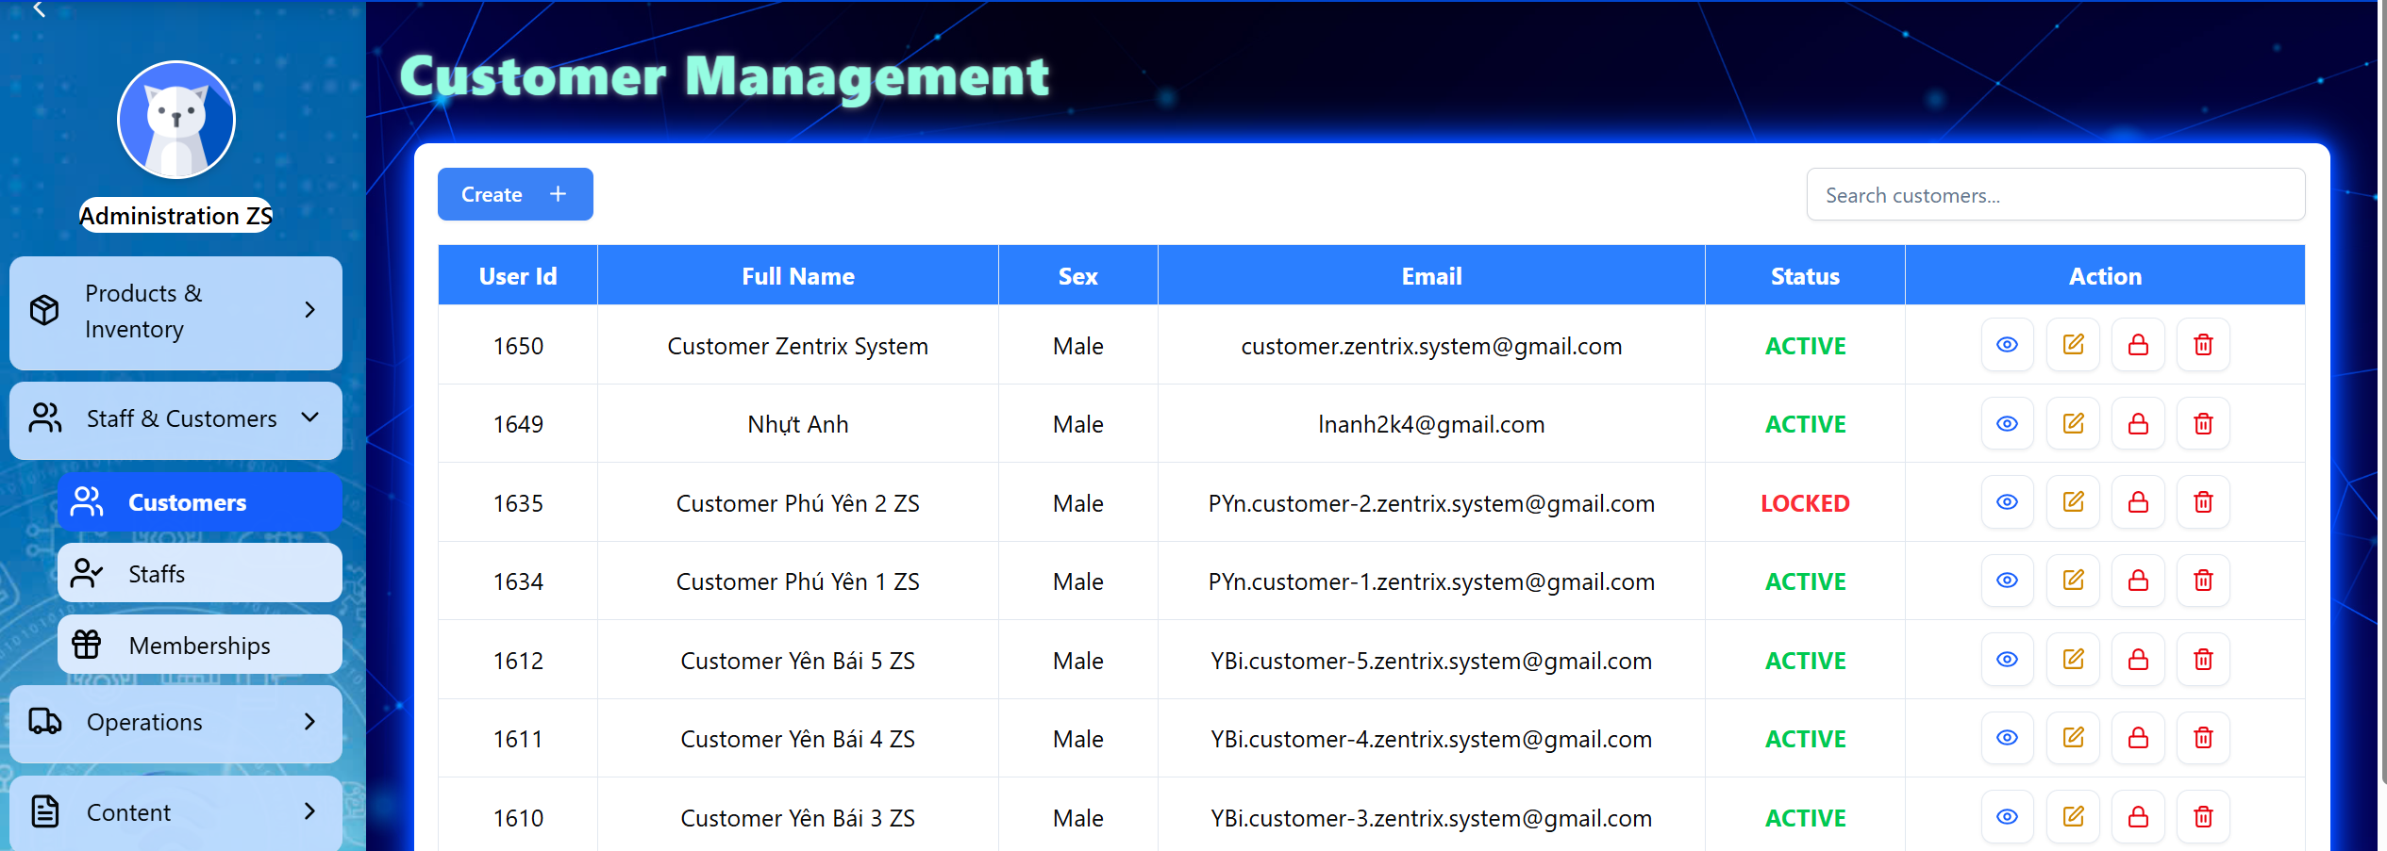

## MANAGE STAFFS

### Add staff

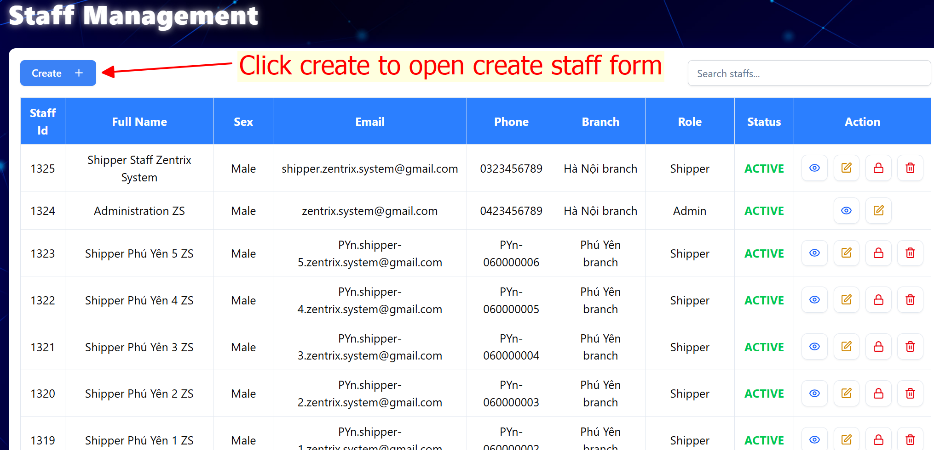

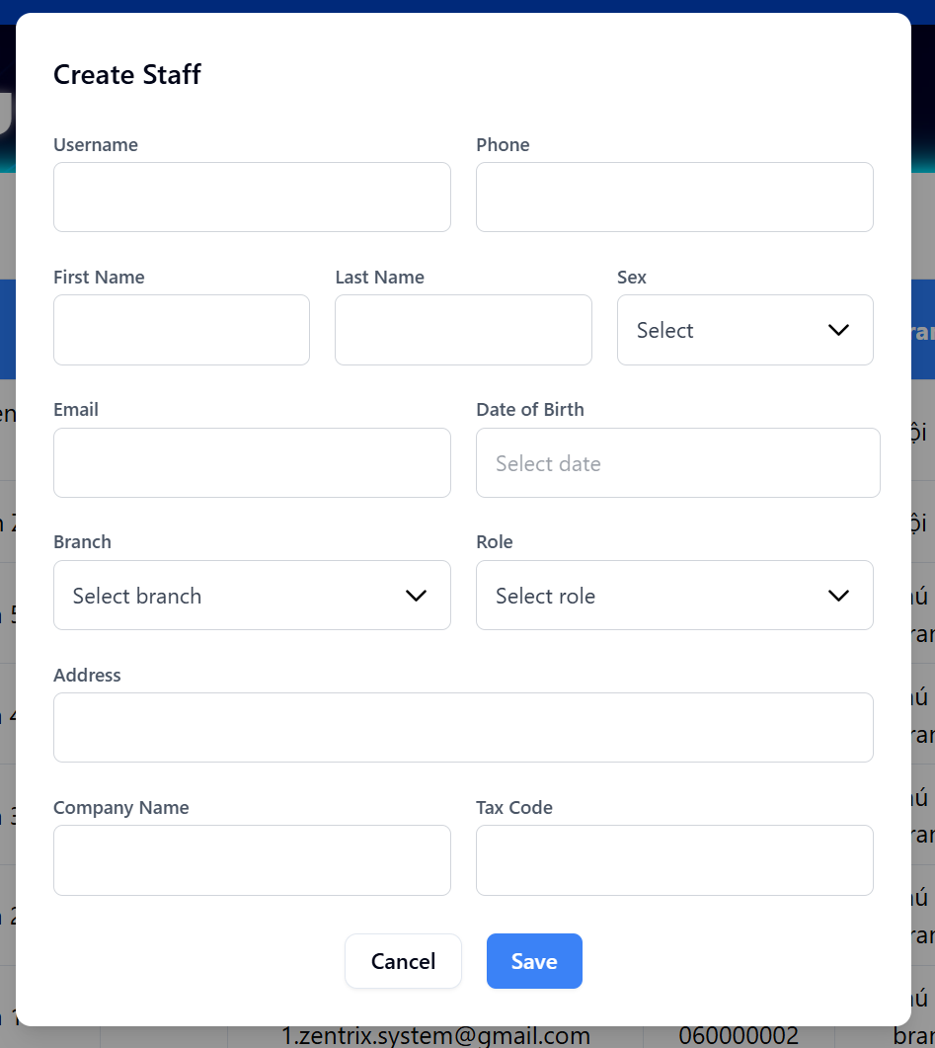

Fill in all fields and click save button to create a new staff. The status of new staff is VERIFYING

**VALIDATION FIELD ADD STAFF TABLE**

|  |  |  |
| --- | --- | --- |
| **No.** | **Field** | **Validation** |
|  | Username | * Must be not blank * Must be at least 3 characters |
|  | First name | * Must be not blank * Only allow letters, Vietnamese letters, “-“, and “_” character |
|  | Last name | * Must be not blank * Only allow letters, Vietnamese letters, “-“, and “_” character |
|  | Phone | * Must be not blank * Must be integers between 9 and 15 digits |
|  | Sex | * Must be not blank |
|  | Email | * Must be not blank * Must be at least “@” character * Must be at least 1 character before “@” character without space * Must be at least 1 character after “@” character without space |
|  | Date of birth | * Must be not blank * Max date is today |
|  | Address | * Must be not blank |
|  | Company name | * Only allow letters, Vietnamese letters, “-“, and “_” character |
|  | Tax code | * Must be integers between 10 and 13 digits |
|  | Role | * Must be not blank |

### View staff detail

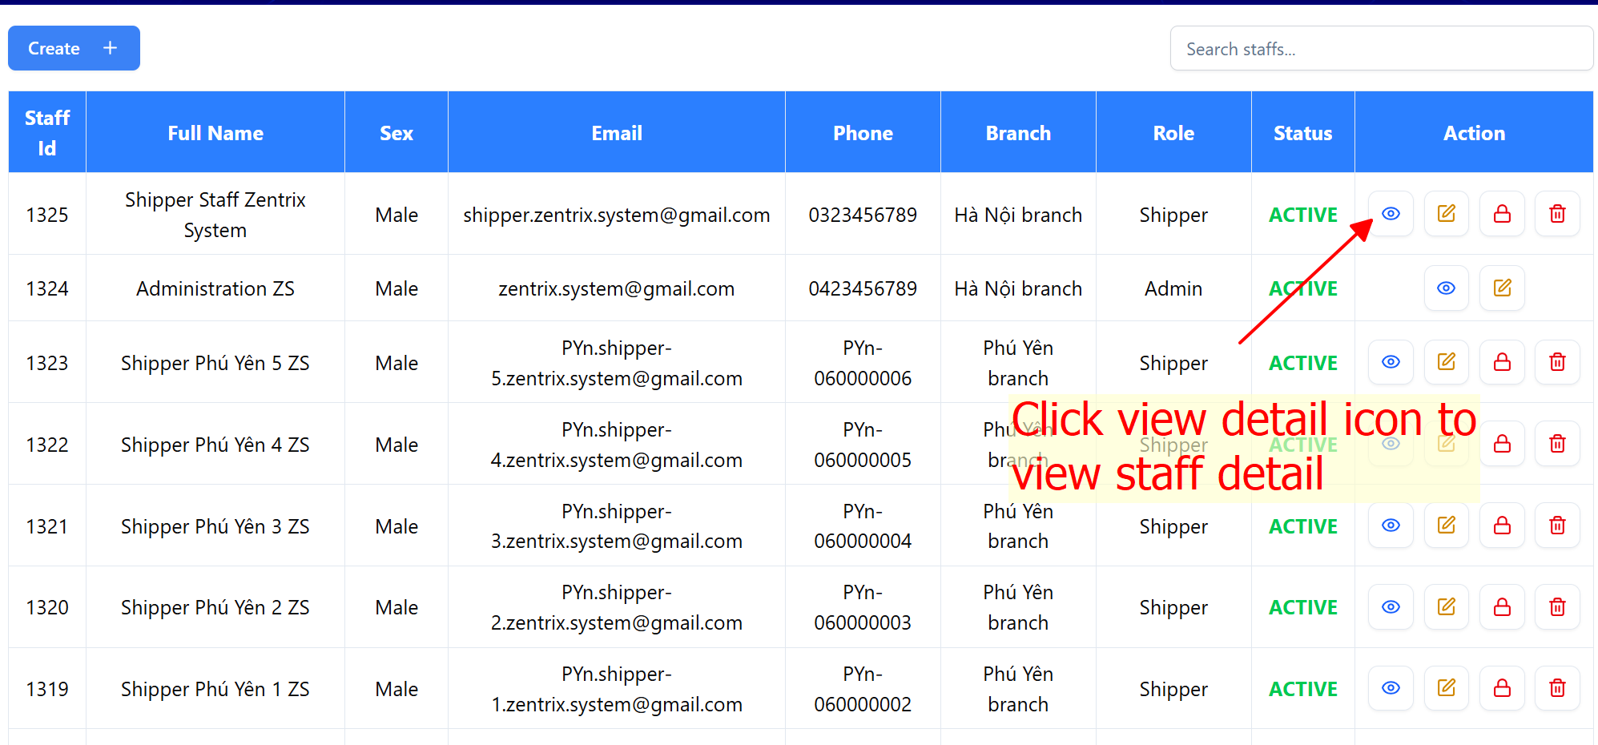

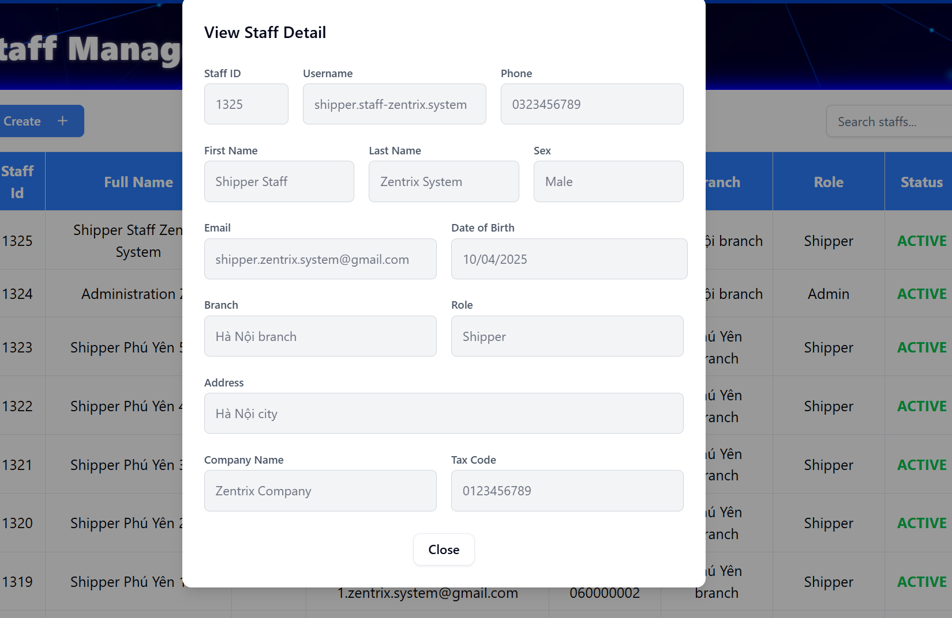

### Edit staff

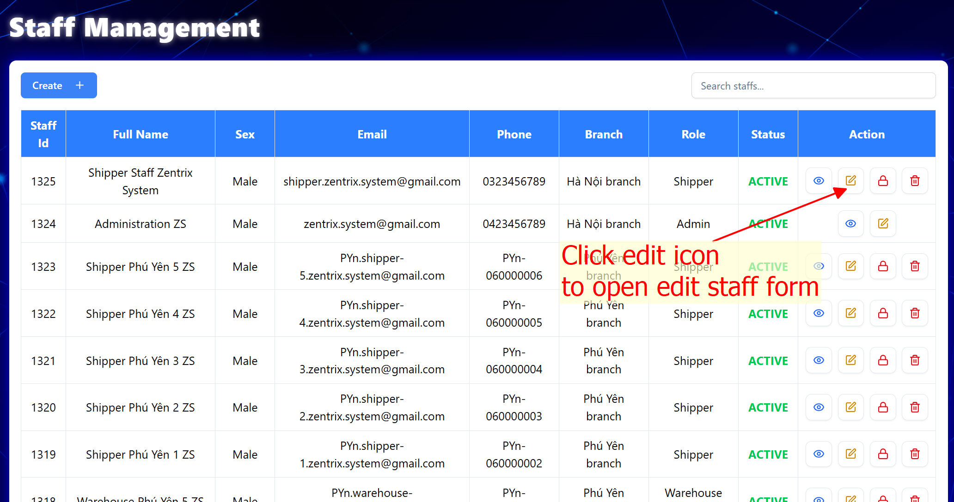

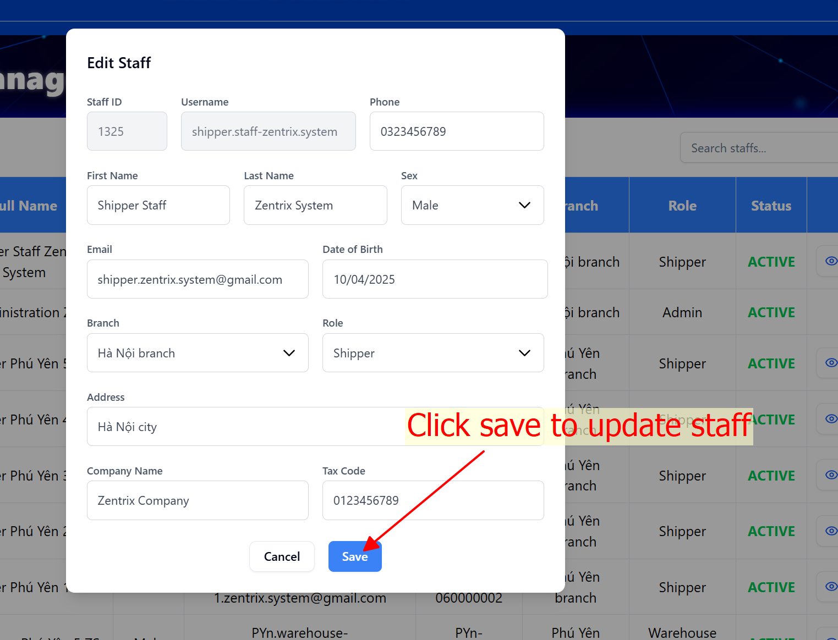

Attention: If email is changed, the status of user will change to verifying although status of user is active.

**VALIDATION FIELD EDIT STAFF TABLE**

|  |  |  |
| --- | --- | --- |
| **No.** | **Field** | **Validation** |
|  | Username | * Must be not blank * Must be at least 3 characters |
|  | First name | * Must be not blank * Only allow letters, Vietnamese letters, “-“, and “_” character |
|  | Last name | * Must be not blank * Only allow letters, Vietnamese letters, “-“, and “_” character |
|  | Phone | * Must be not blank * Must be integers between 9 and 15 digits |
|  | Sex | * Must be not blank |
|  | Email | * Must be not blank * Must be at least “@” character * Must be at least 1 character before “@” character without space * Must be at least 1 character after “@” character without space |
|  | Date of birth | * Must be not blank * Max date is today |
|  | Address | * Must be not blank |
|  | Company name | * Only allow letters, Vietnamese letters, “-“, and “_” character |
|  | Tax code | * Must be integers between 10 and 13 digits |
|  | Role | * Must be not blank |

### Delete staff

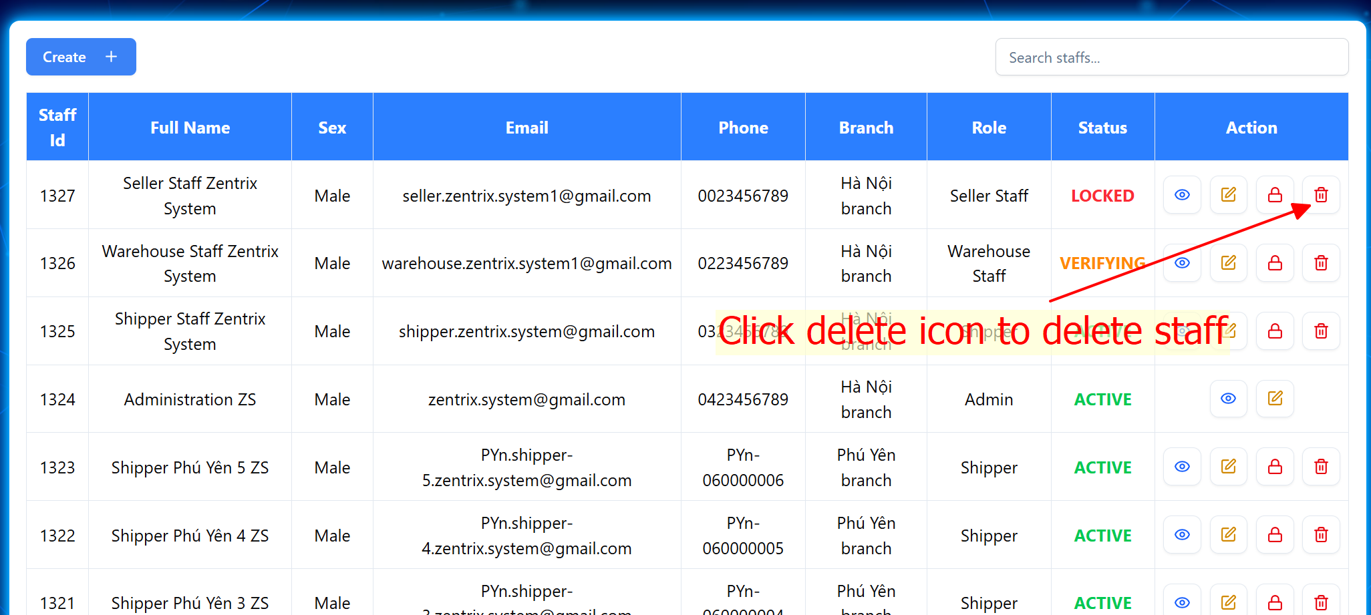

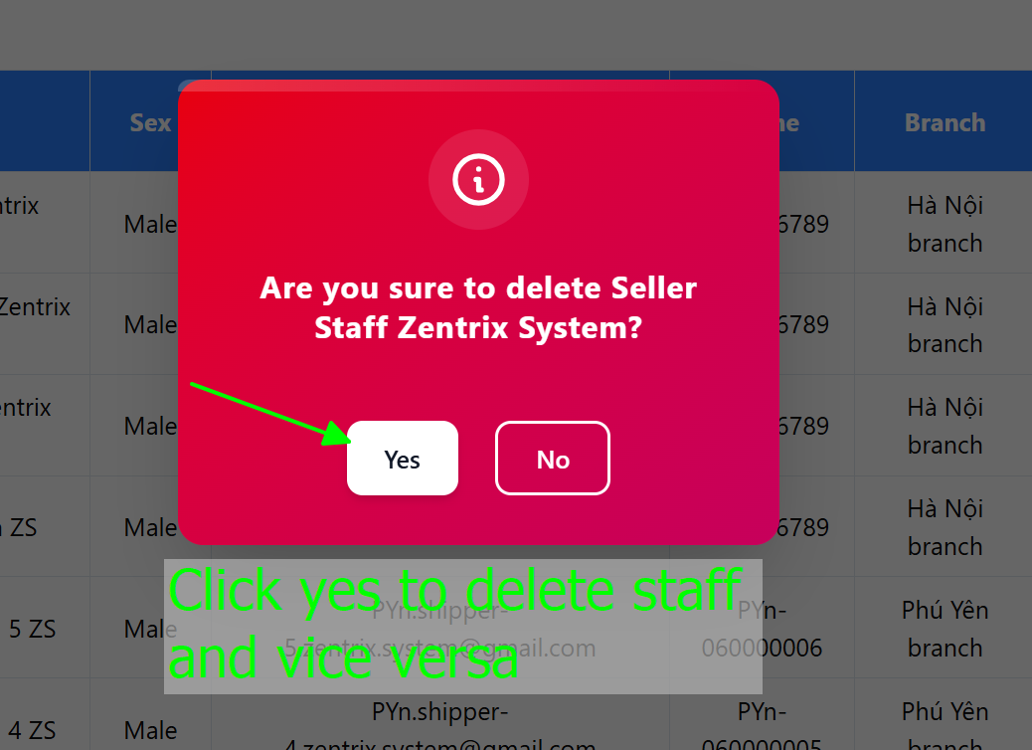

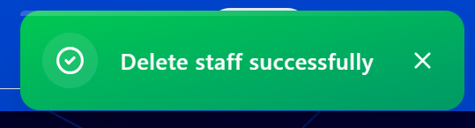

### Lock/Unlock staff

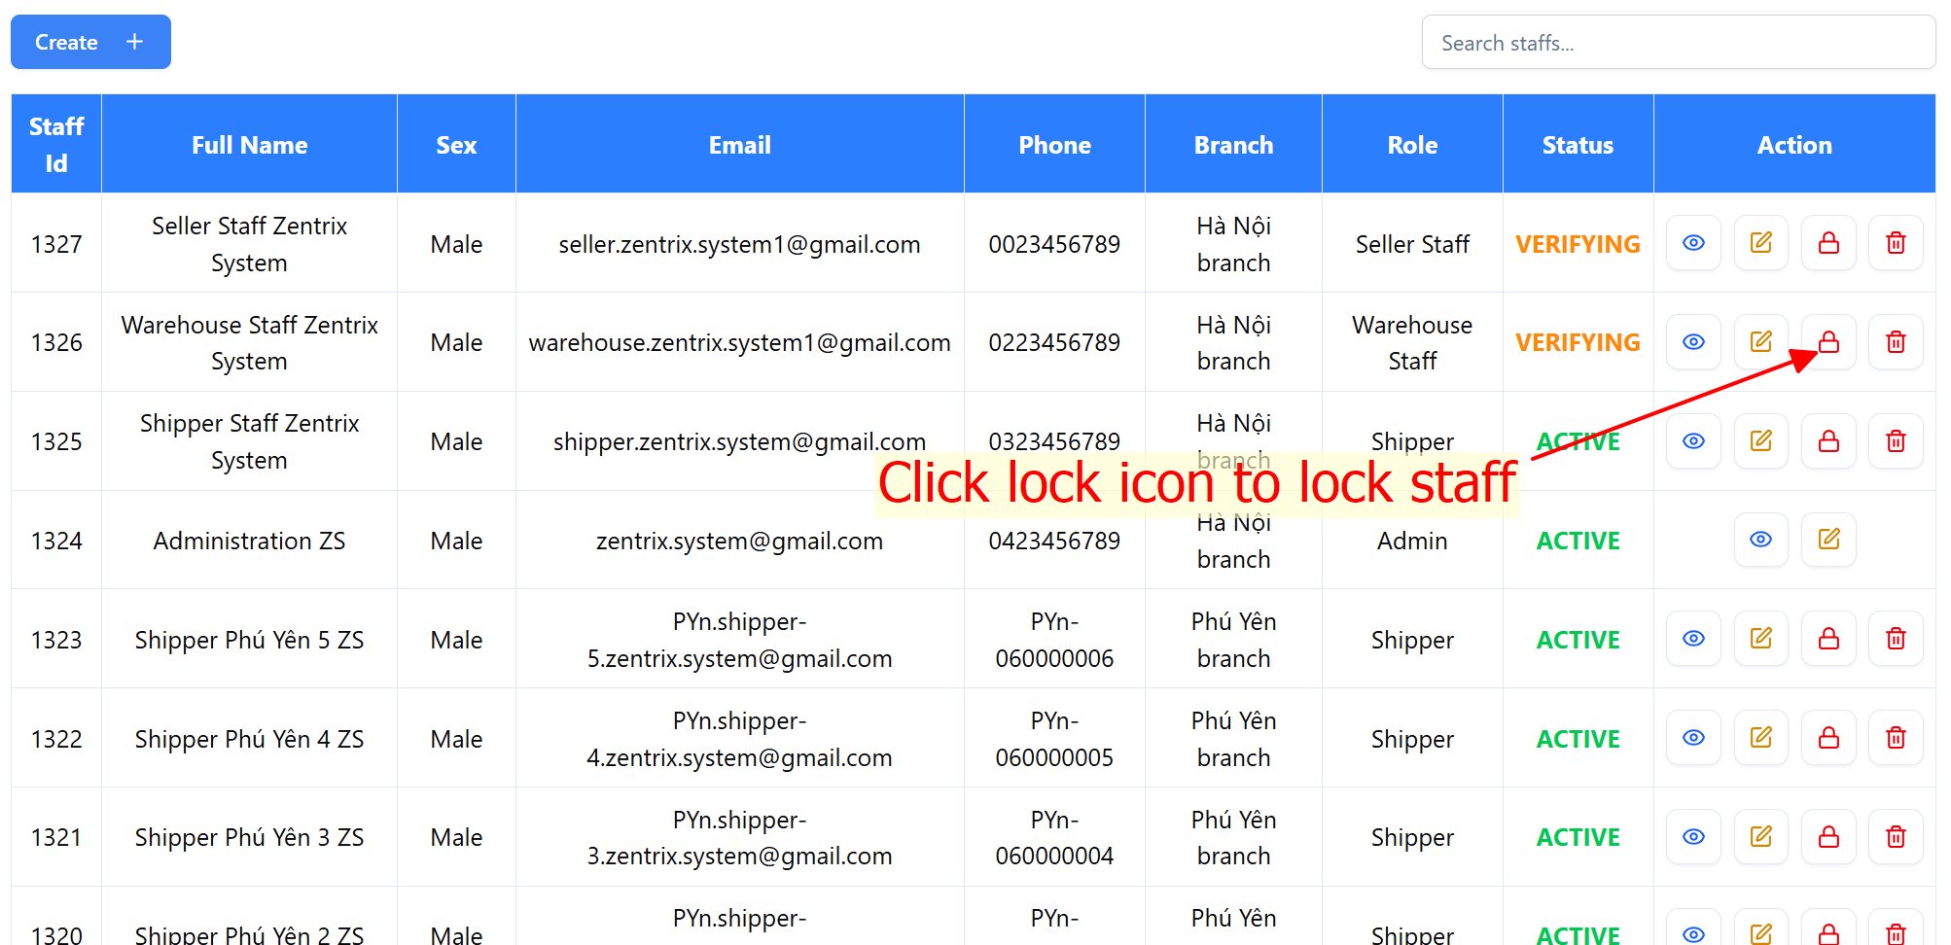

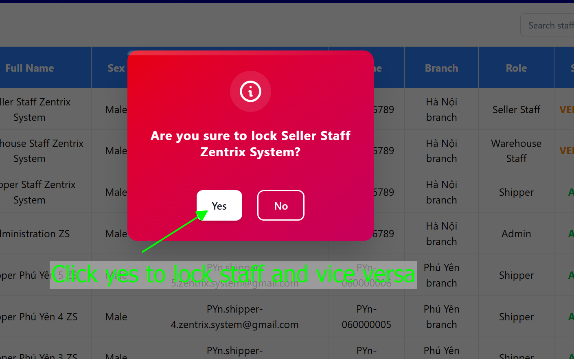

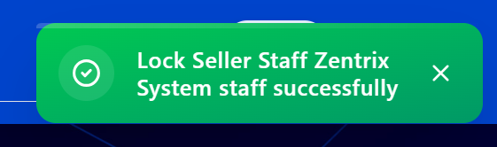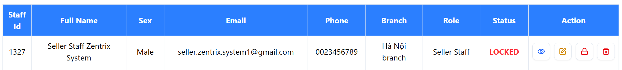

### Search staff

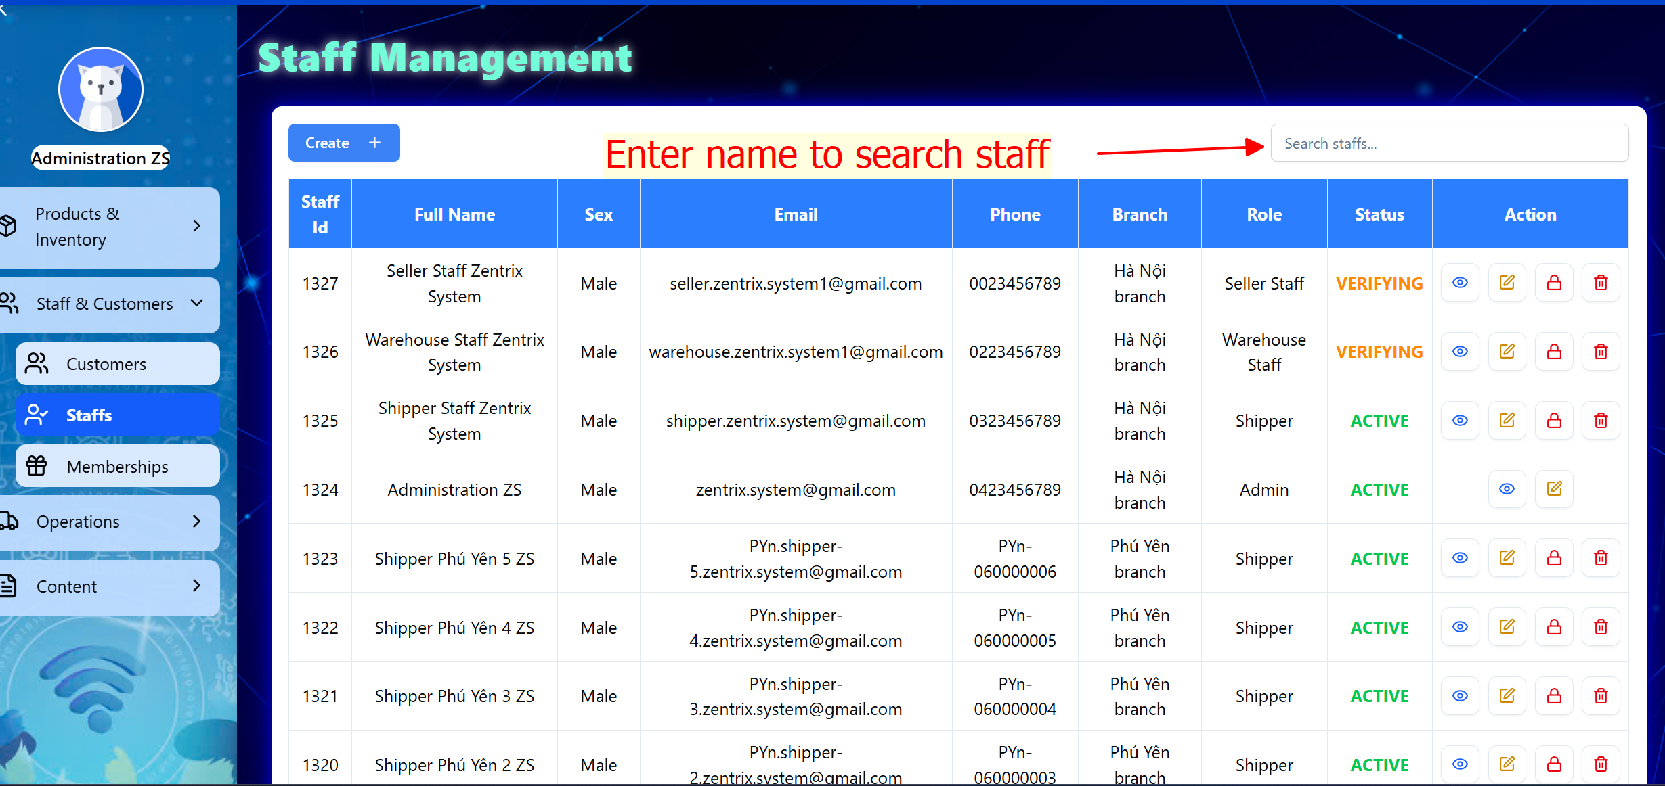

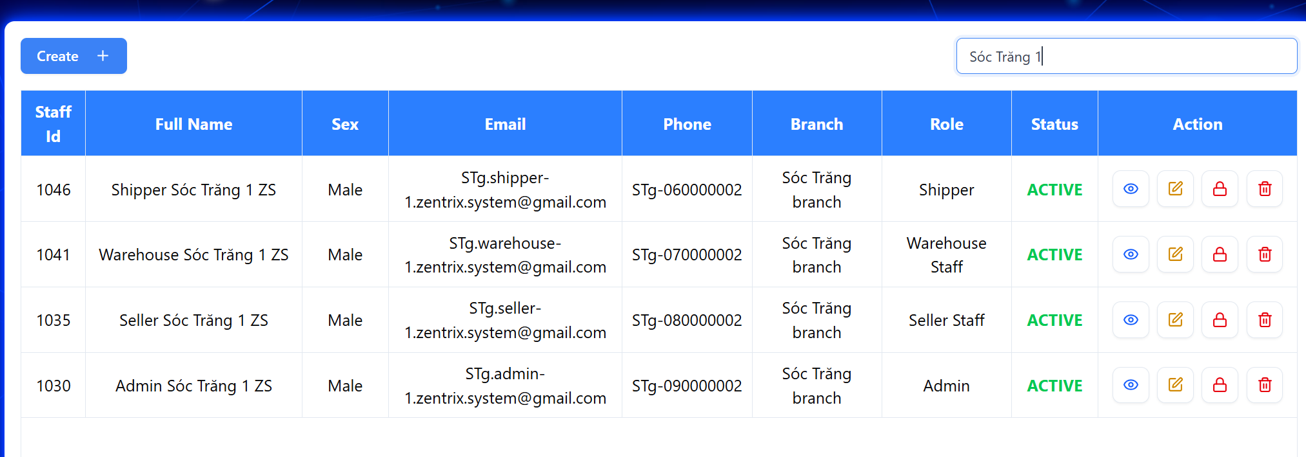

Figure . Search staff successfully

### View staffs list

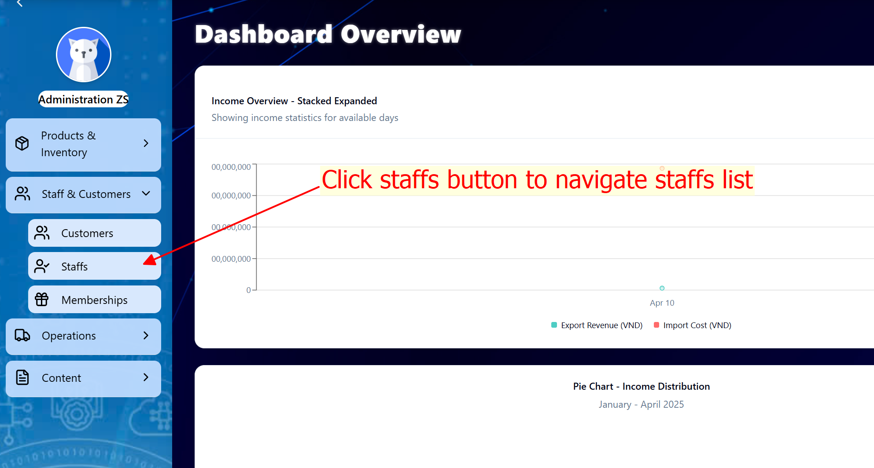

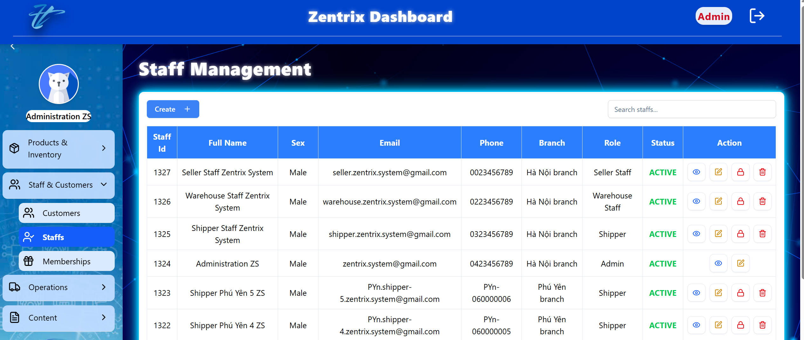

## MANAGE MEMBERSHIPS

### Add membership

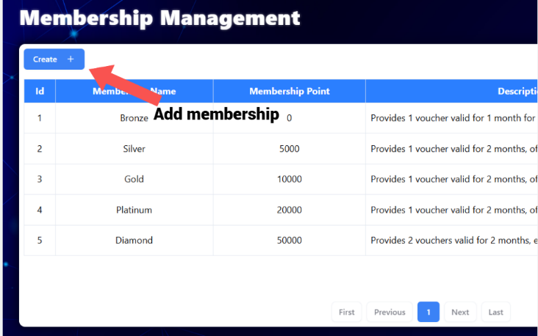

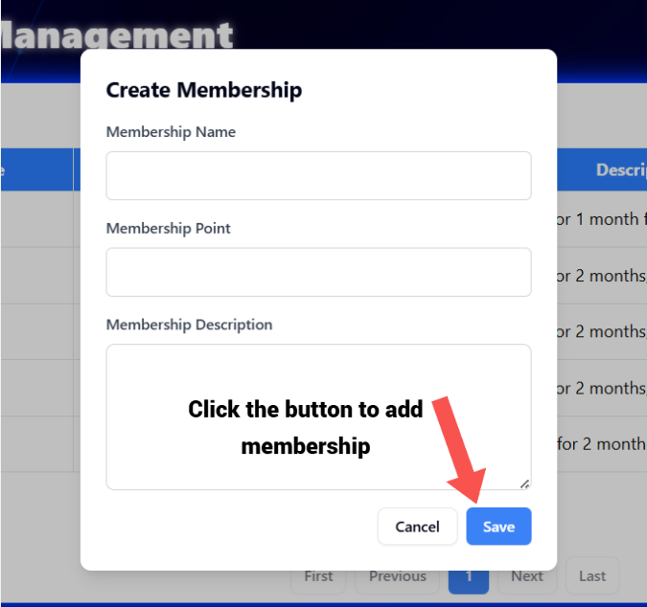

### View memebership detail

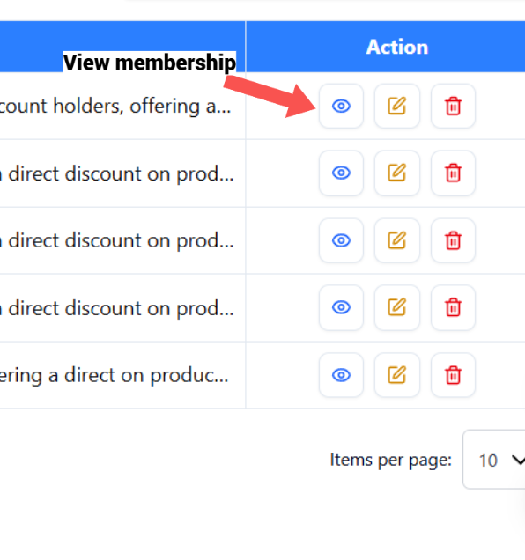

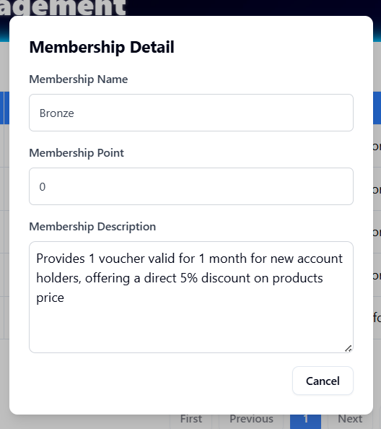

### Edit membership

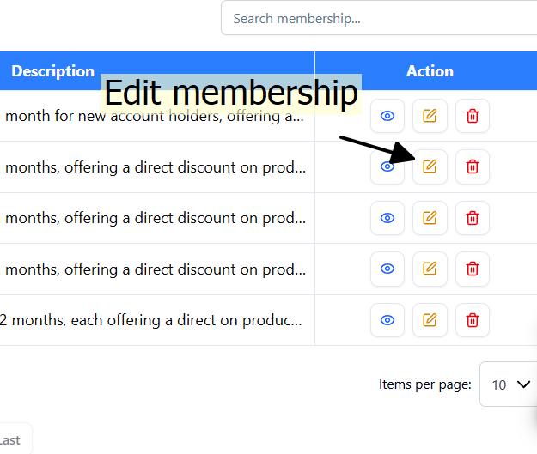

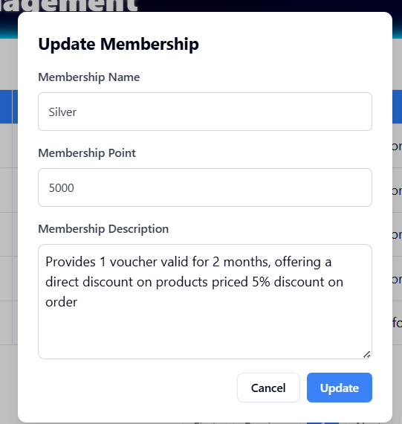

### Delete membership

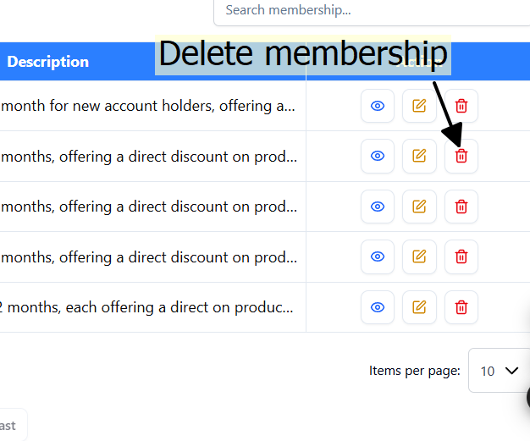

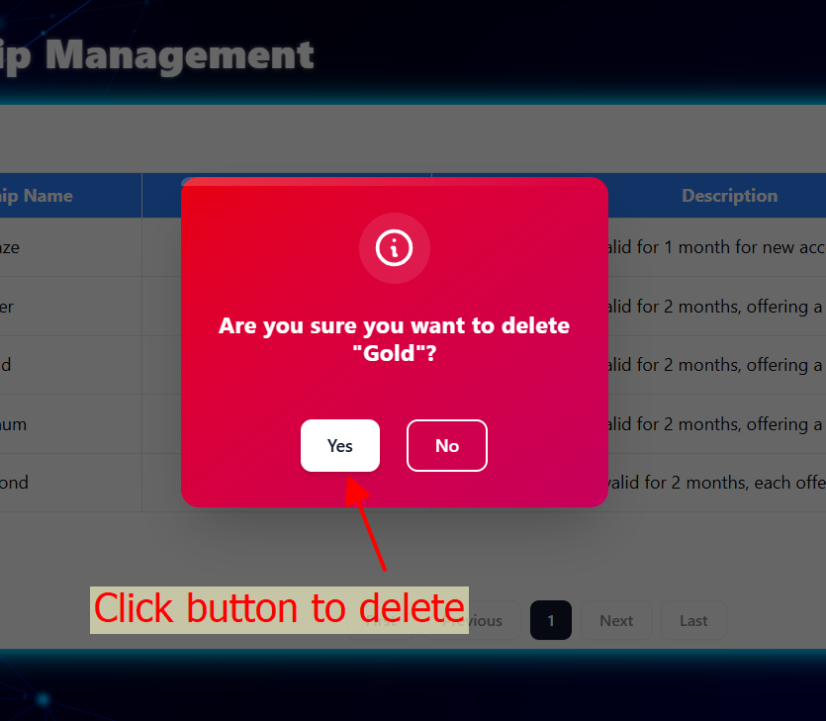

### View memberships list

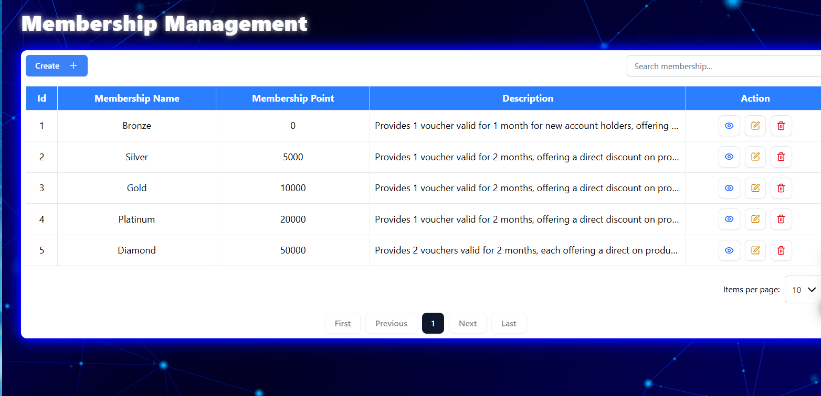

### Search membership

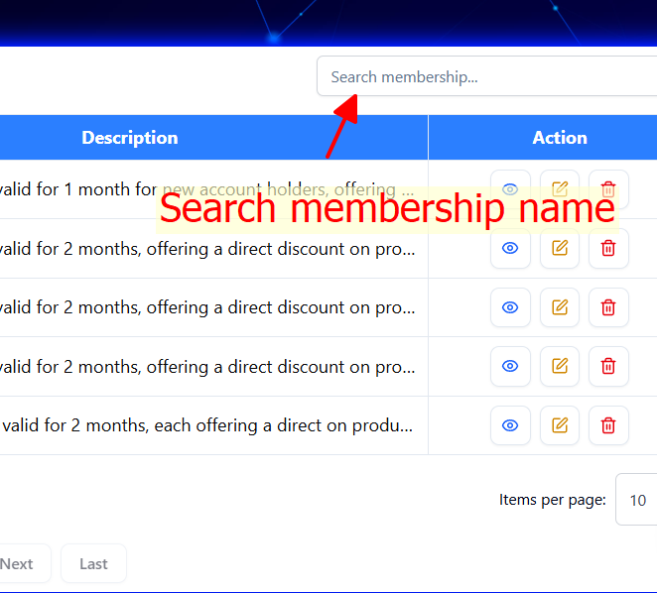

## MANAGE PRODUCTS IN HOMEPAGE

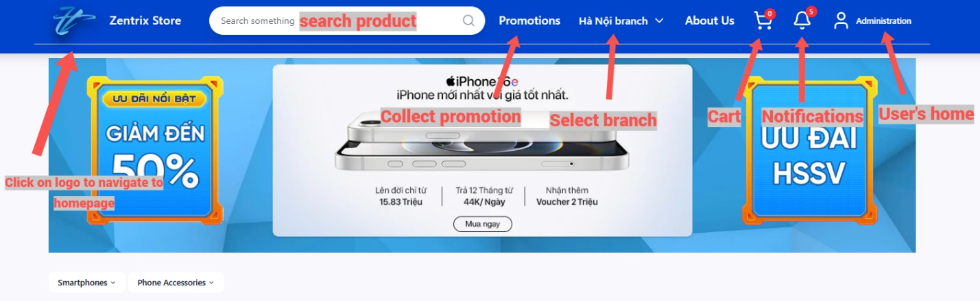

Figure . Header in homepage

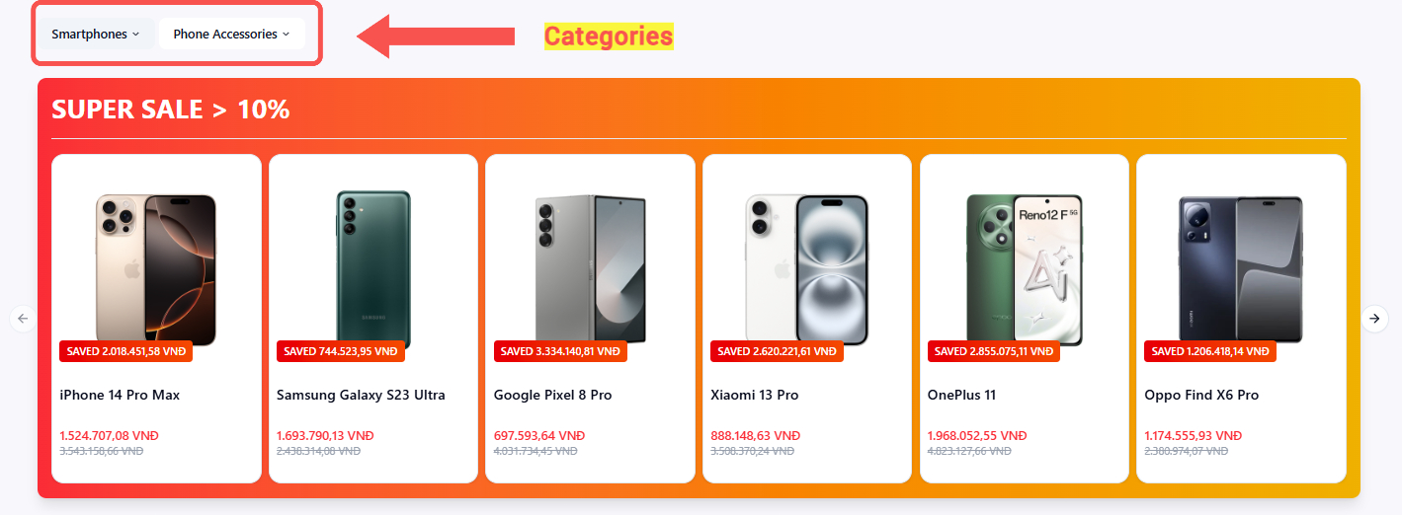

Figure . Categories in homepage

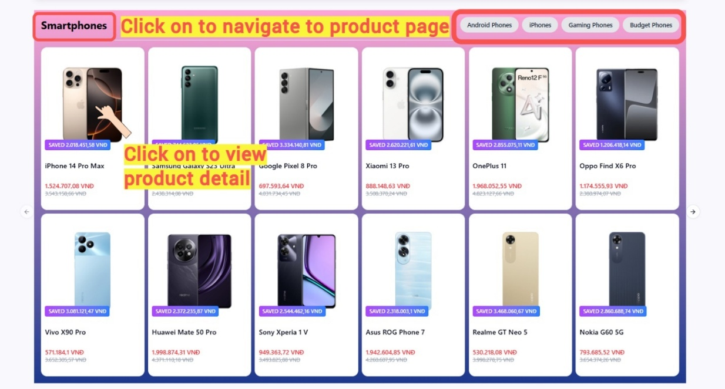

Figure . View product by categories

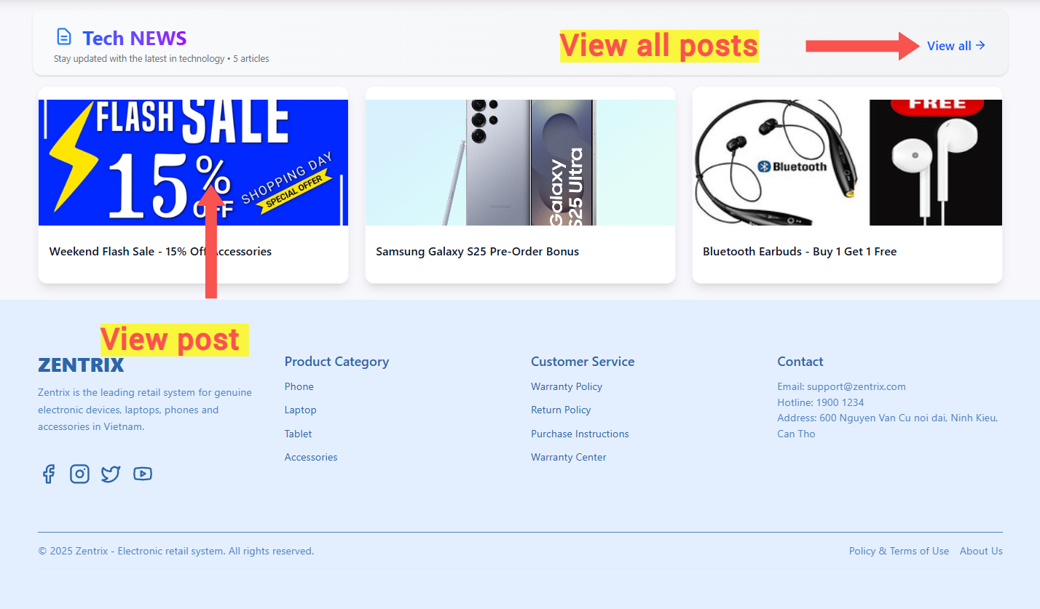

Figure . View posts and footer

### View product detail

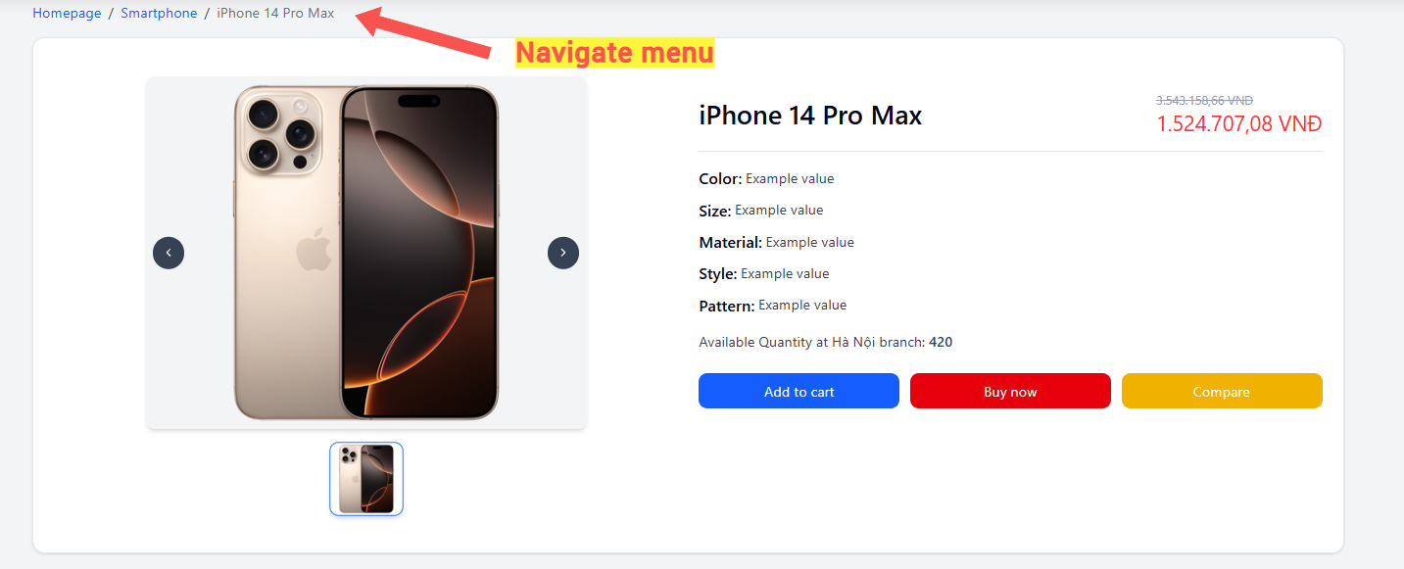

Figure . View product detail

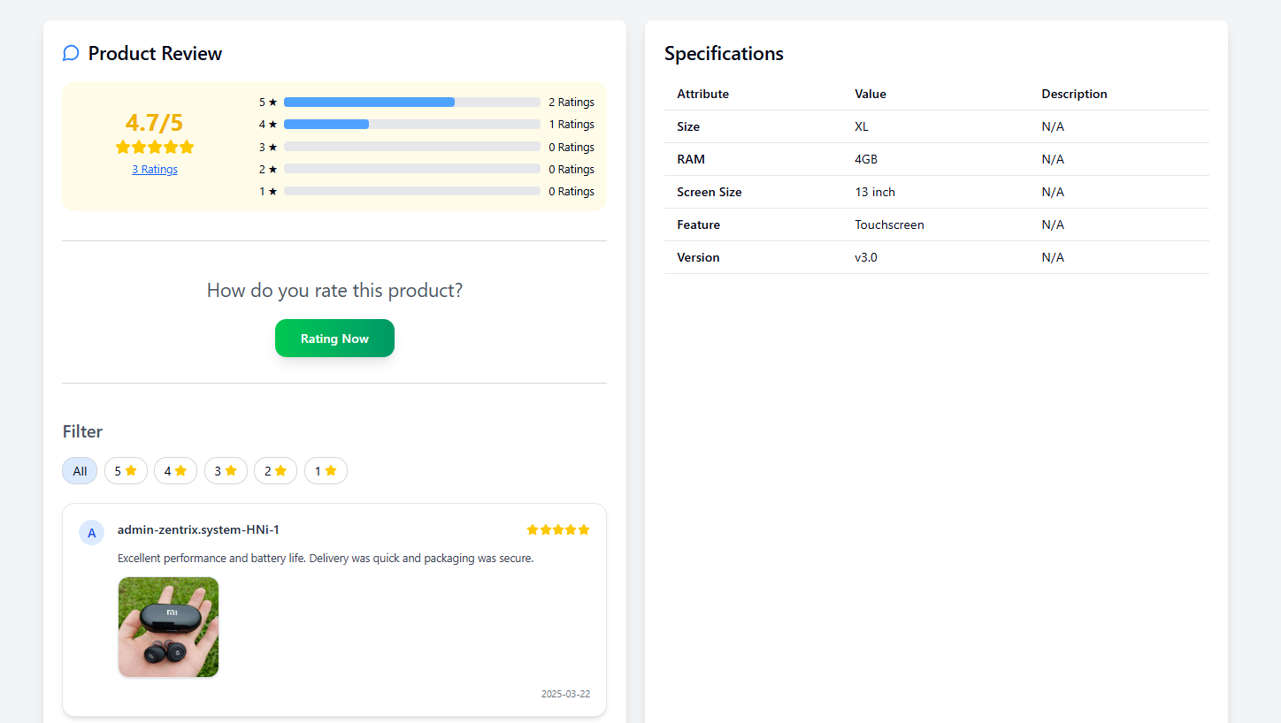

Figure . Review and product attribute

### Search product

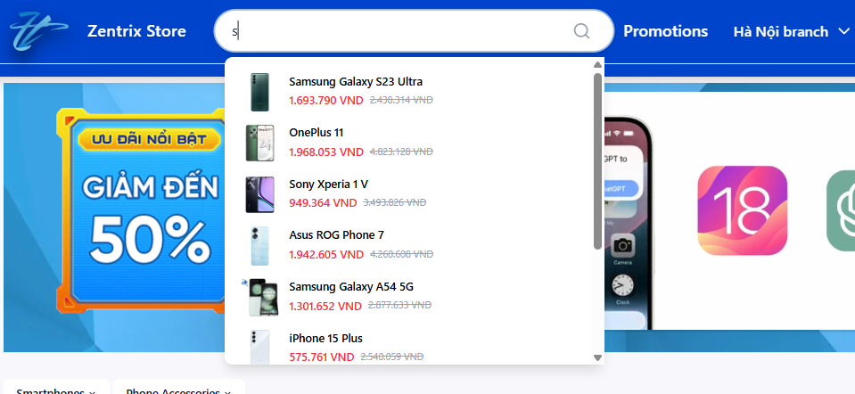

Figure . Search products

### View products list

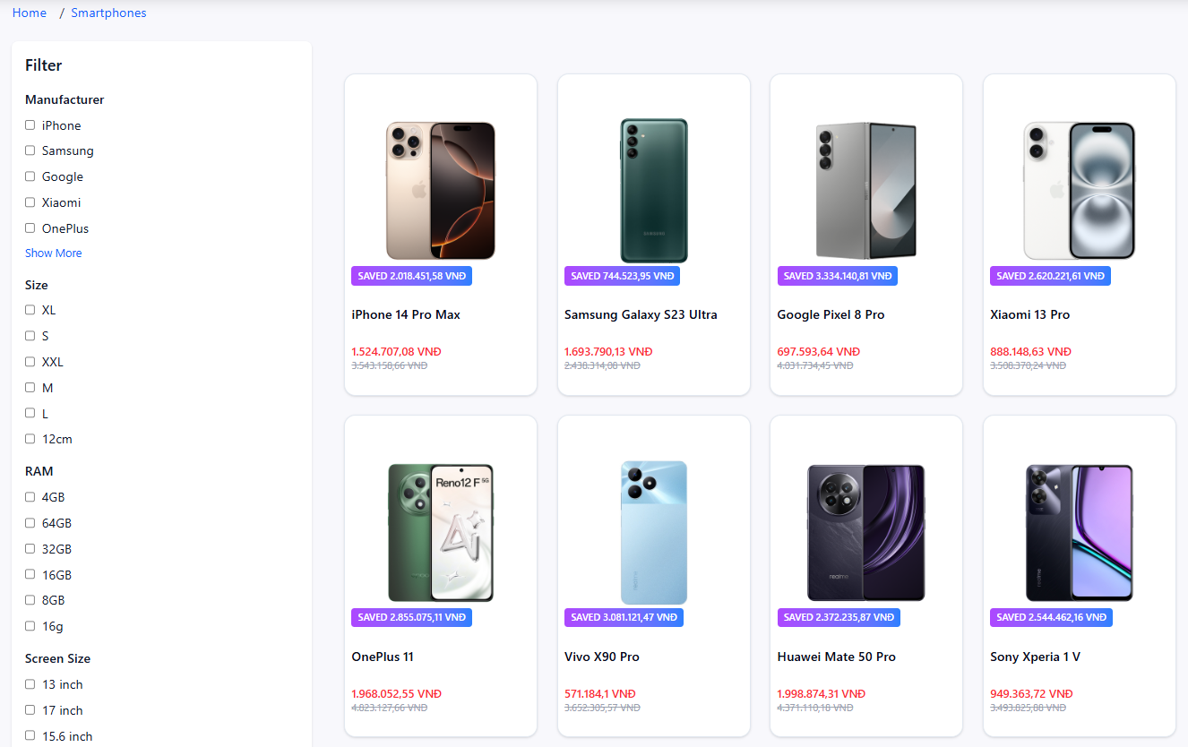

Figure . View products list in product page

### Sort product

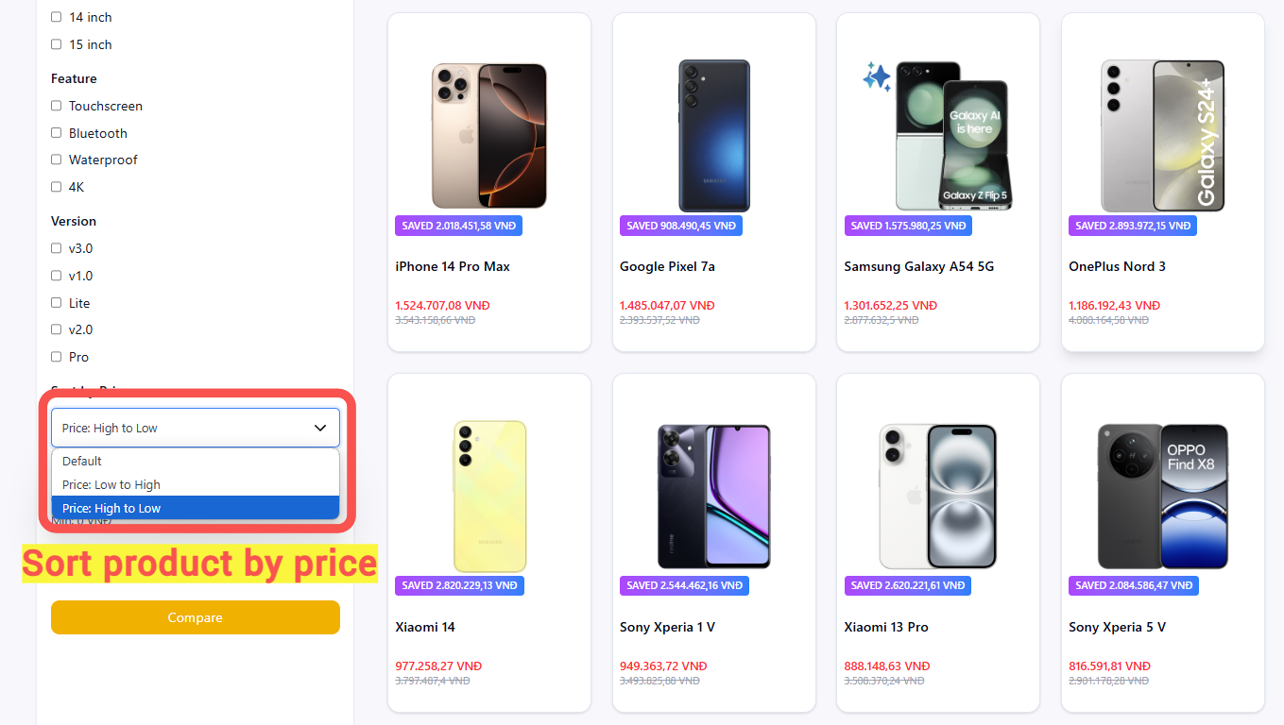

Figure . Sort product by price

### Filter product

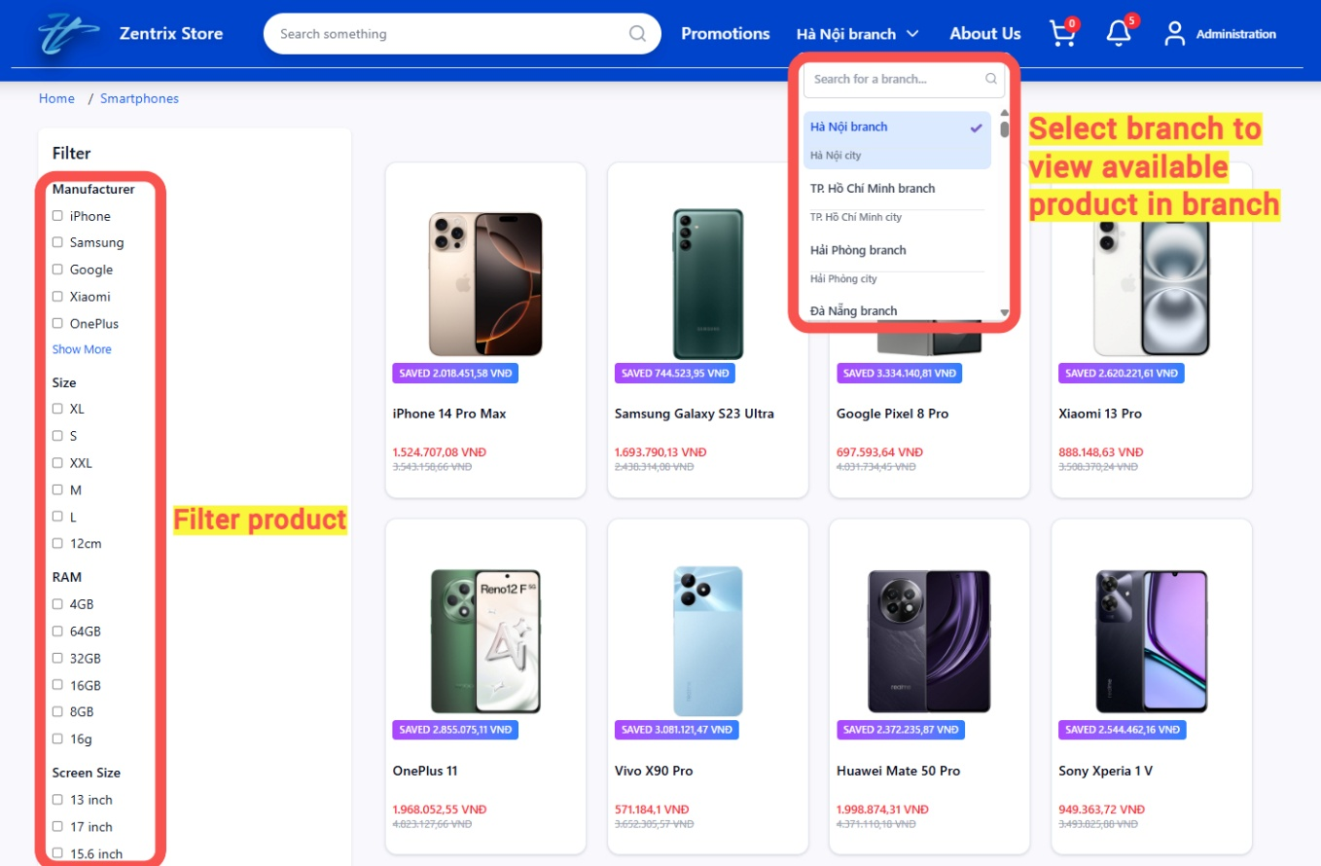

Figure . Filter product by attribute

## MANAGE PRODUCTS IN DASHBOARD

### Add product

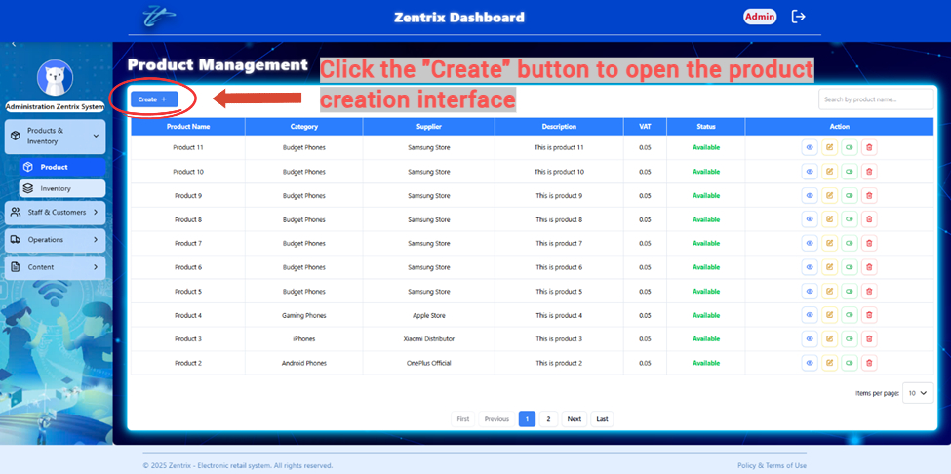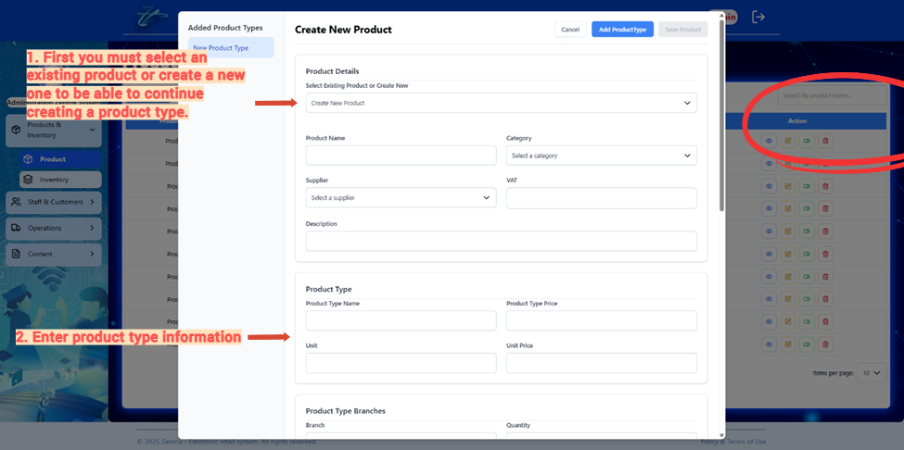

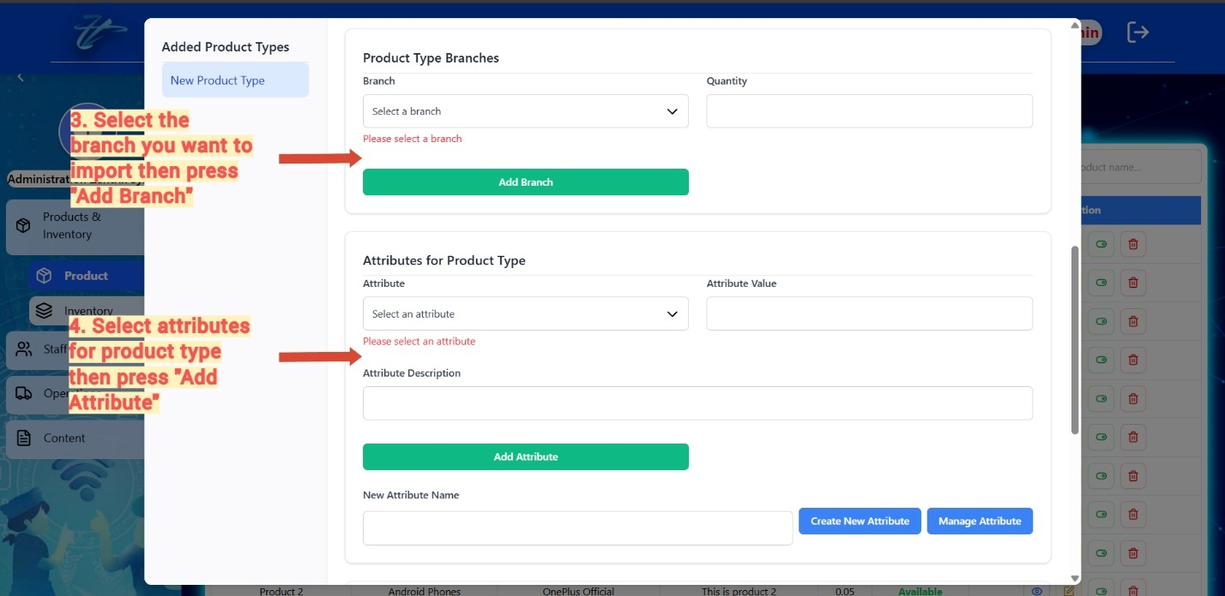

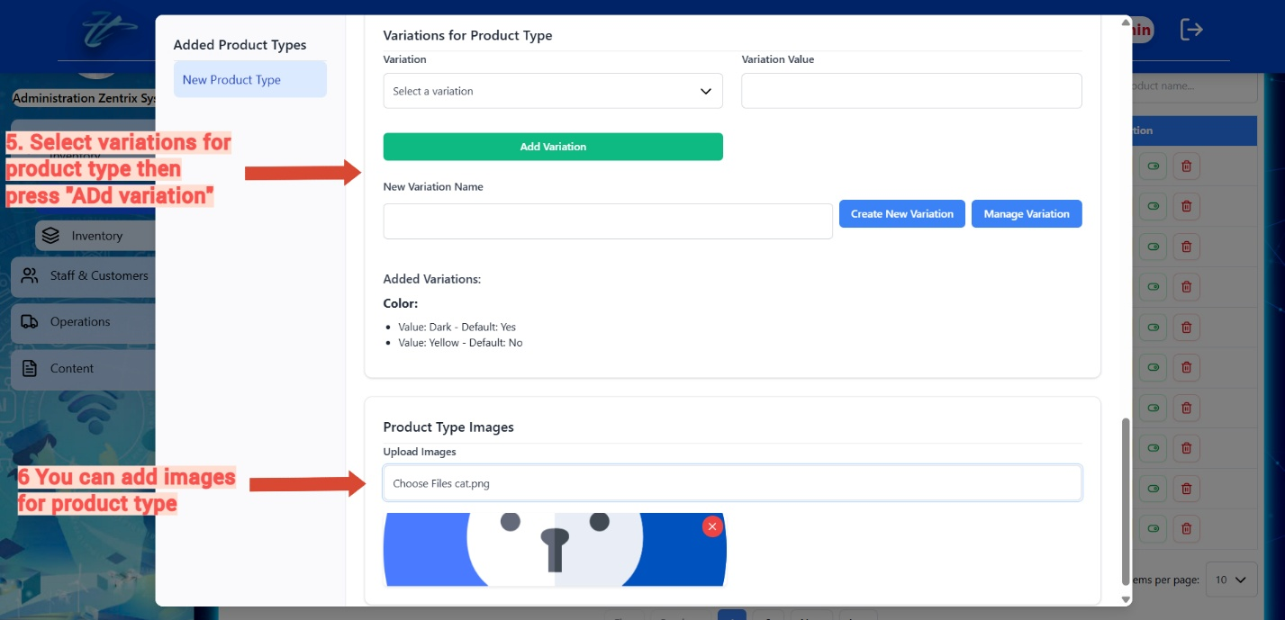

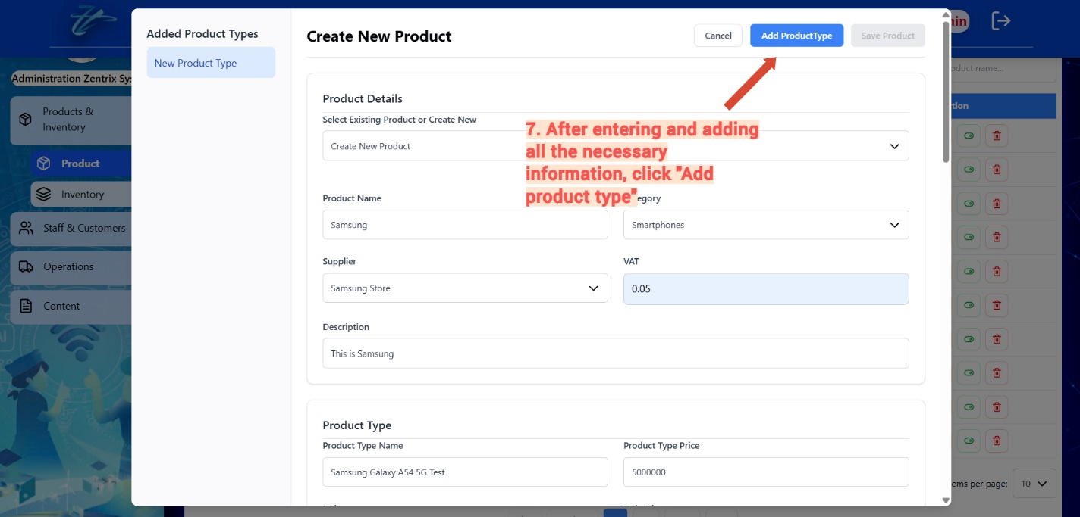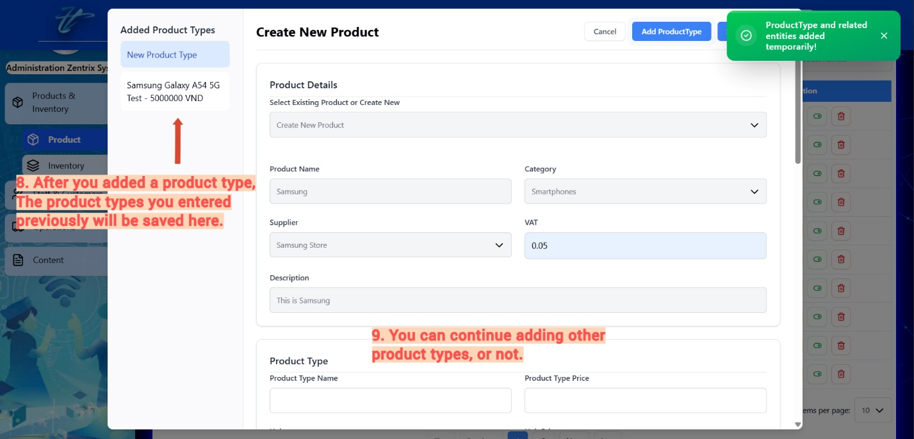

### View product detail

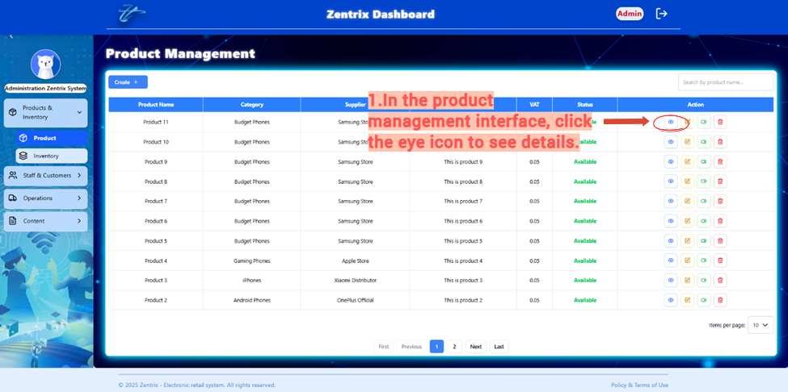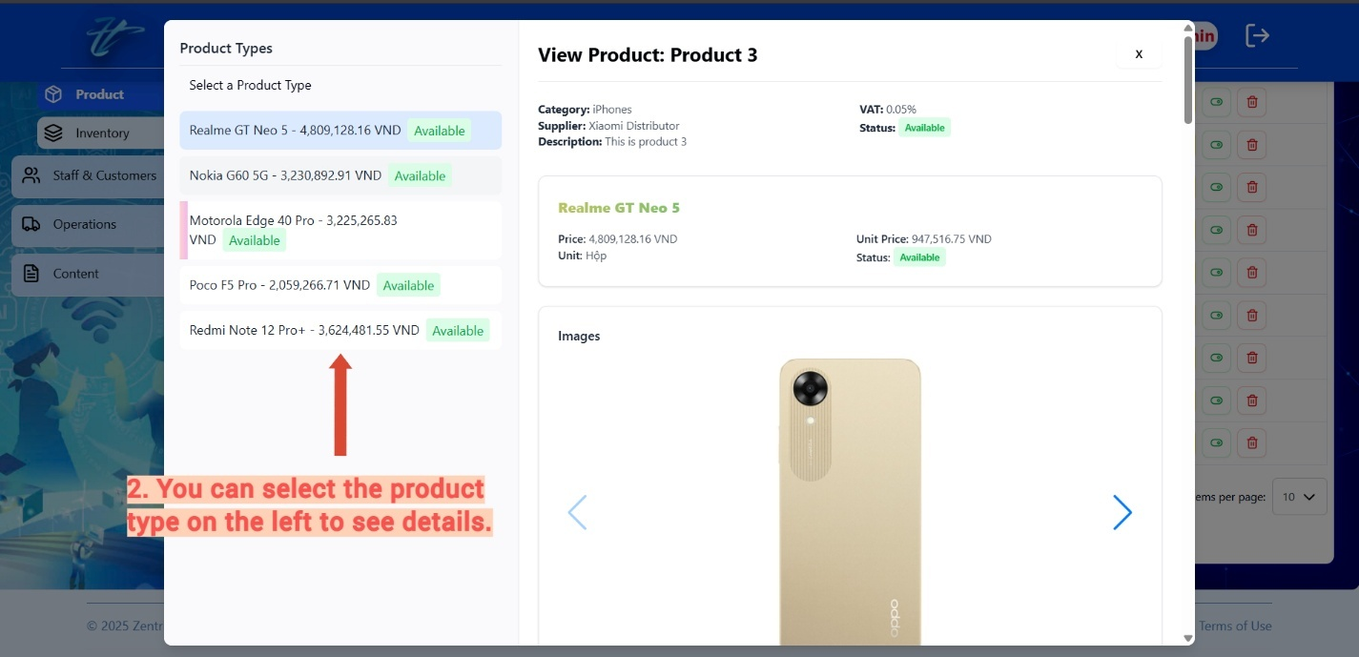

### Edit product

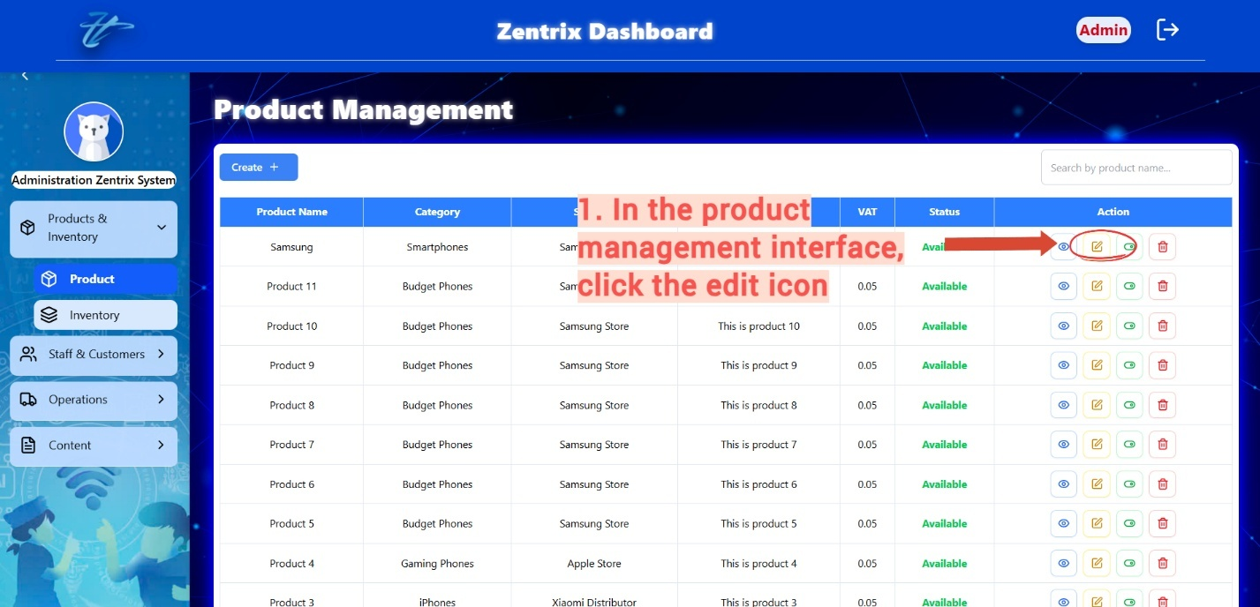

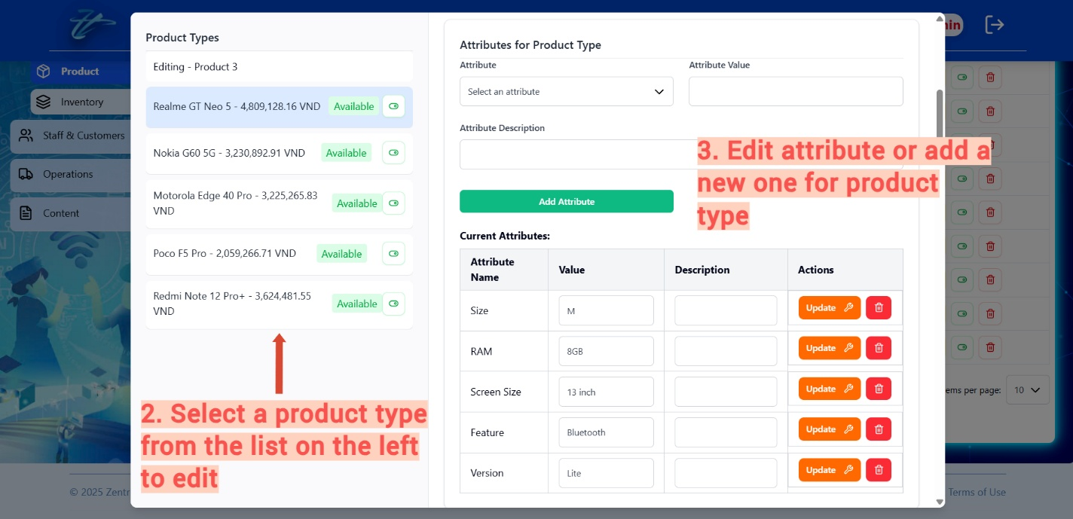

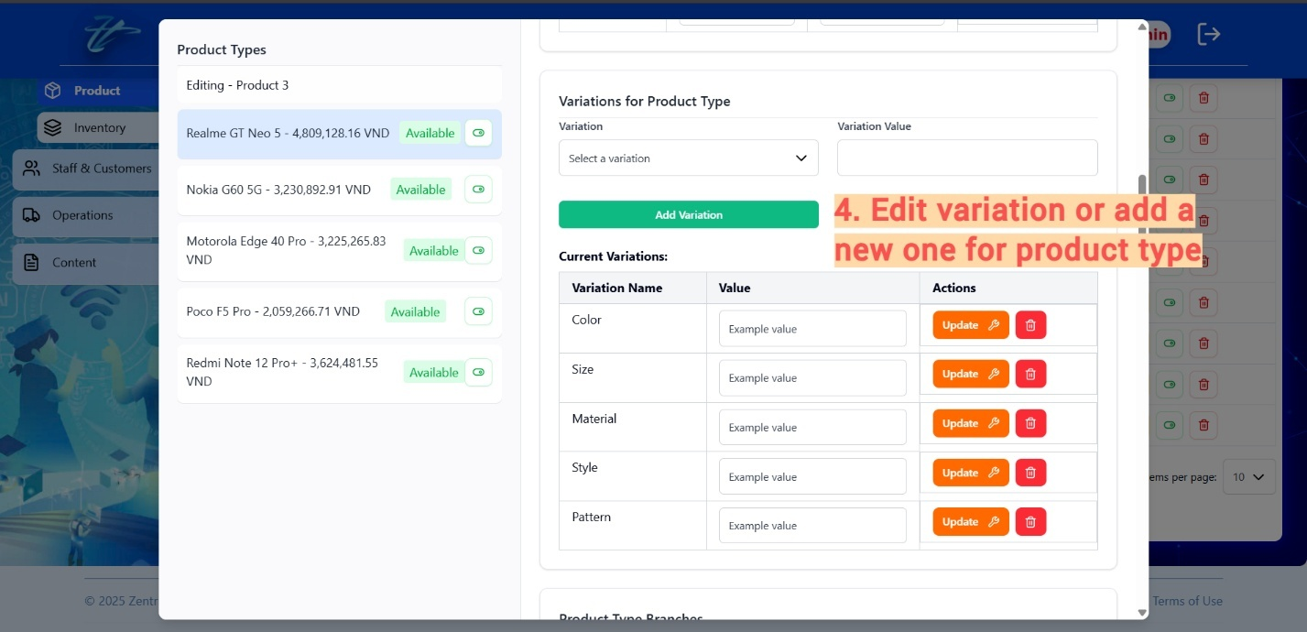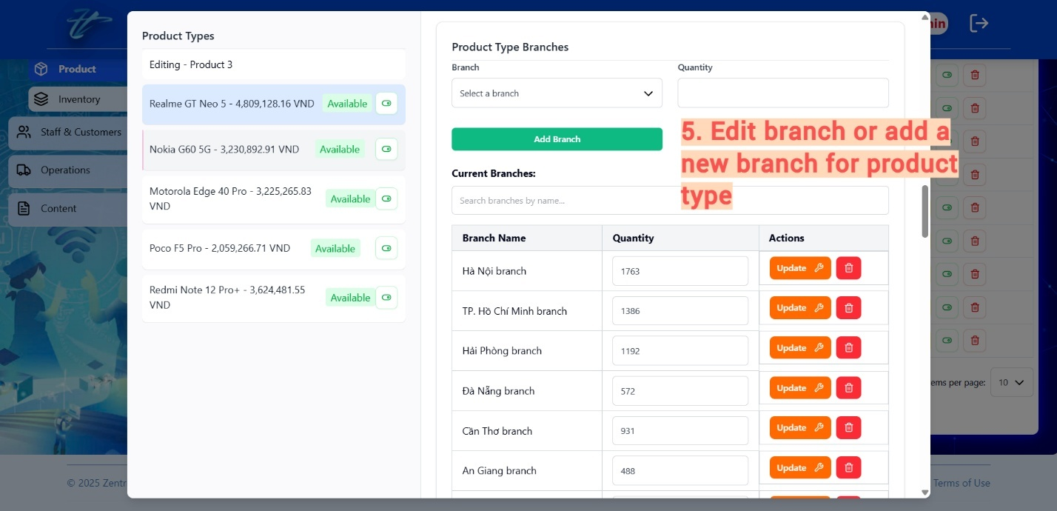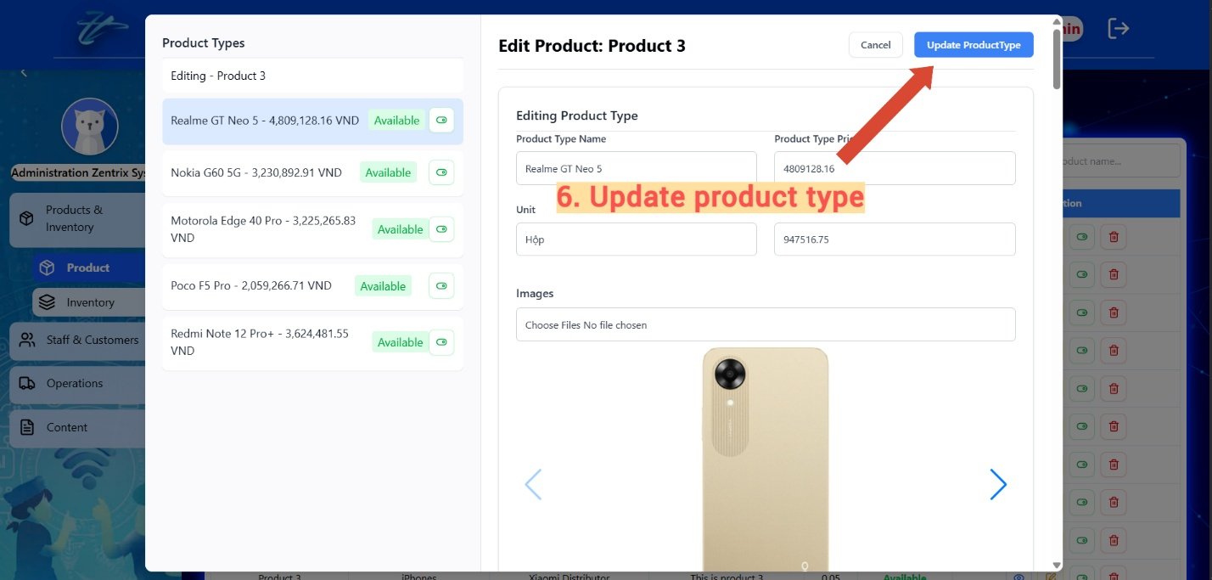

### Delete product

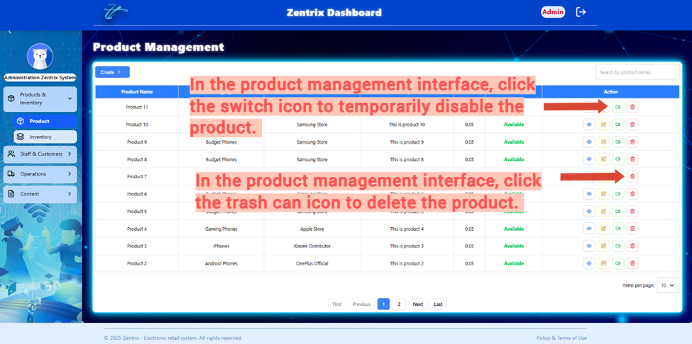

### Search product

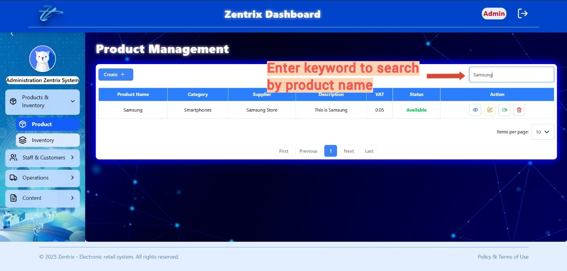

### View products list

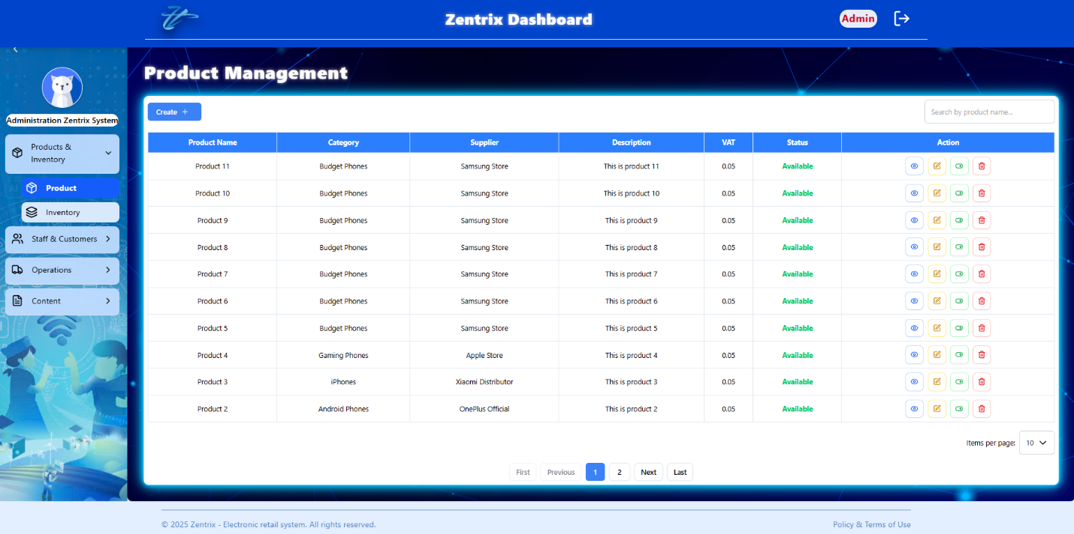

## MANAGE ORDERS

### Add order

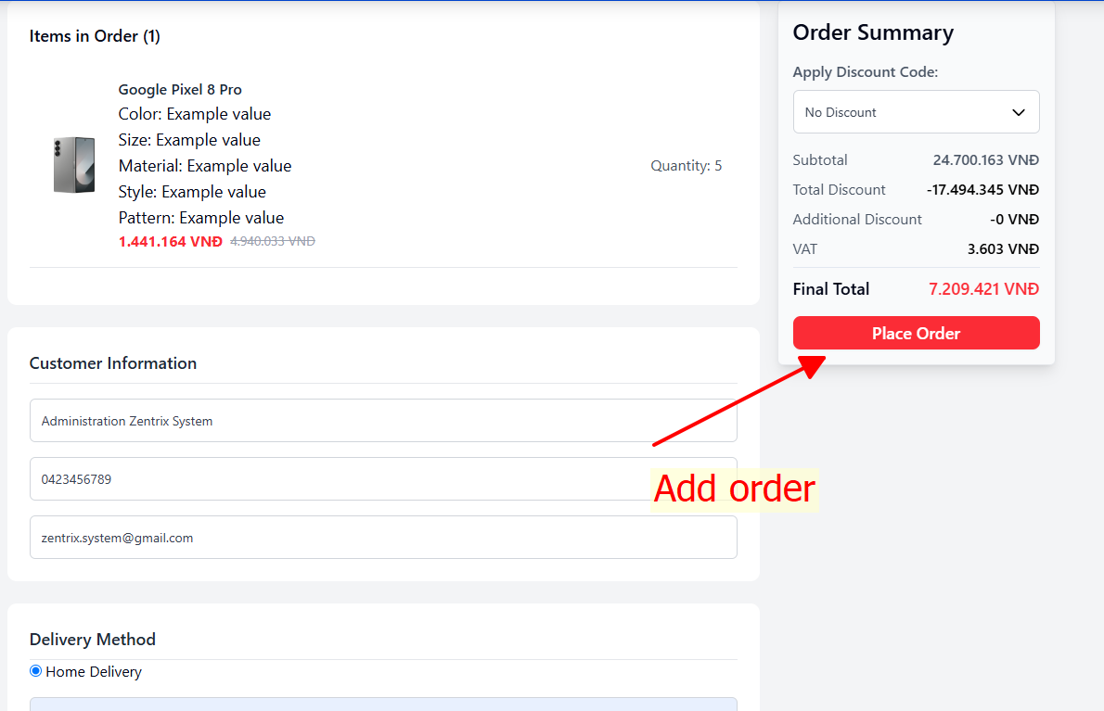

### View order detail

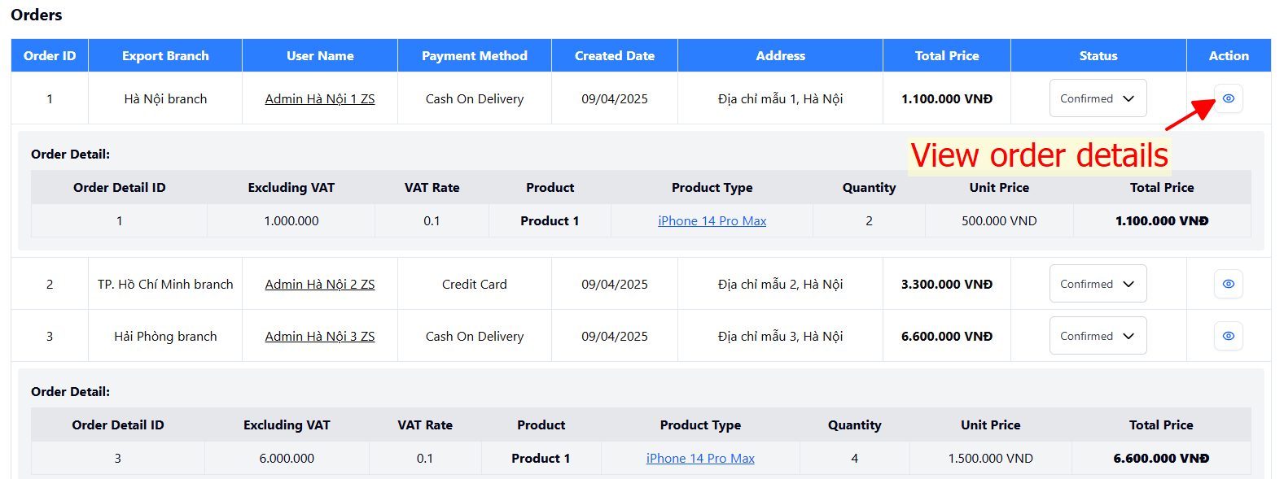

### Search order

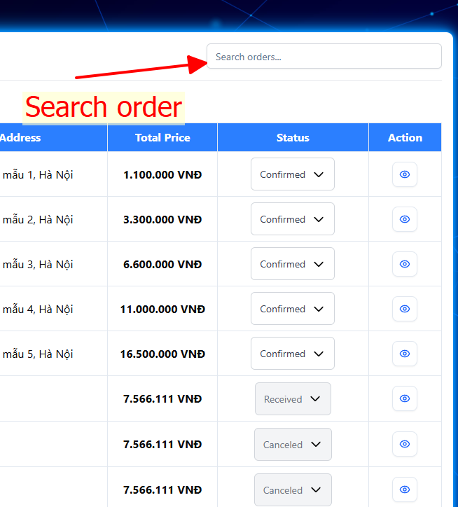

### View orders list

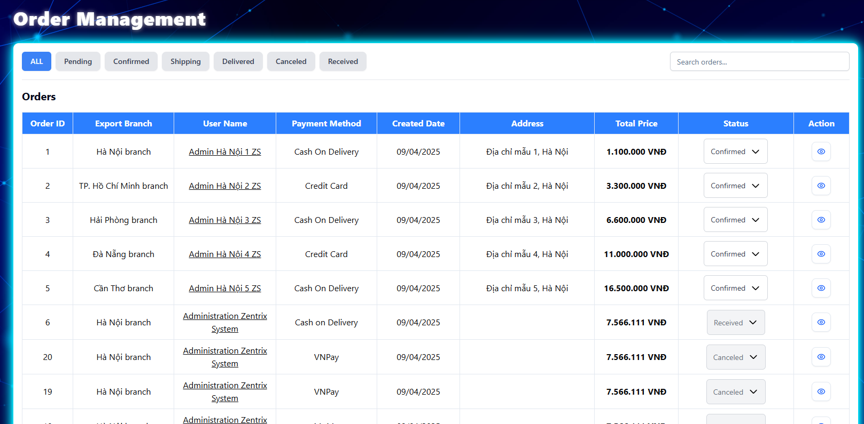

### Export order pdf file

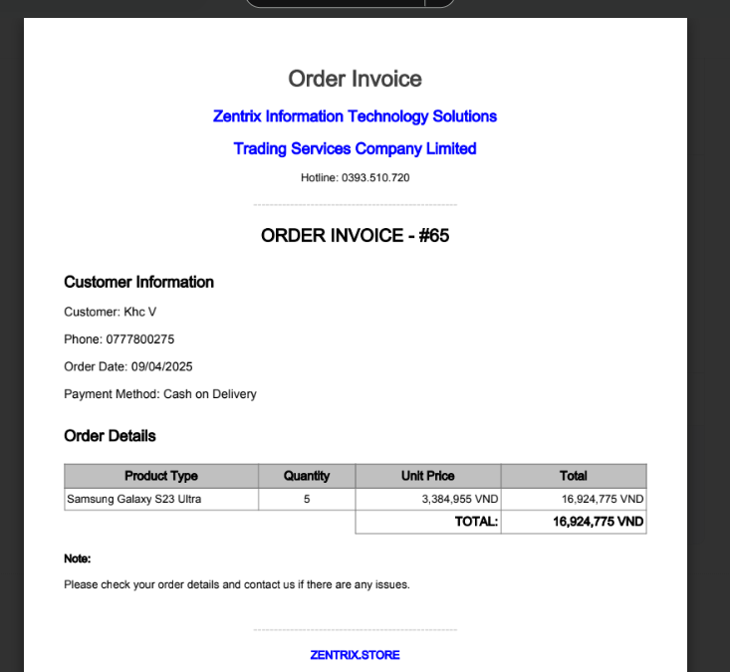

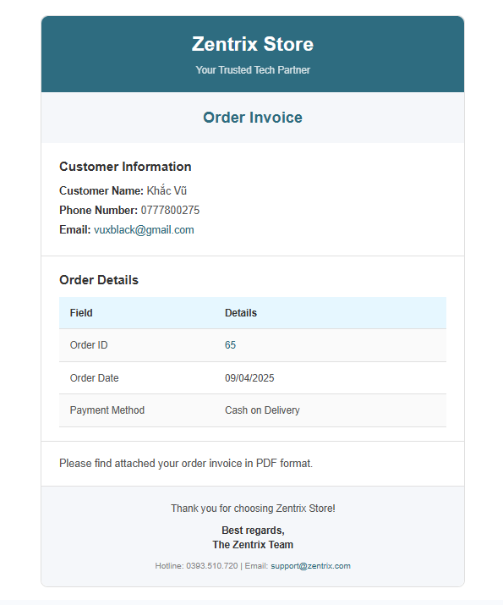

## MANAGE PAYMENTS

### Payment by VNPay

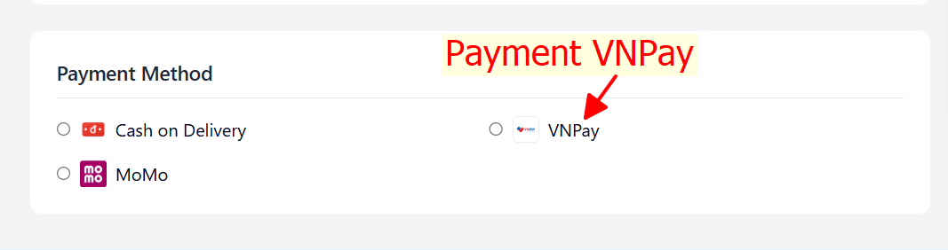

### Payment by Momo

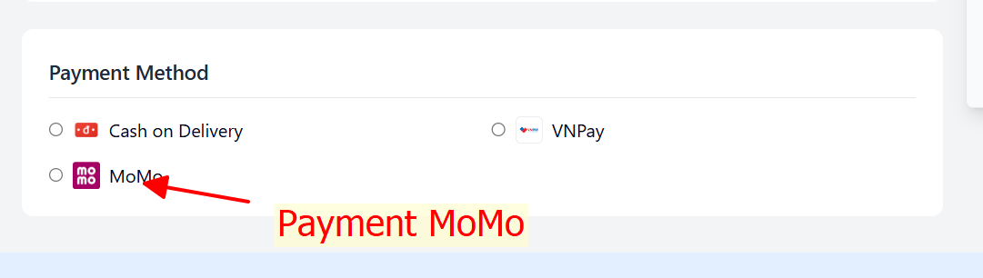

## MANAGE CARTS

### Add product to cart

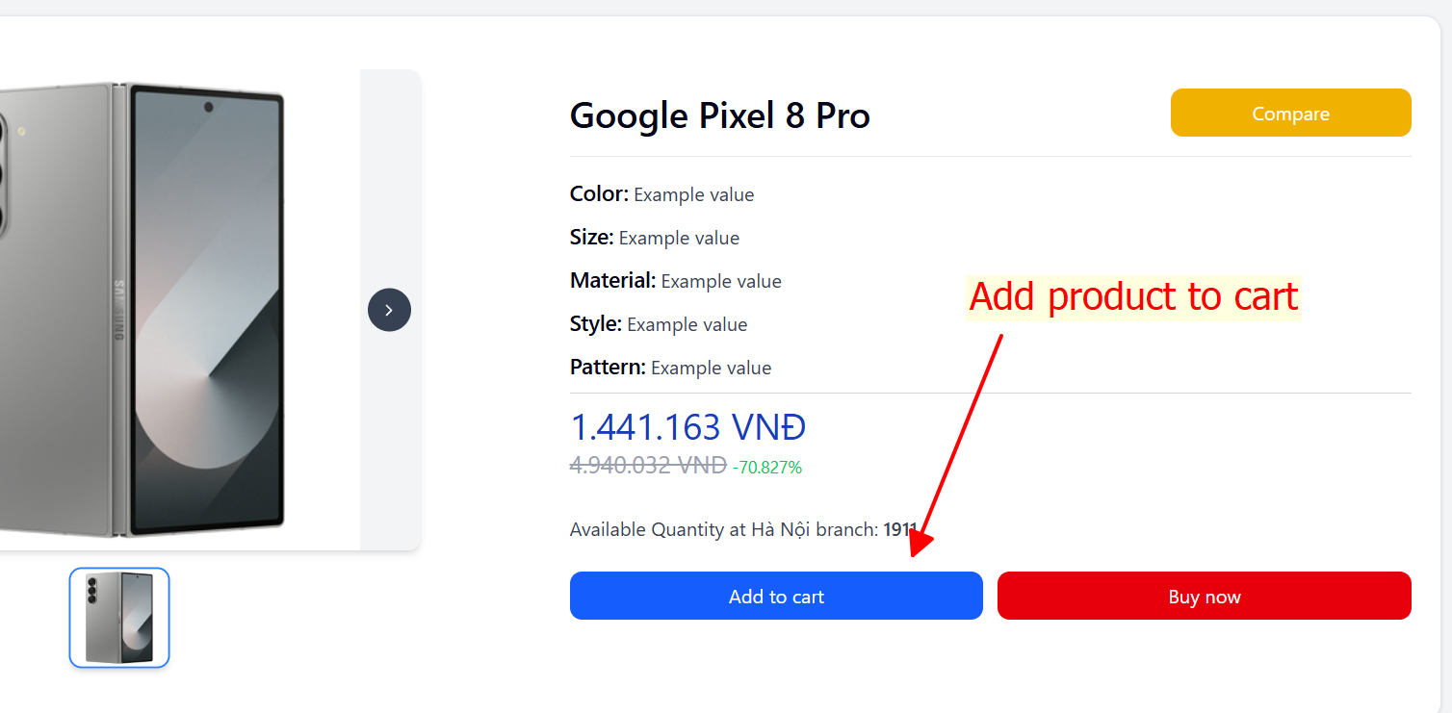

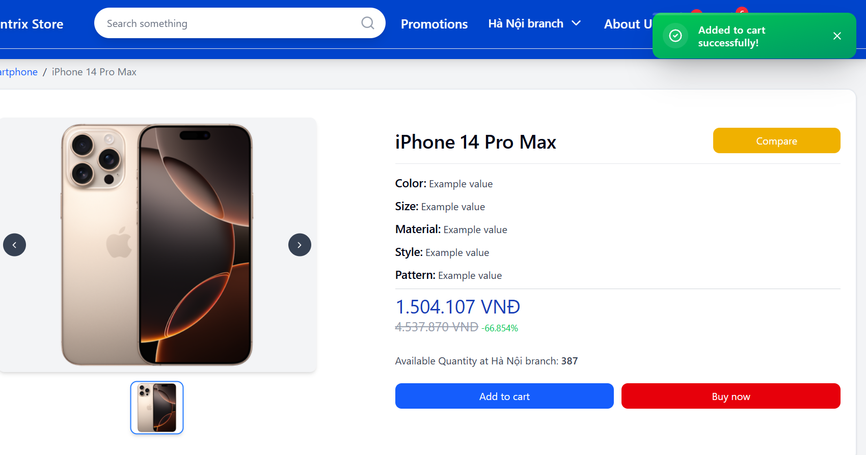

### View cart

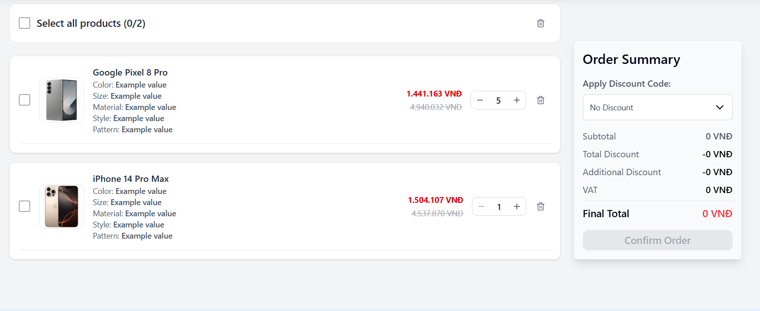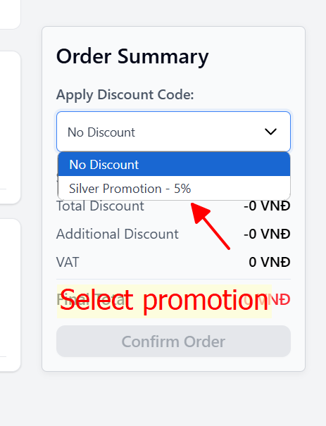

### Edit quantity product in cart

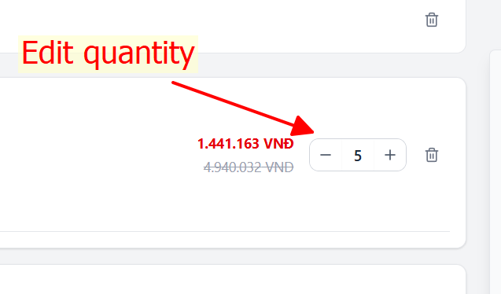

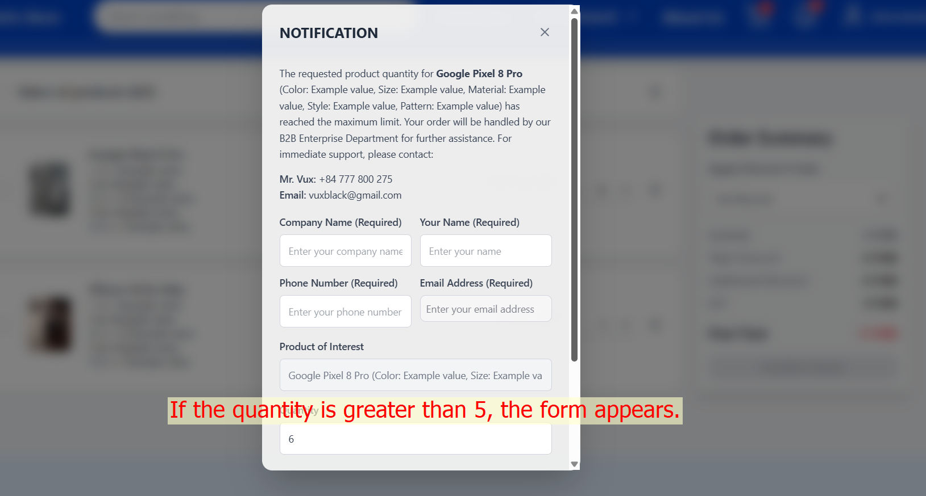

### Delete product from cart

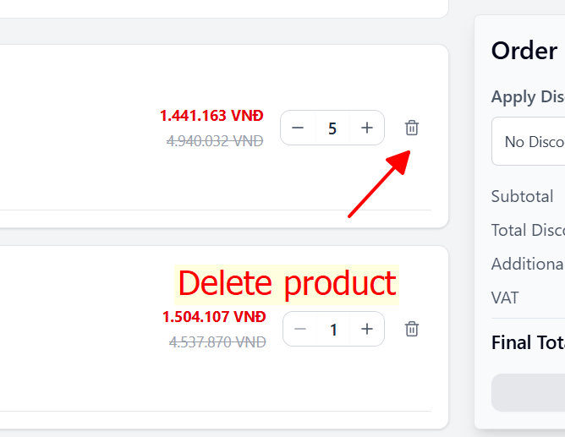

## MANAGE PROMOTIONS

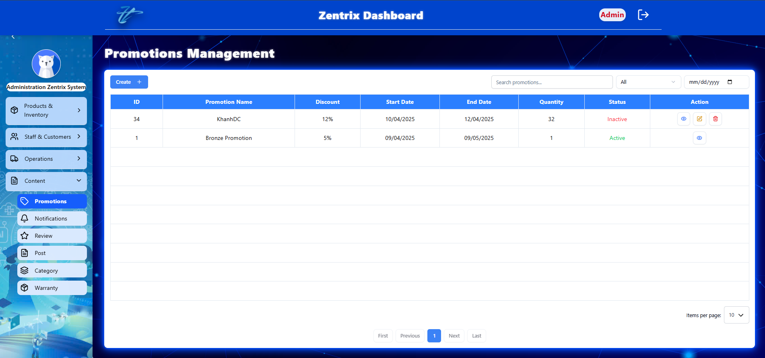

Figure . Manage promotion in dashboard

### Add promotion

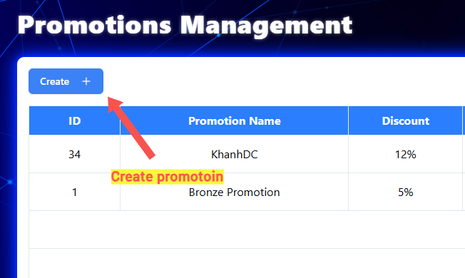

Figure . Create promotion button

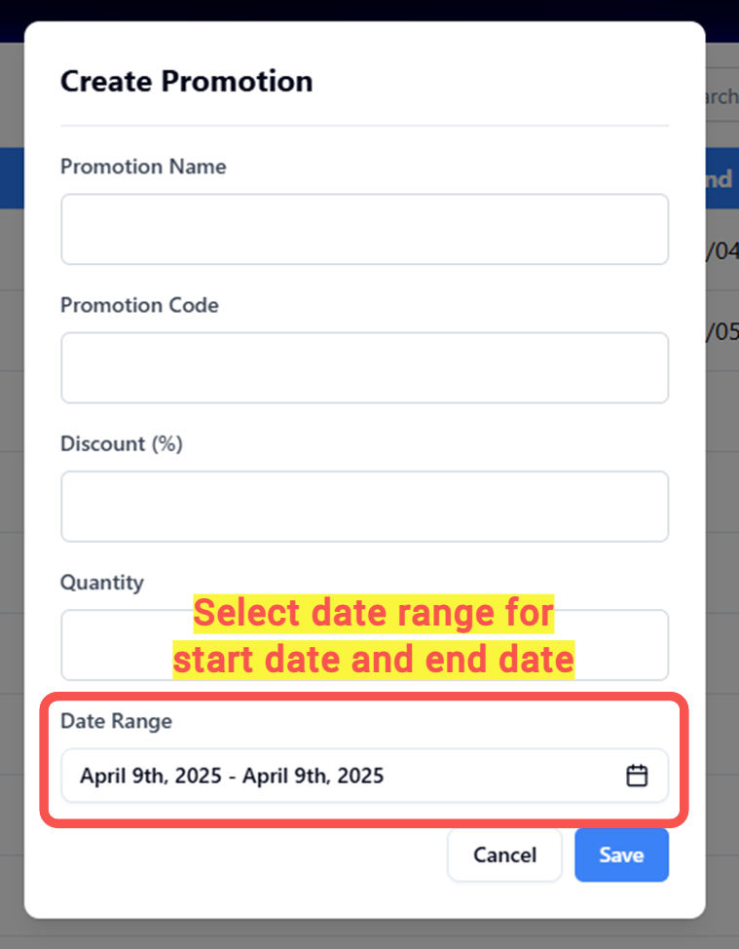

Figure . Create promotion

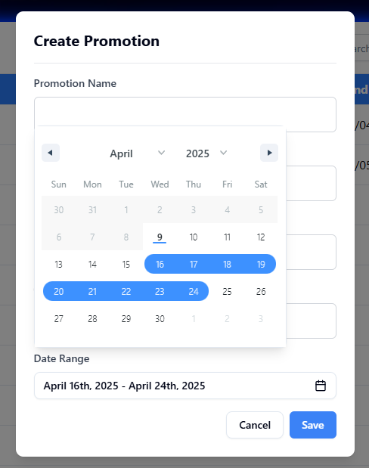

Figure . Select date range

### View promotion detail

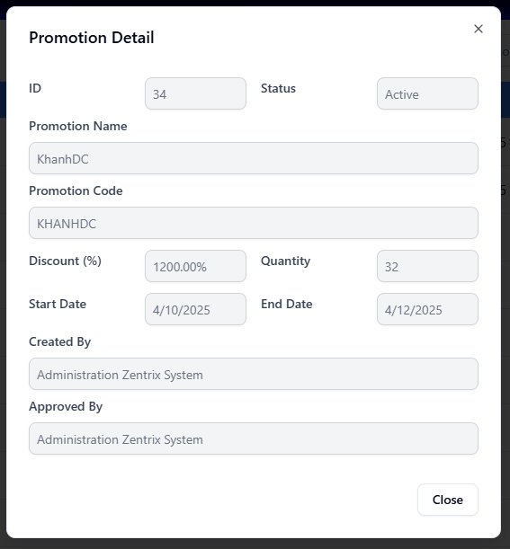

Figure . View promotion detail

### Edit promotion

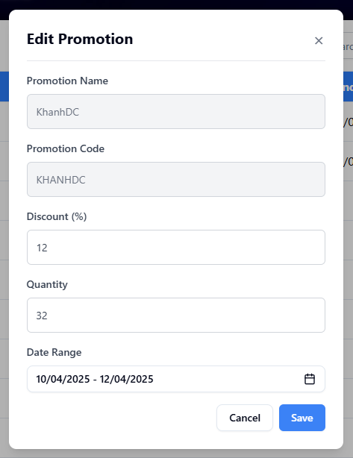

Figure . Edit promotion

### Delete promotion

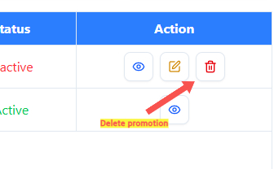

### Search promotion

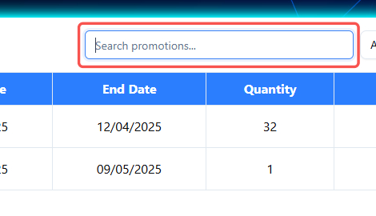

Figure . Search promotion

### View promotions list

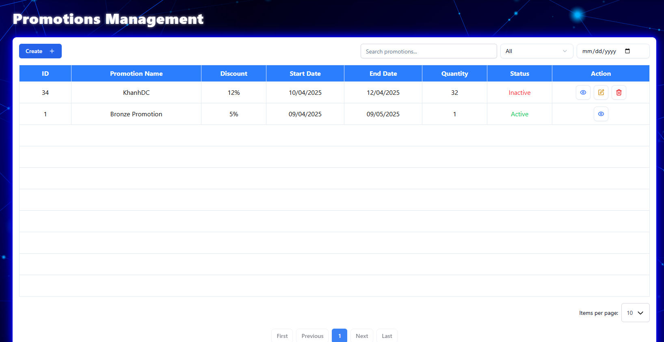

Figure . View promotions list

### Filter promotion

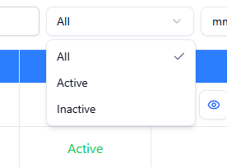

Figure . Filter promotions by status

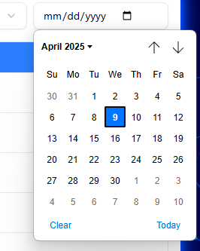

### Collect promotion

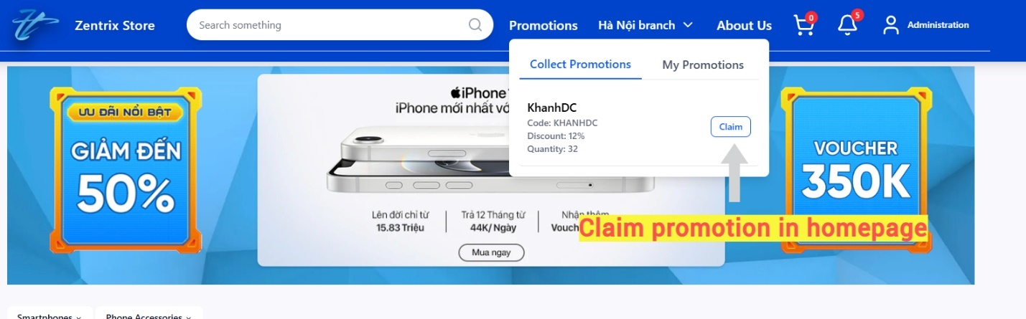

Figure . Collect promotion

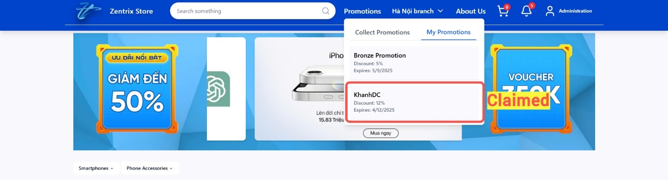

Figure . Show collected promotion

## MANAGE WARRANTIES

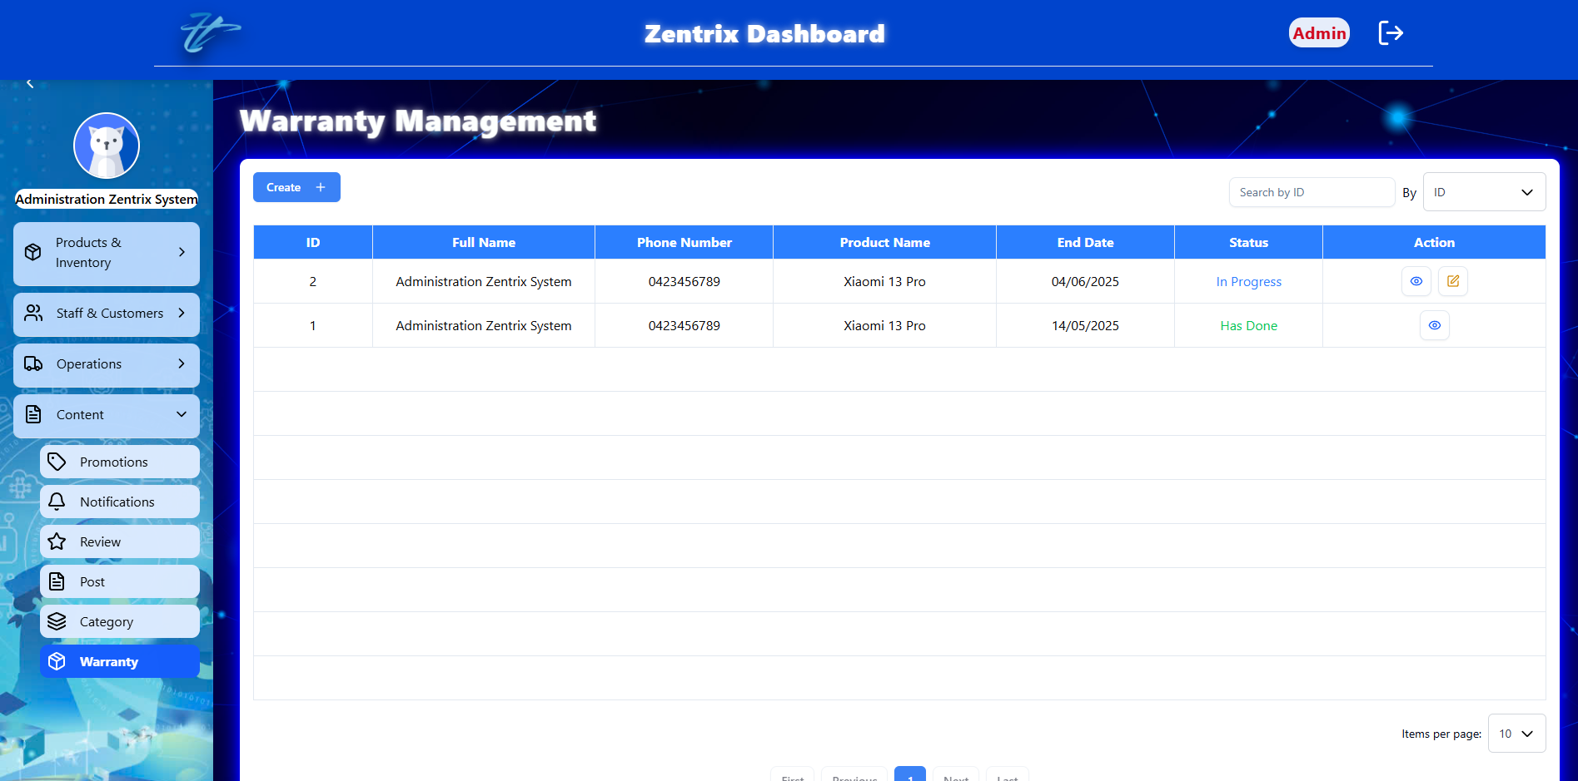

Figure . Manage warranty in dashboard

### Add warranty

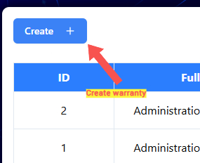

Figure . Create warranty button

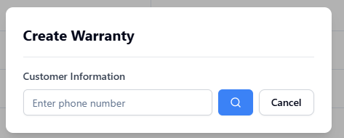

Figure . Search customer phone

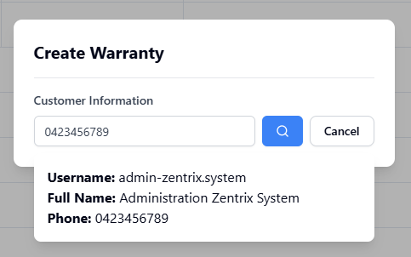

Figure . Select customer phone

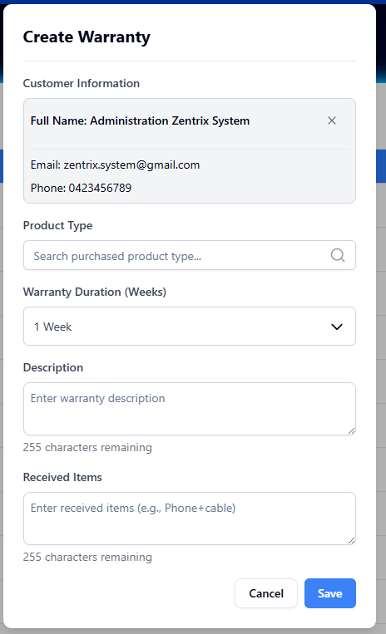

Figure . Add warranty table

### View warranty detail

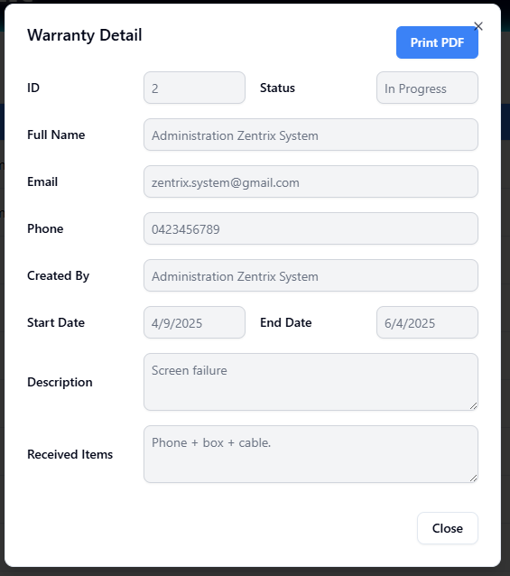

Figure . View warranty detail

### Edit warranty

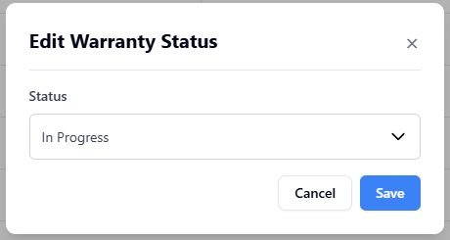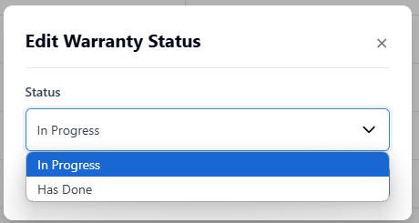

Figure . Edit warranty

### Search warranty

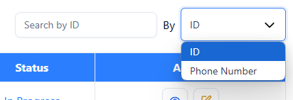

Figure . Search warranty by phone and id

### View warranties list

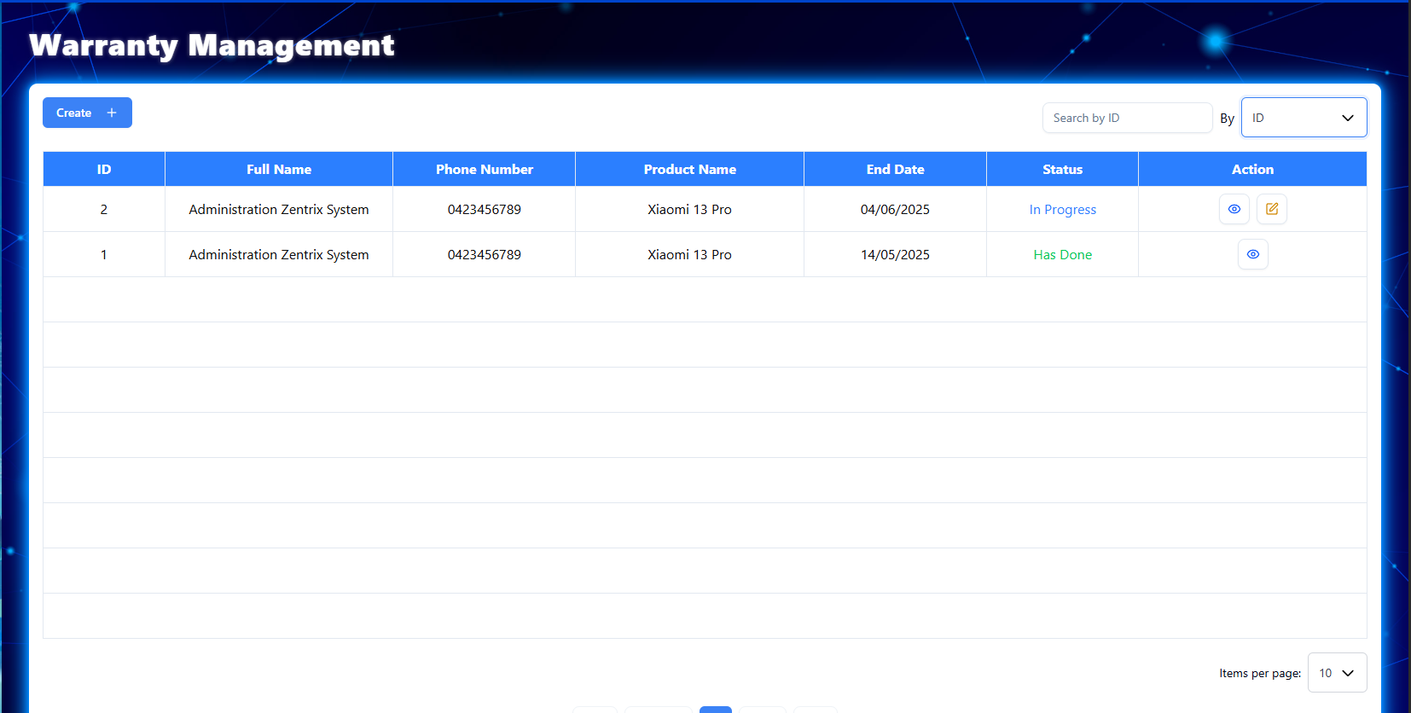

### Export warranty file

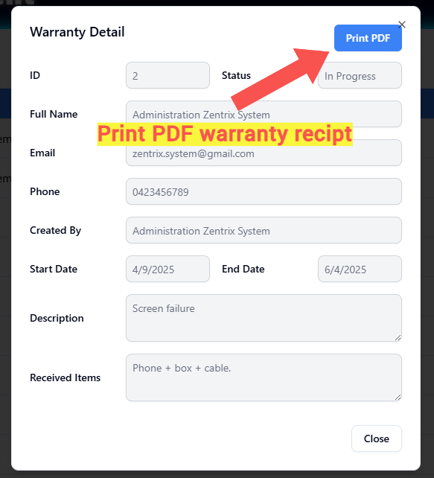

Figure . Print warranty PDF

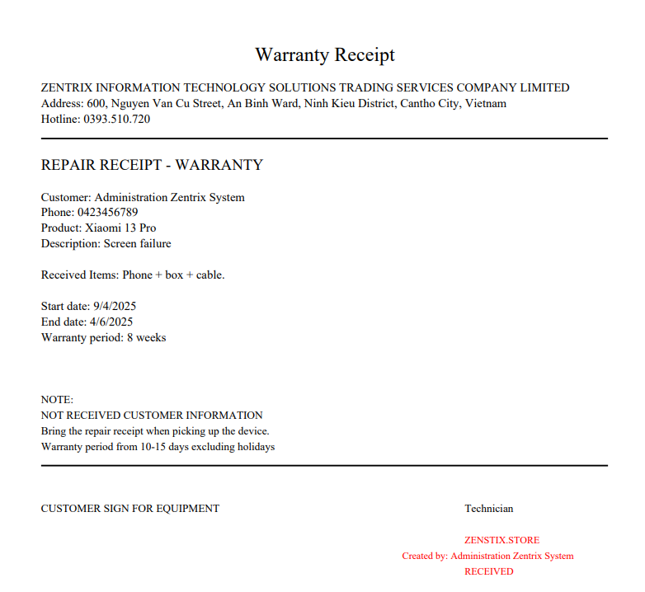

Figure . Warranty PDF

## MANAGE STOCKS

### Import stock

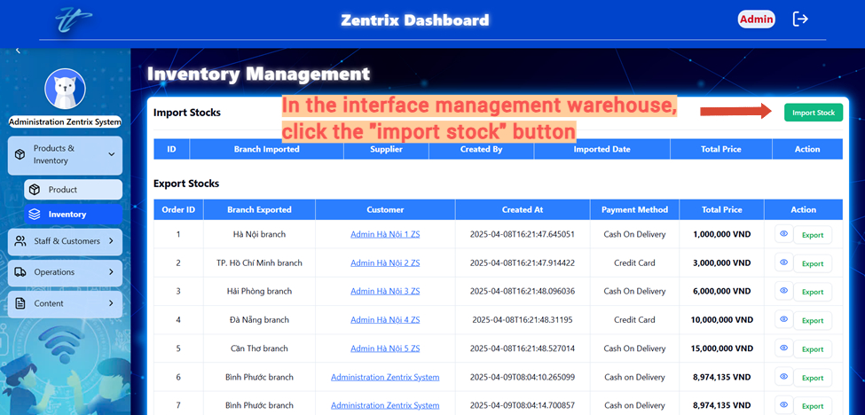

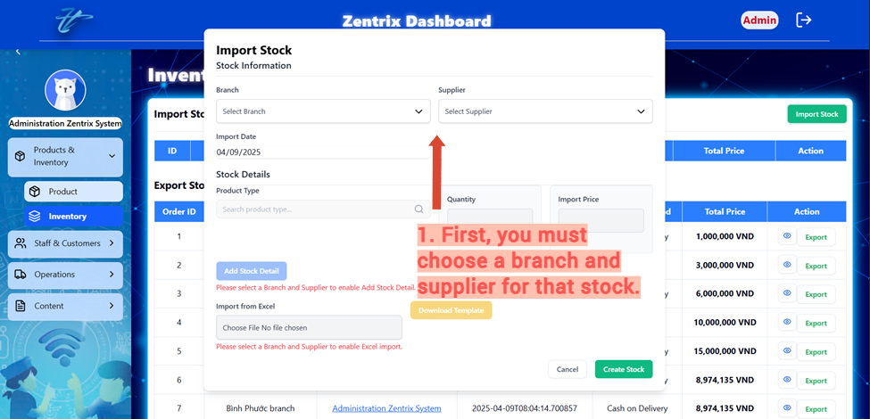

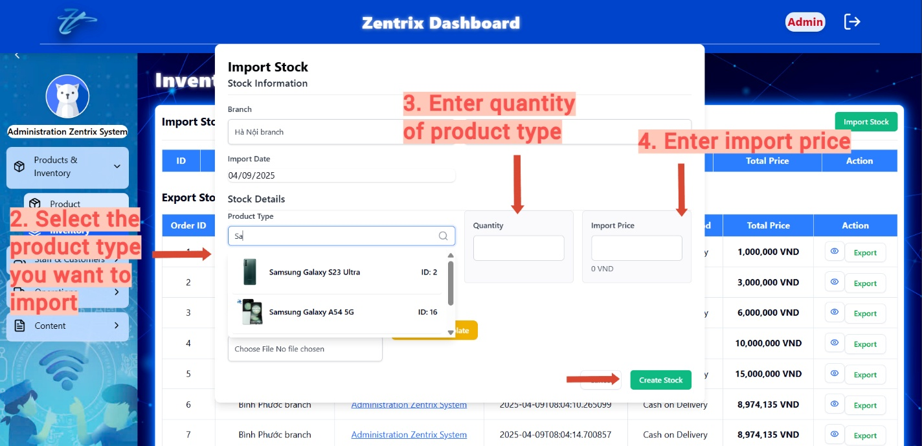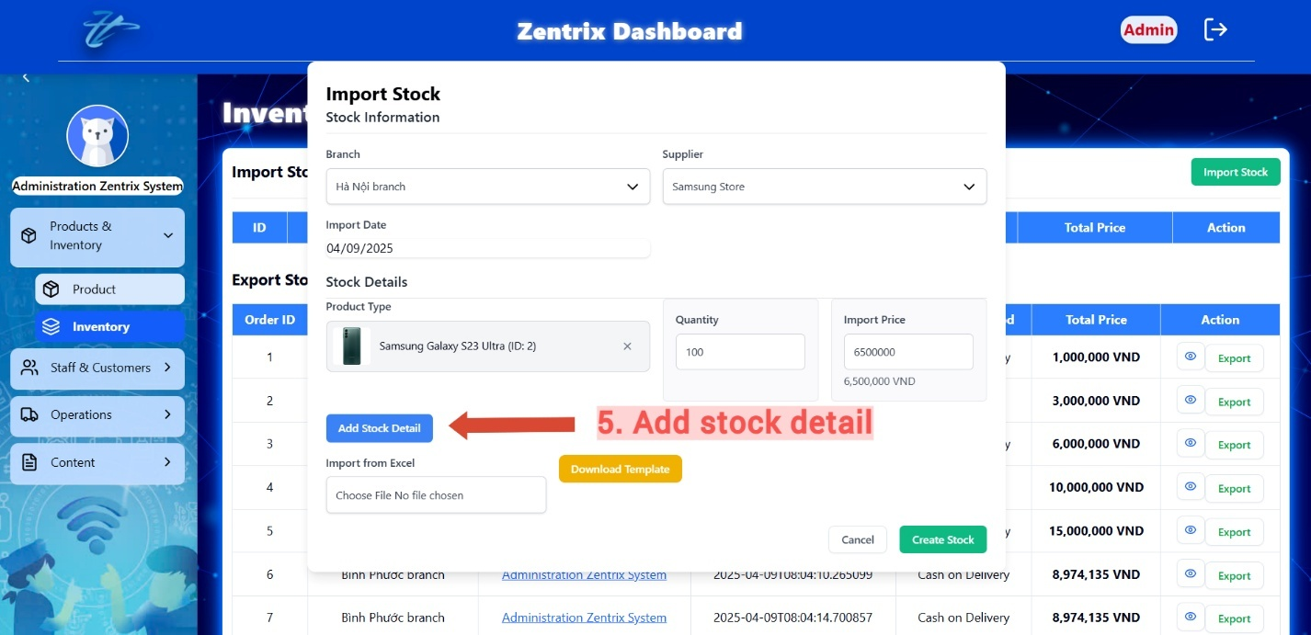

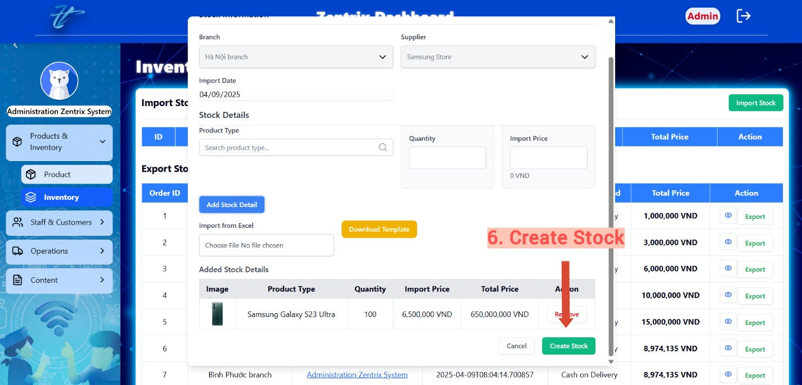

### Import stock by using Excel

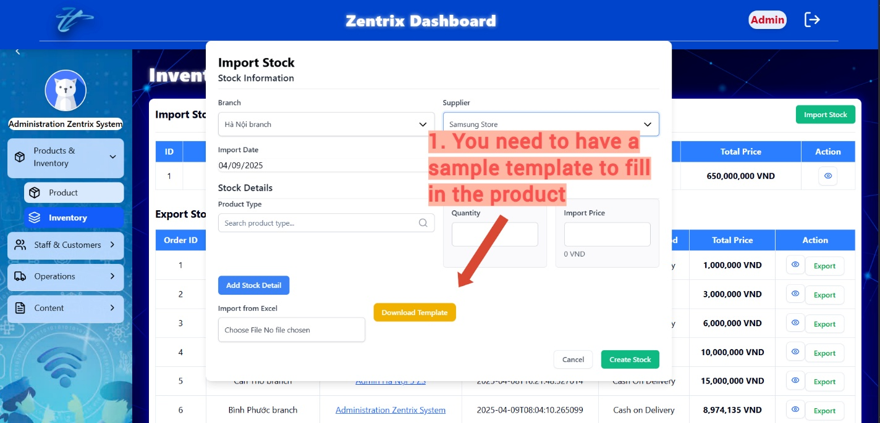

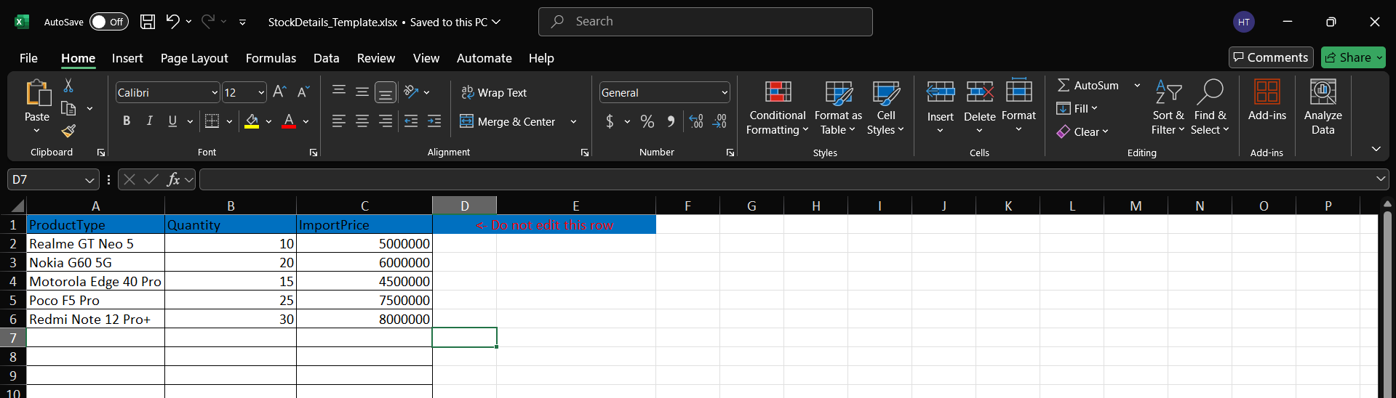

Figure . Example Product

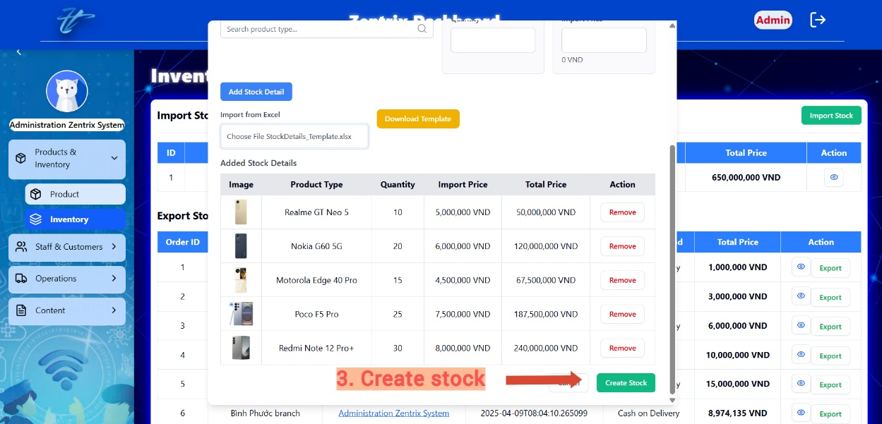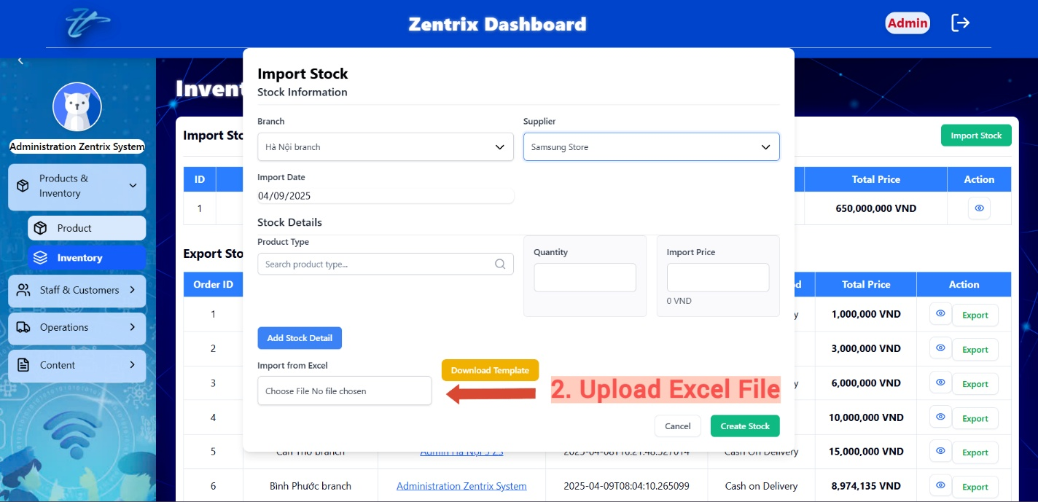

### View import stock detail

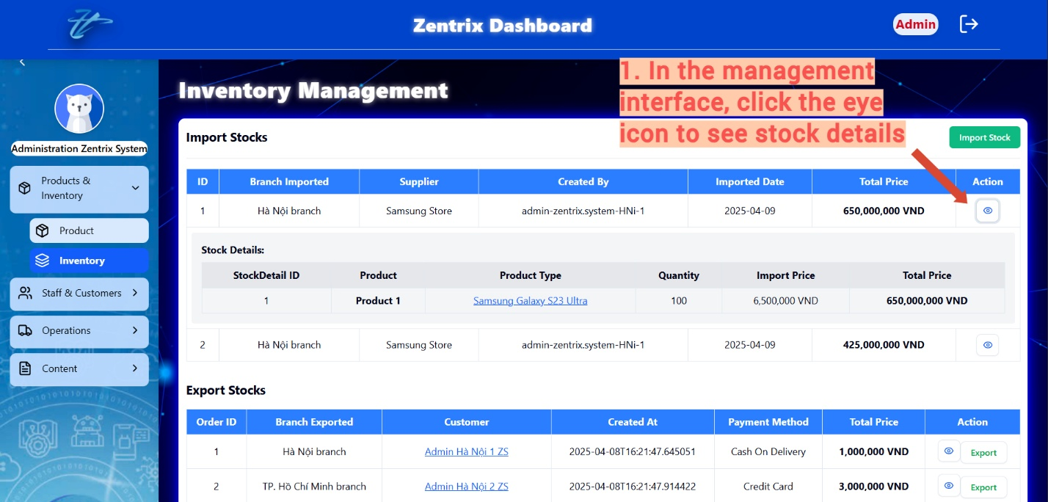

### View export stock detail

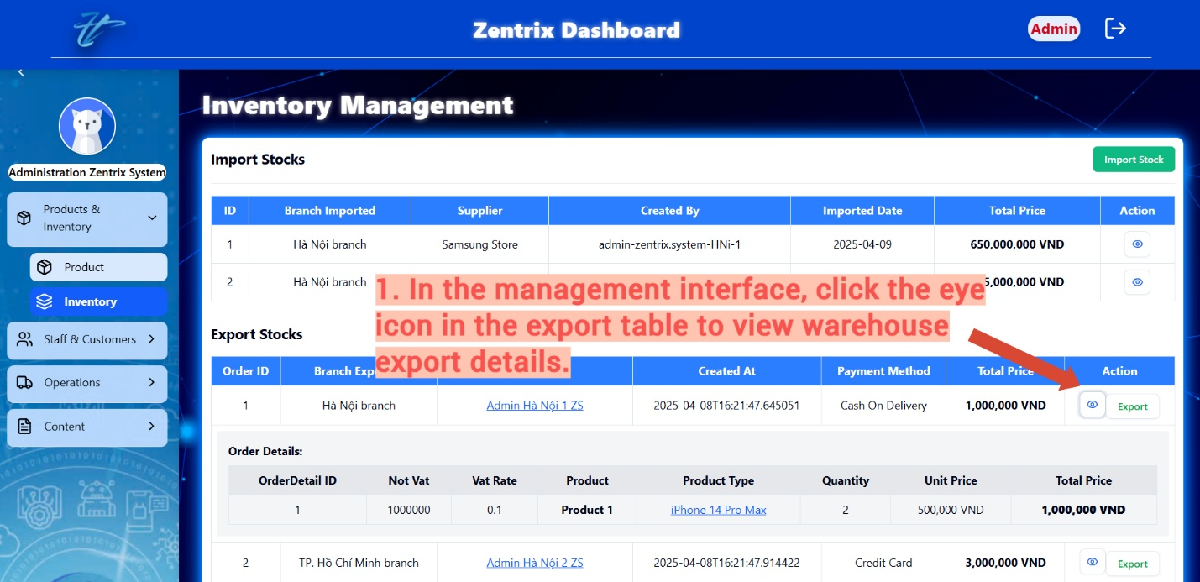

### Export stock to Excel

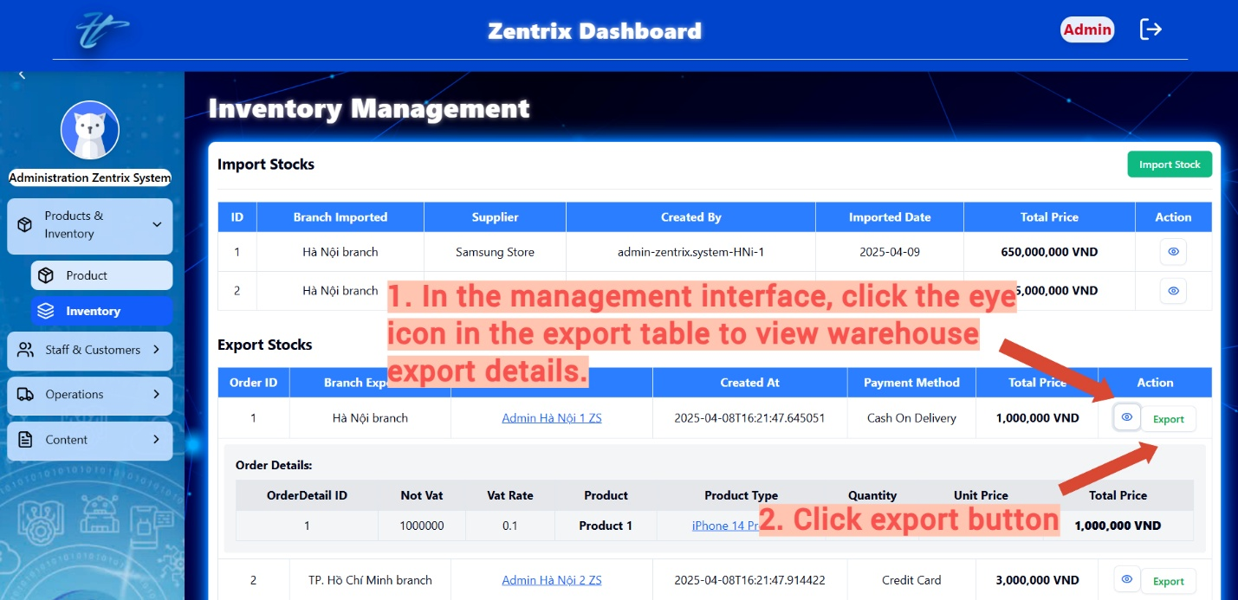

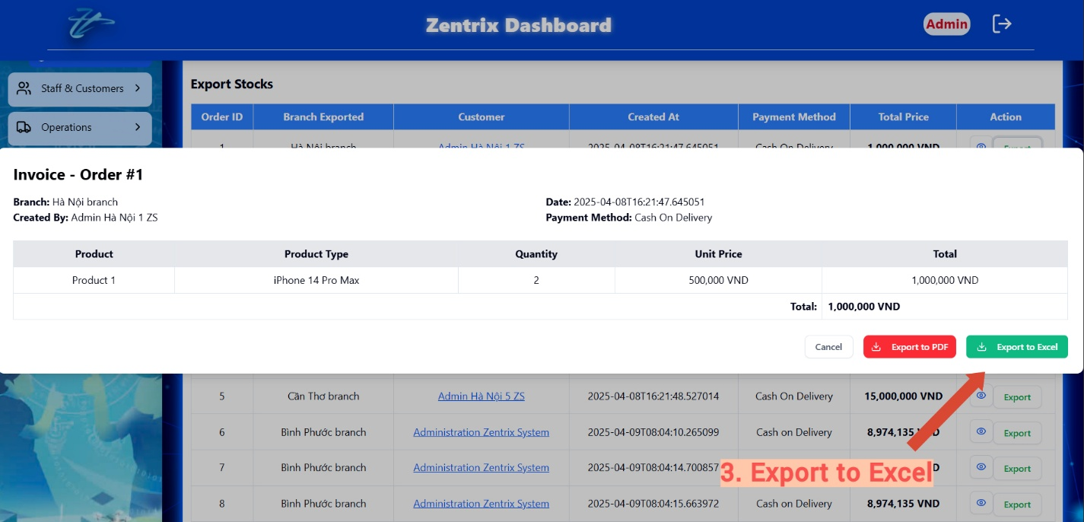

### Export stock to PDF



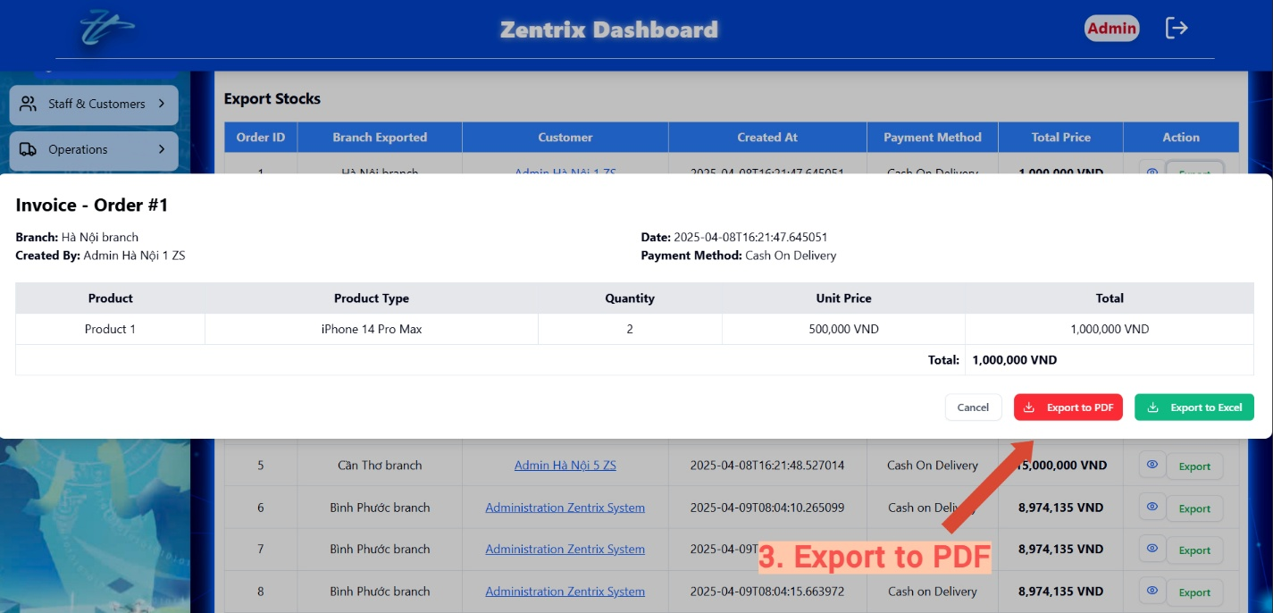

### View import products list

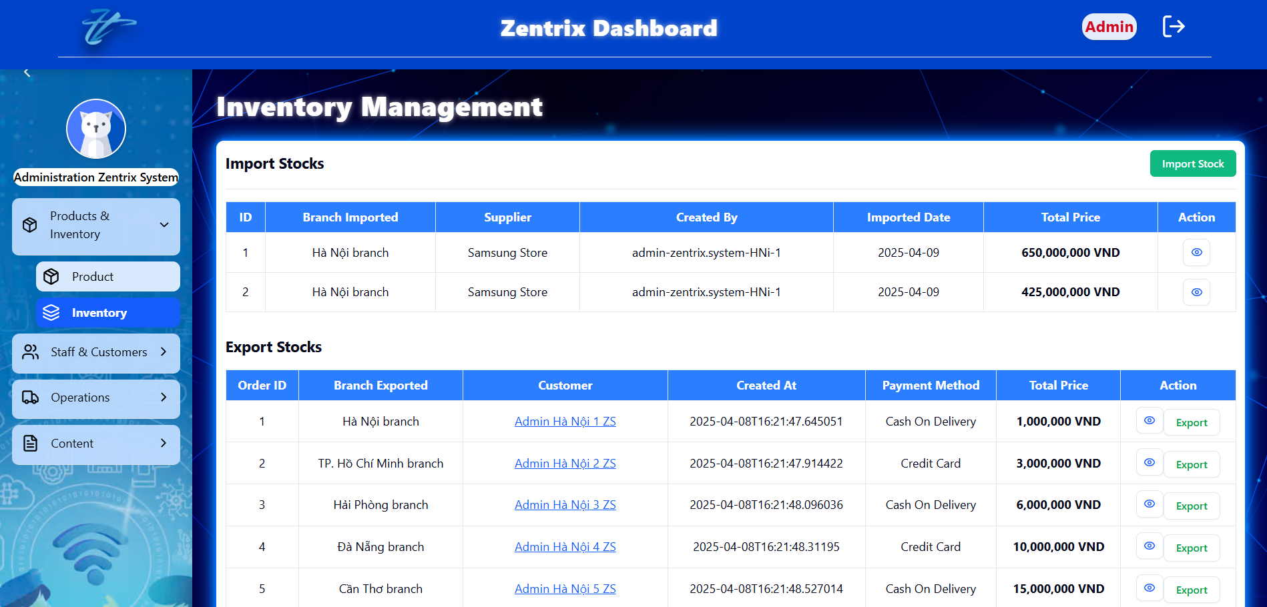

### View export products list



## MANAGE NOTIFICATIONS

### Add notification

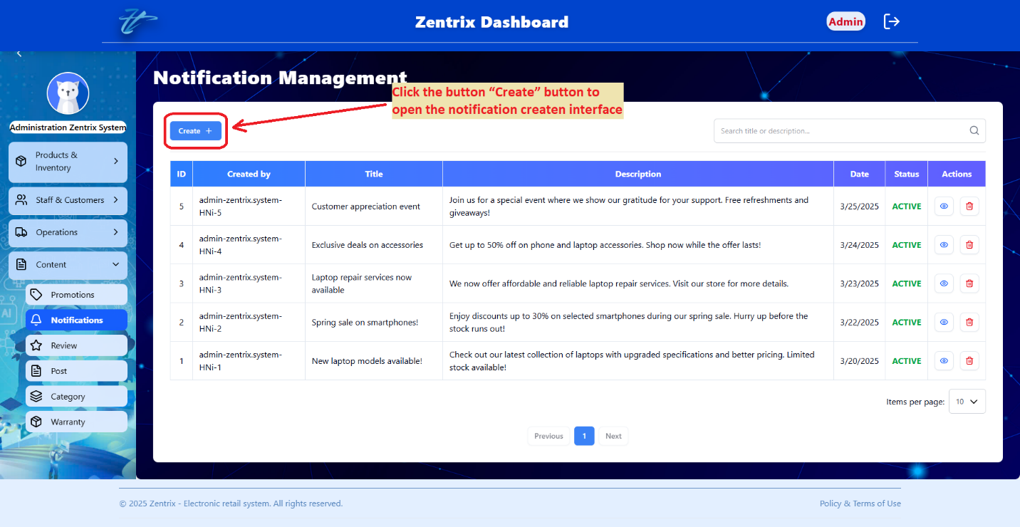

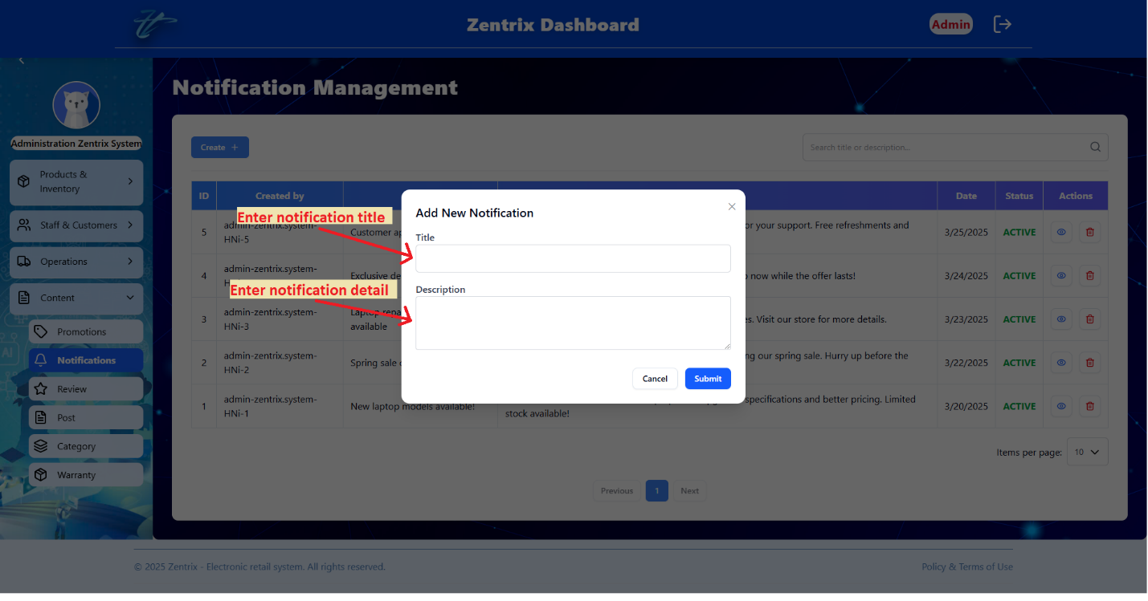

### View notification detail

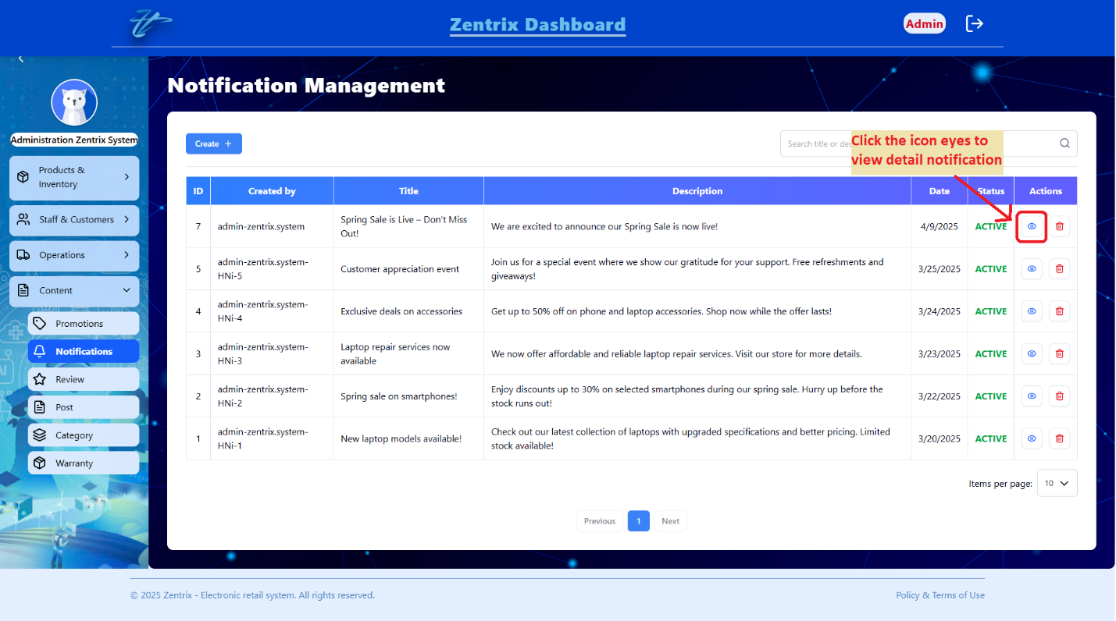

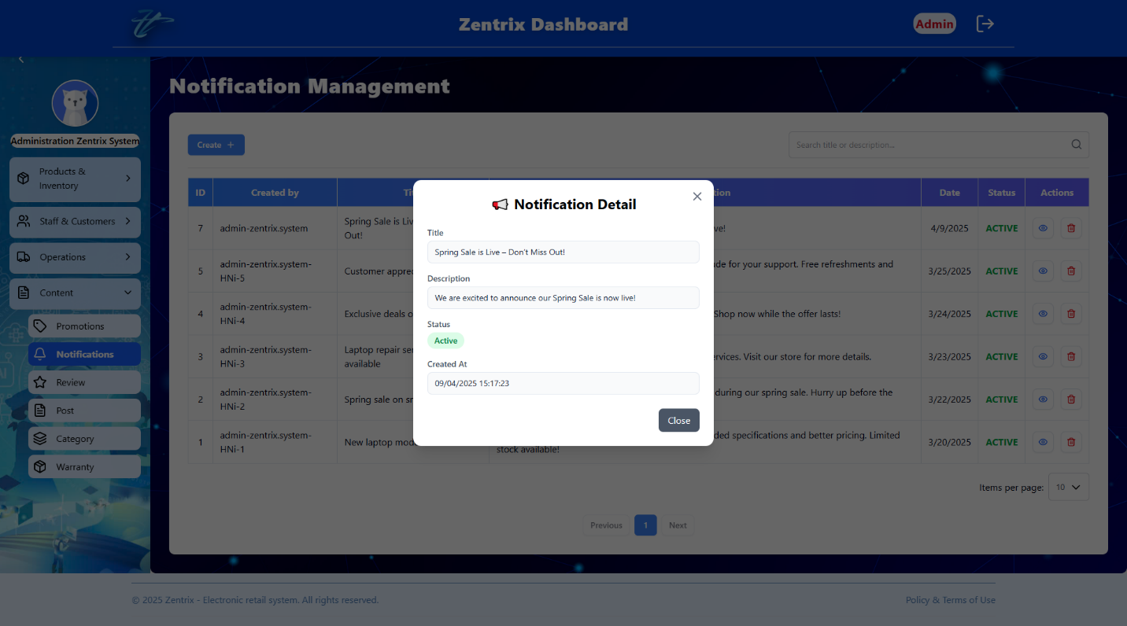

### Delete notification

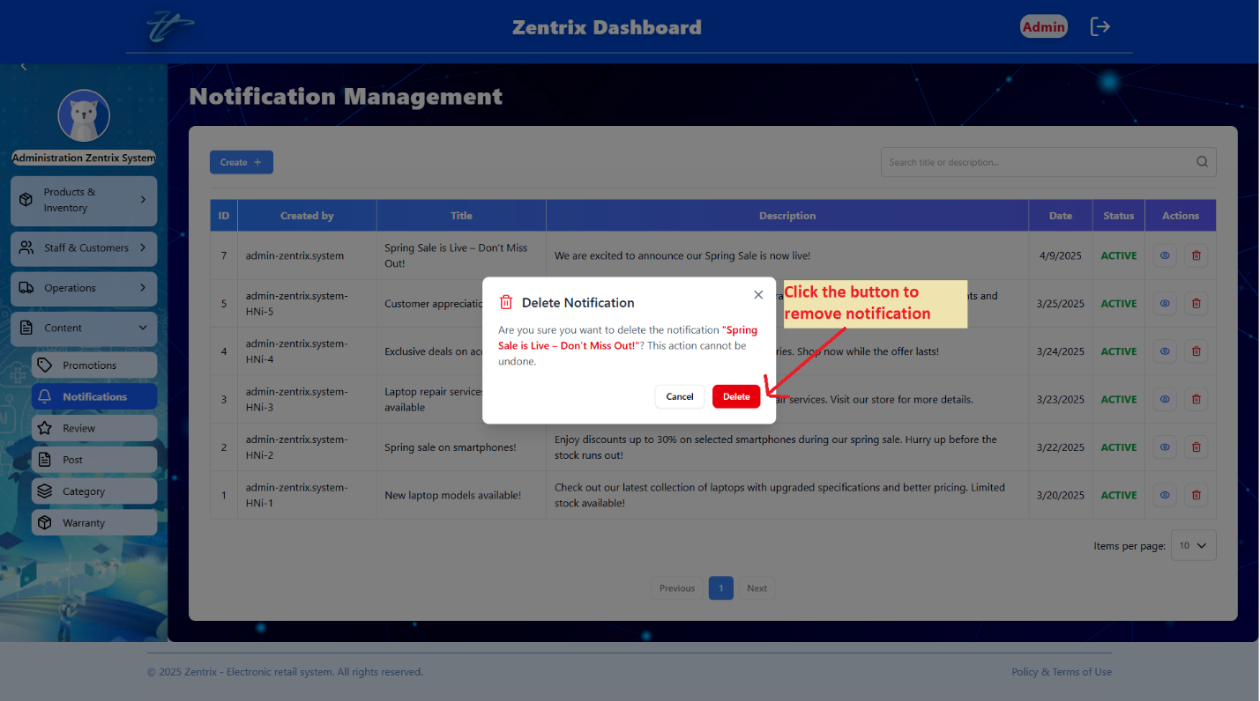

### Search notification

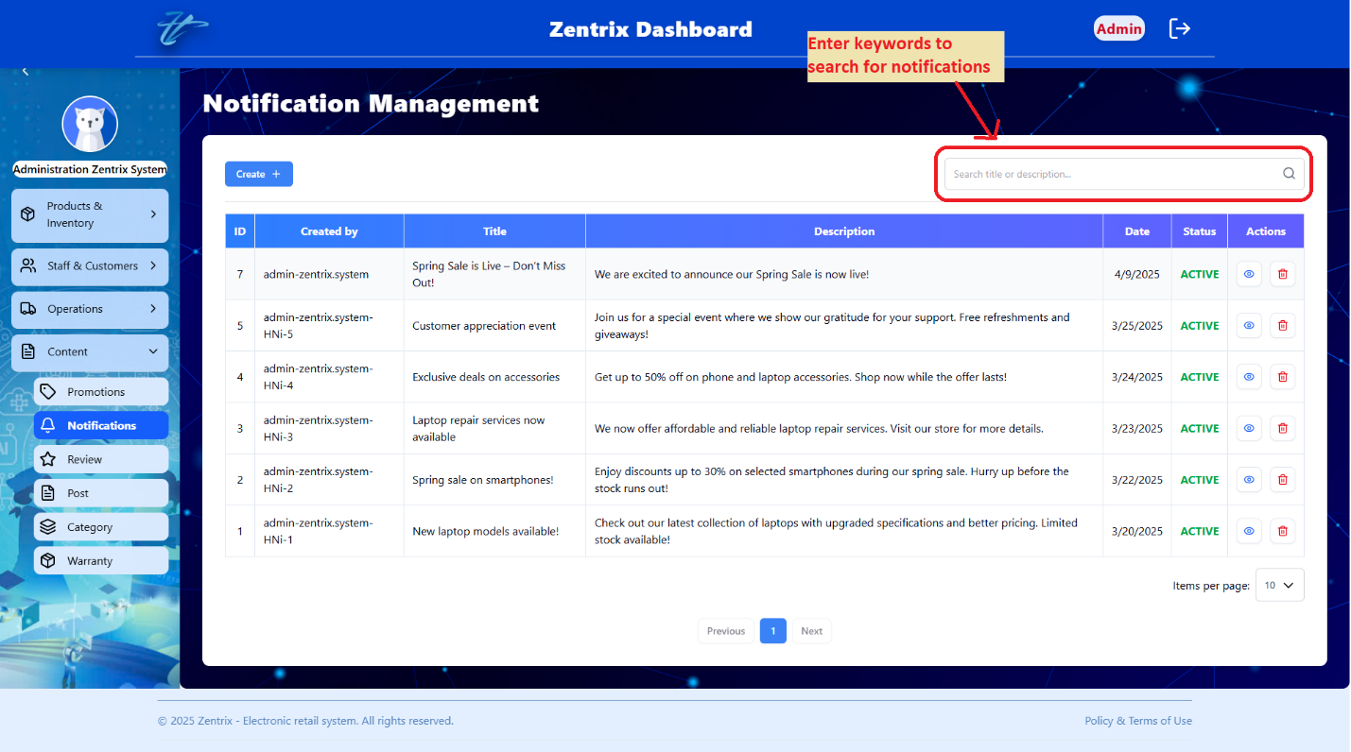

### View notifications list

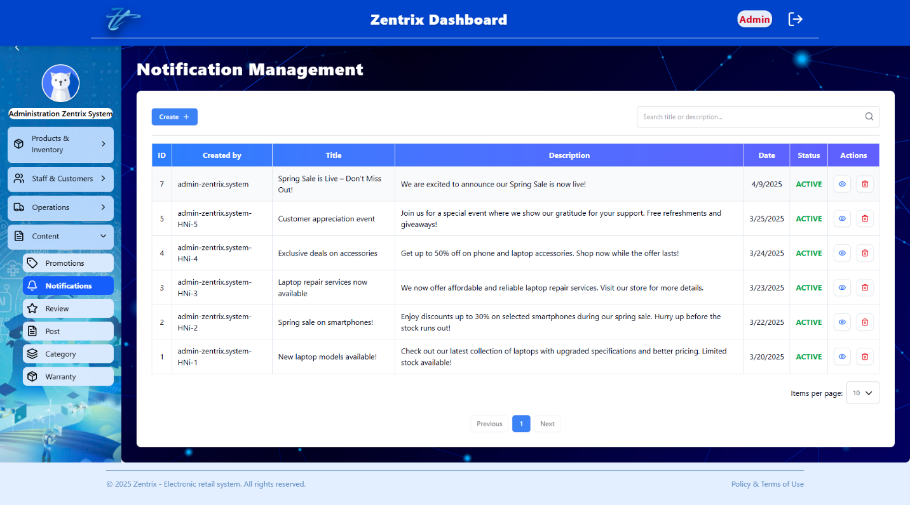

## MANAGE REVIEWS

### Add review

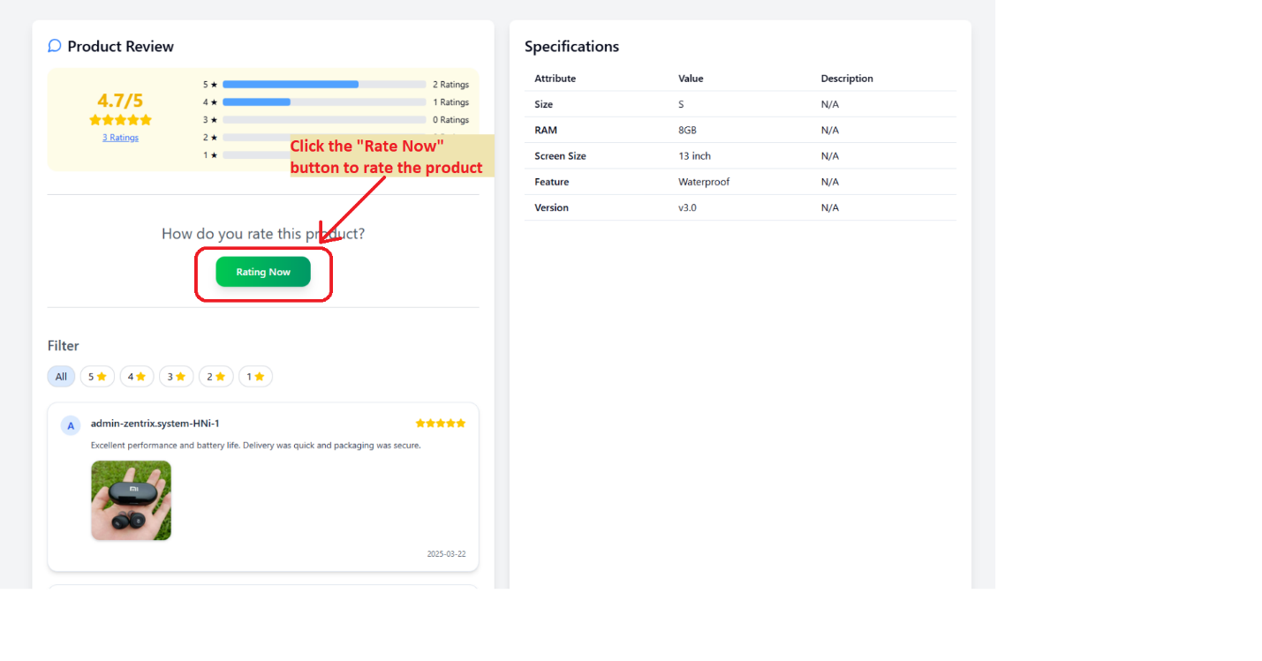

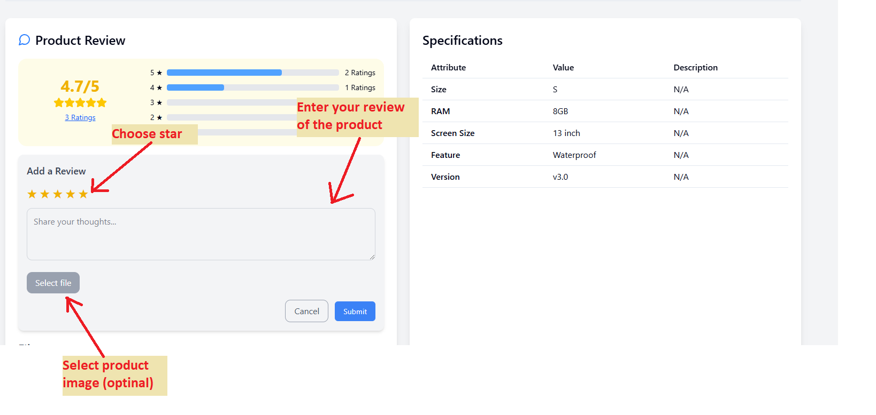

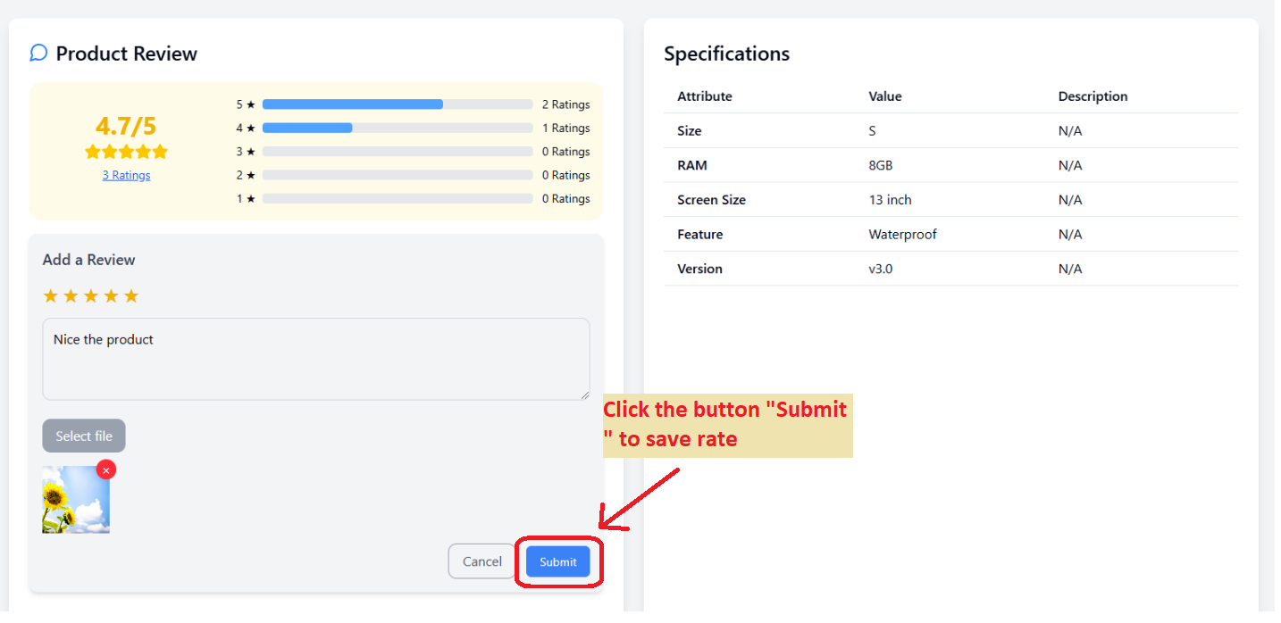

### View review detail

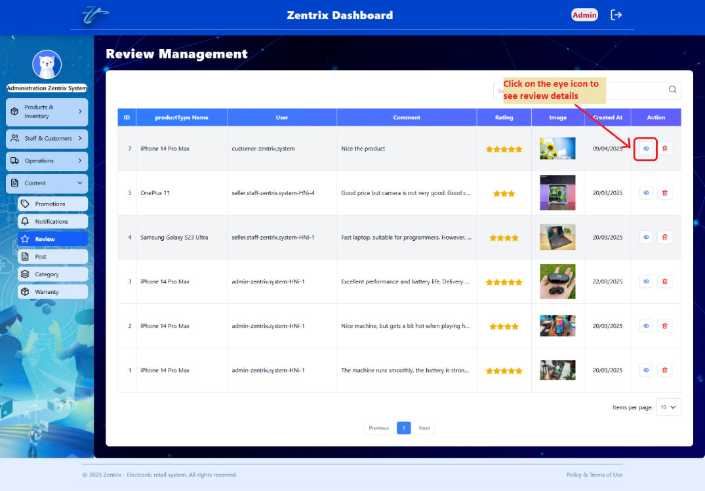

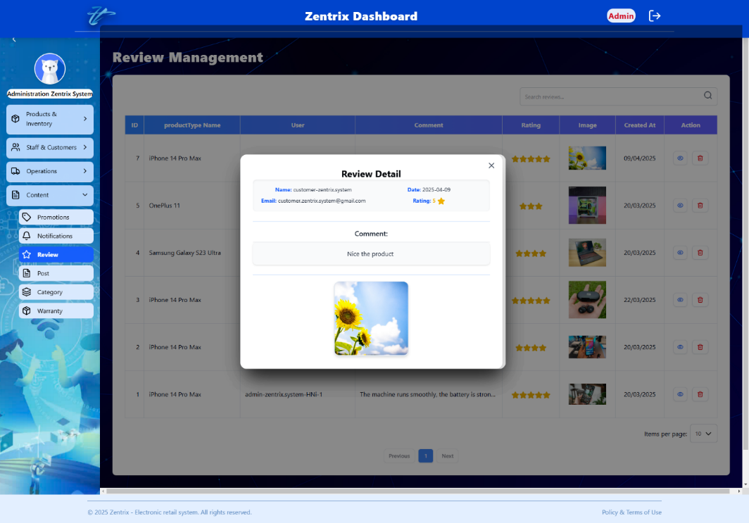

### Edit review

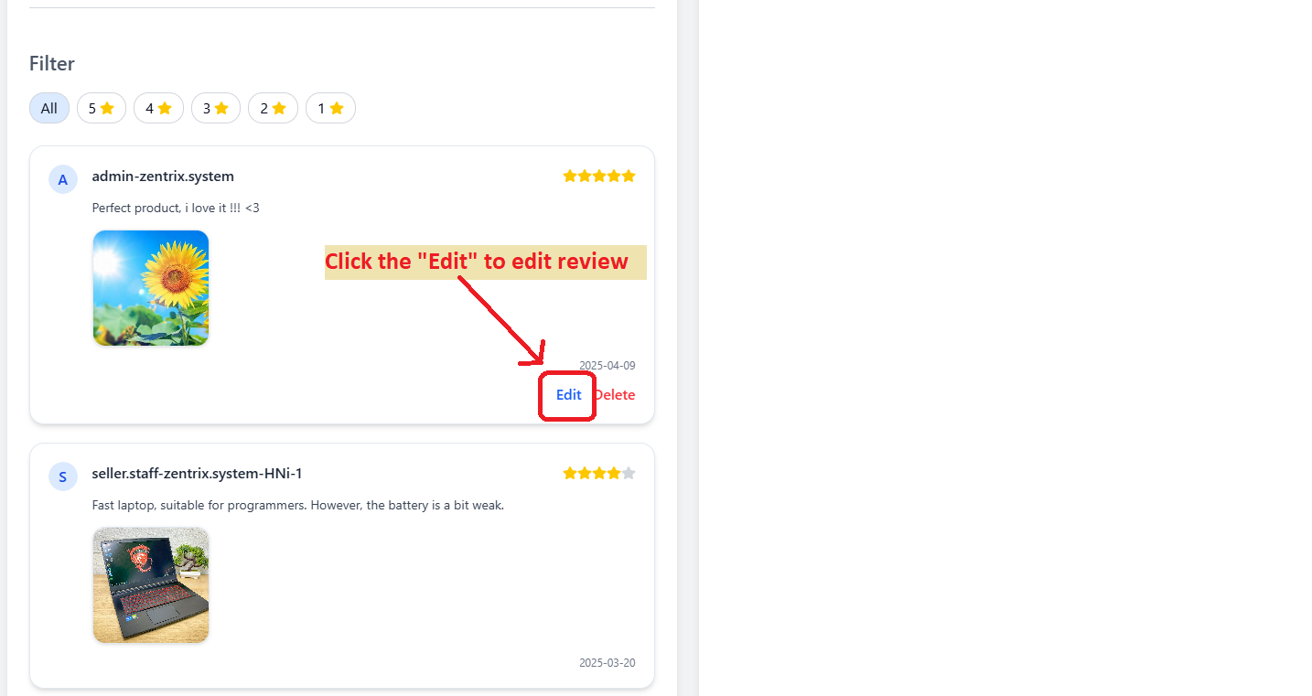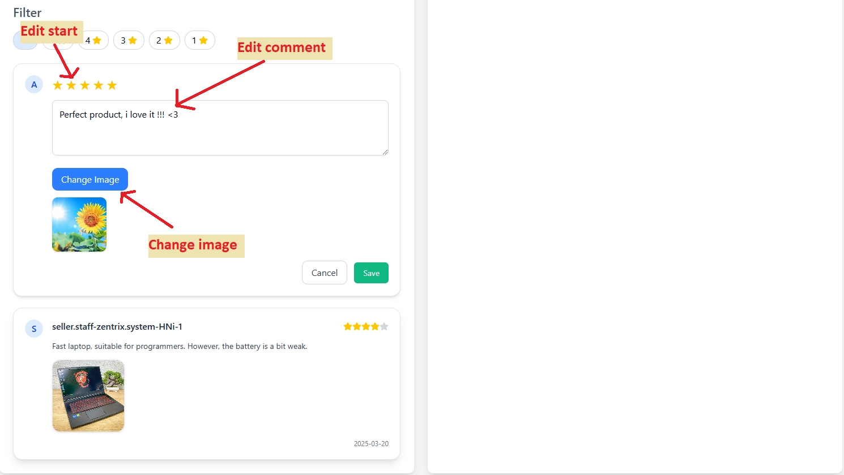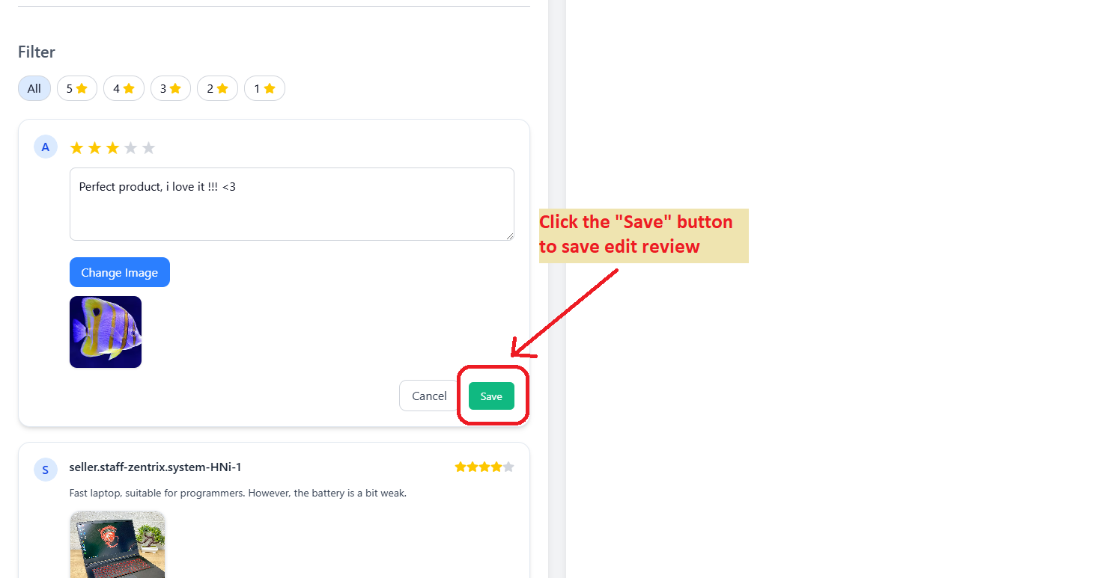

### Delete review

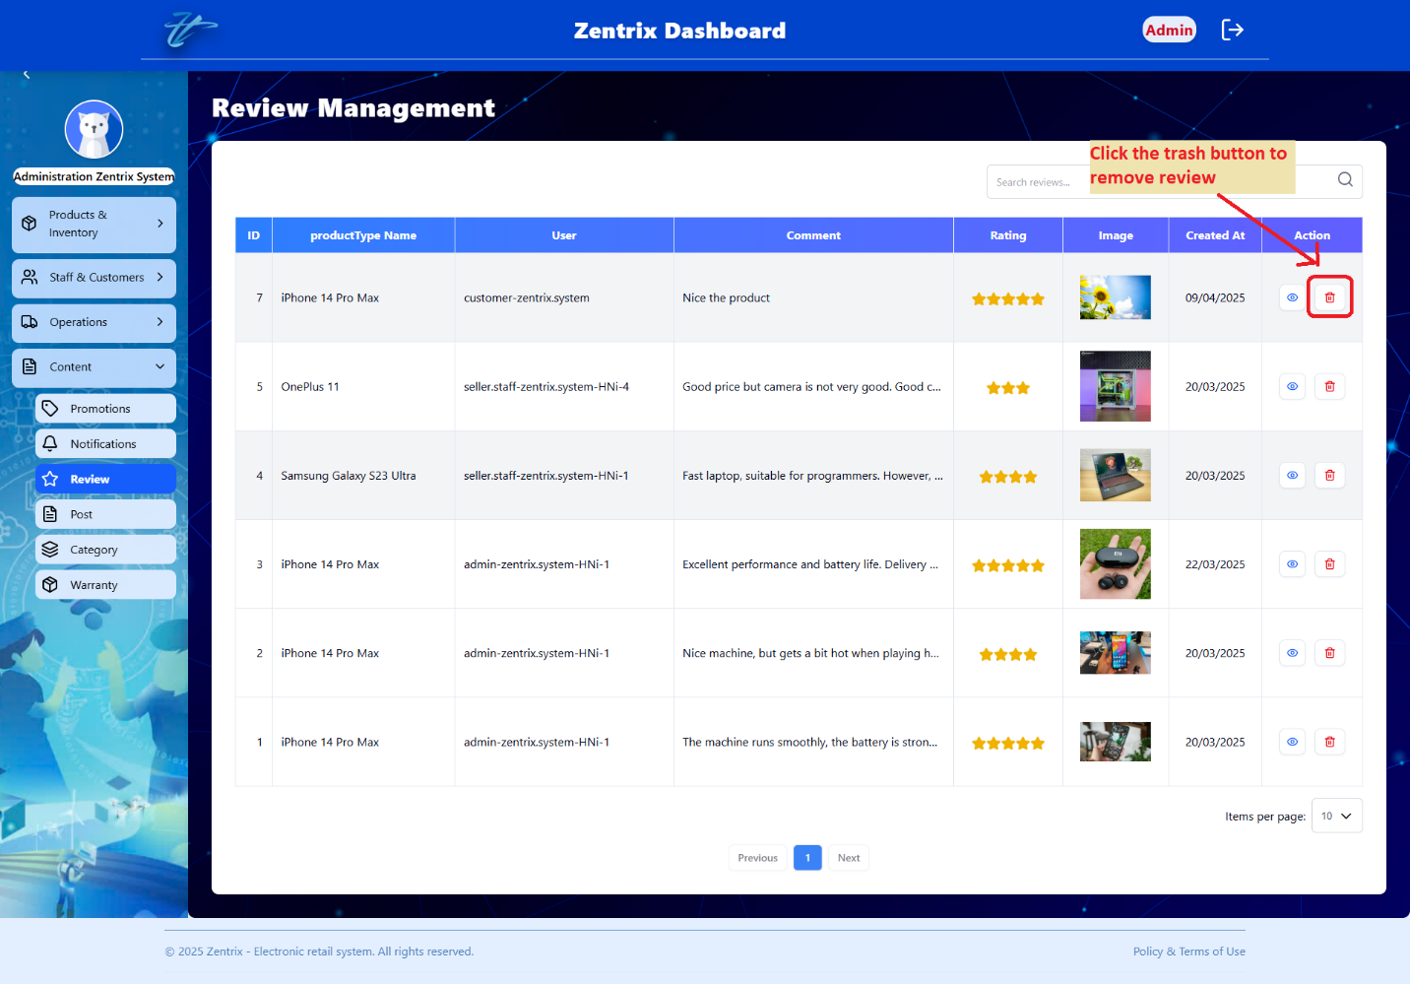

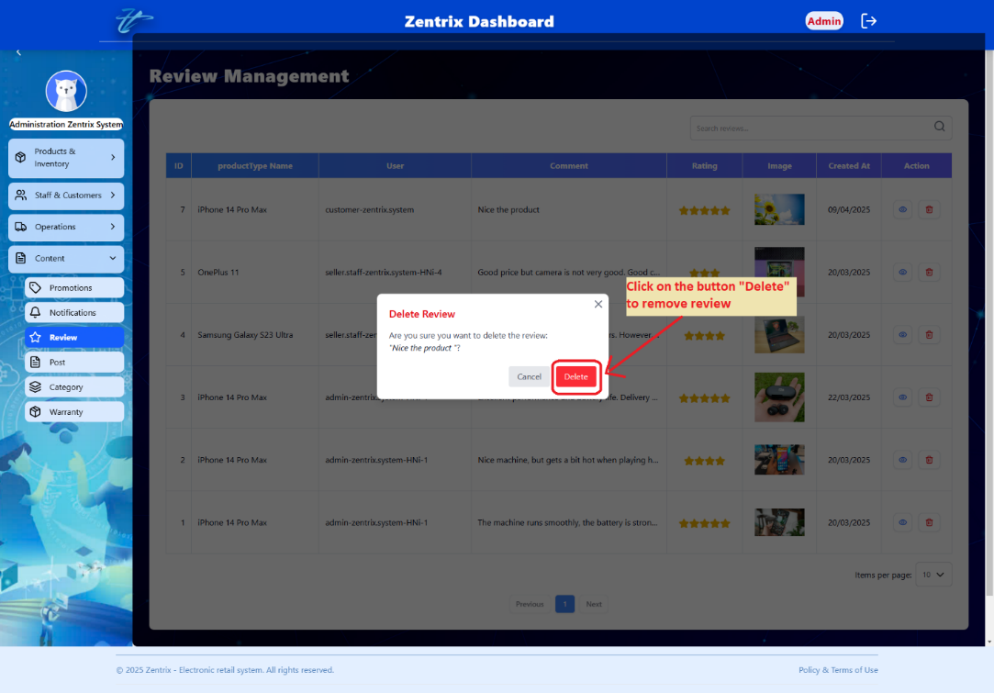

### Search review

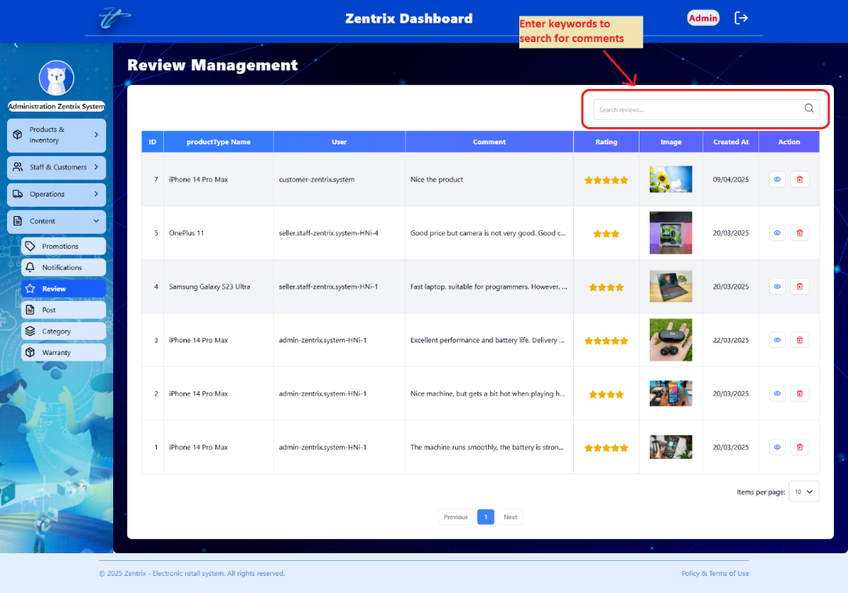

### View reviews list

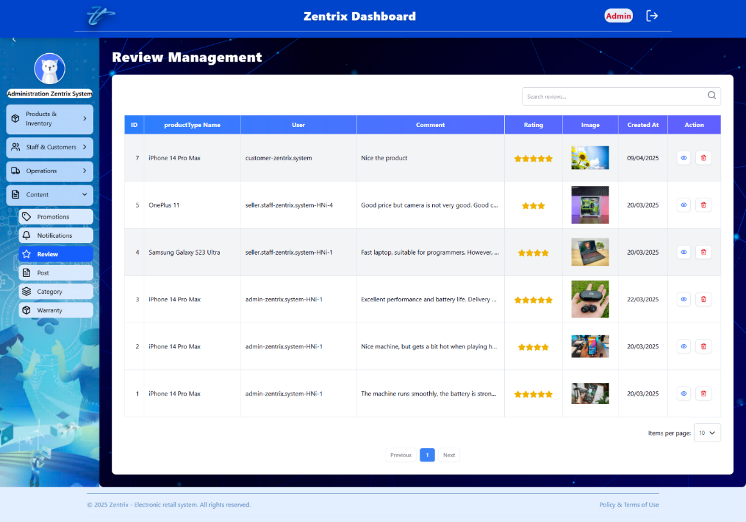

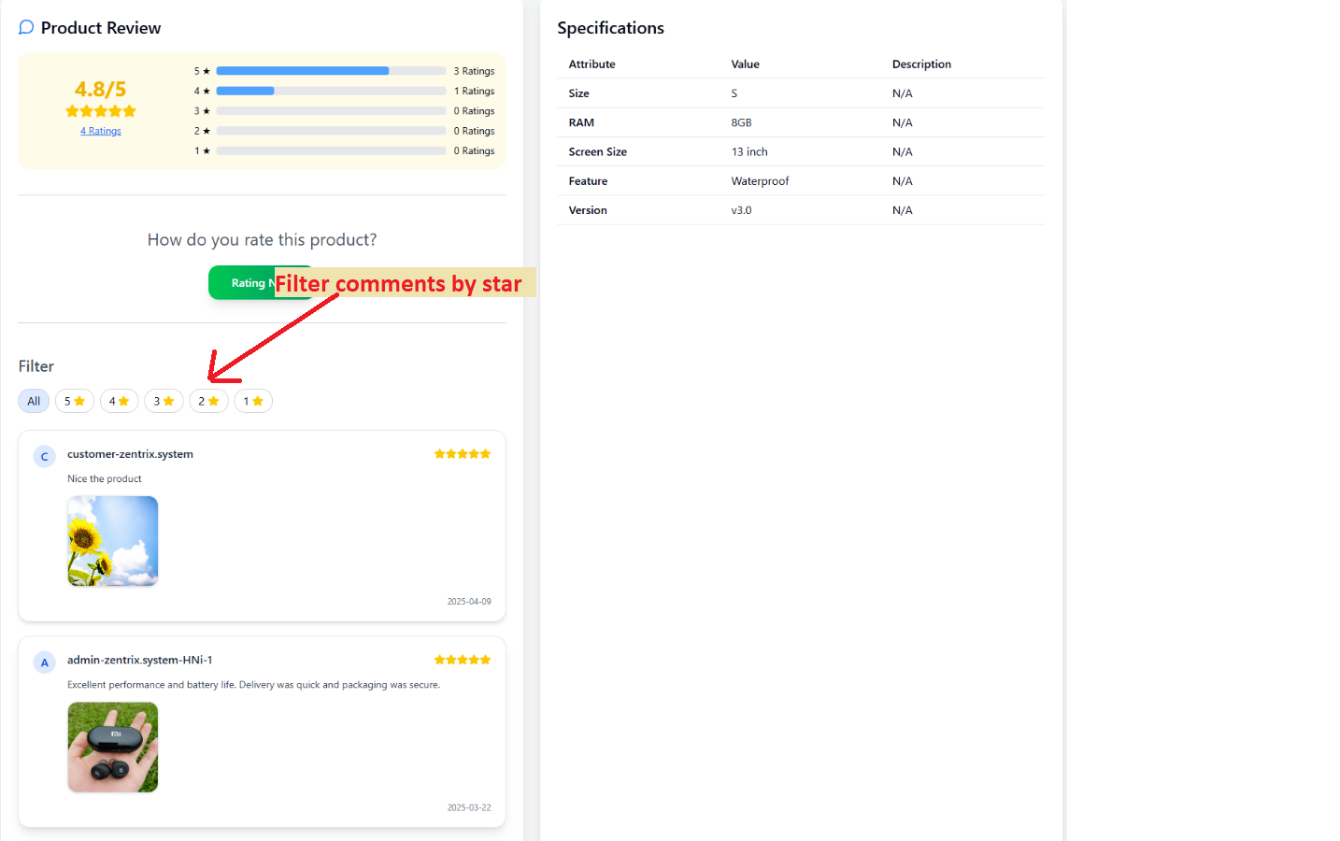

## MANAGE POSTS

### Add post

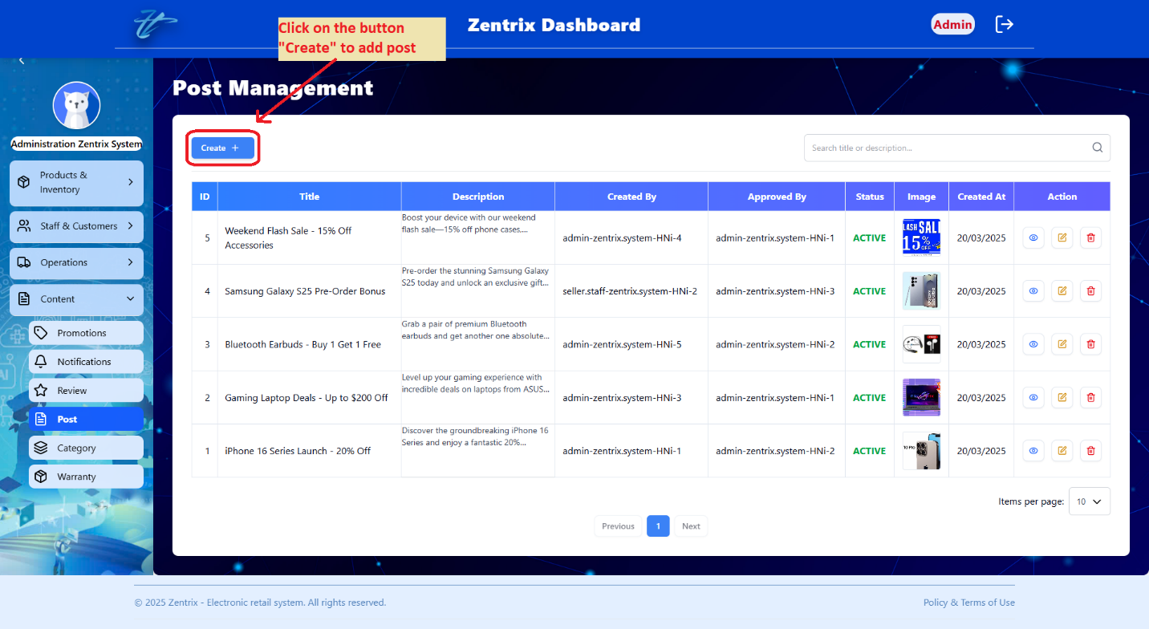

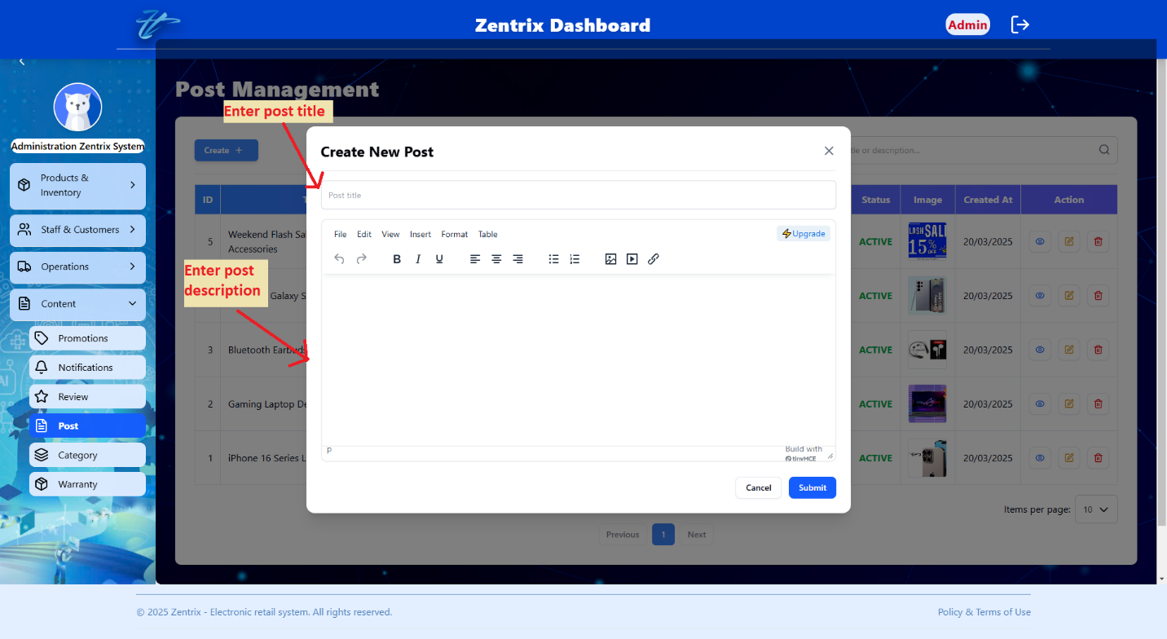

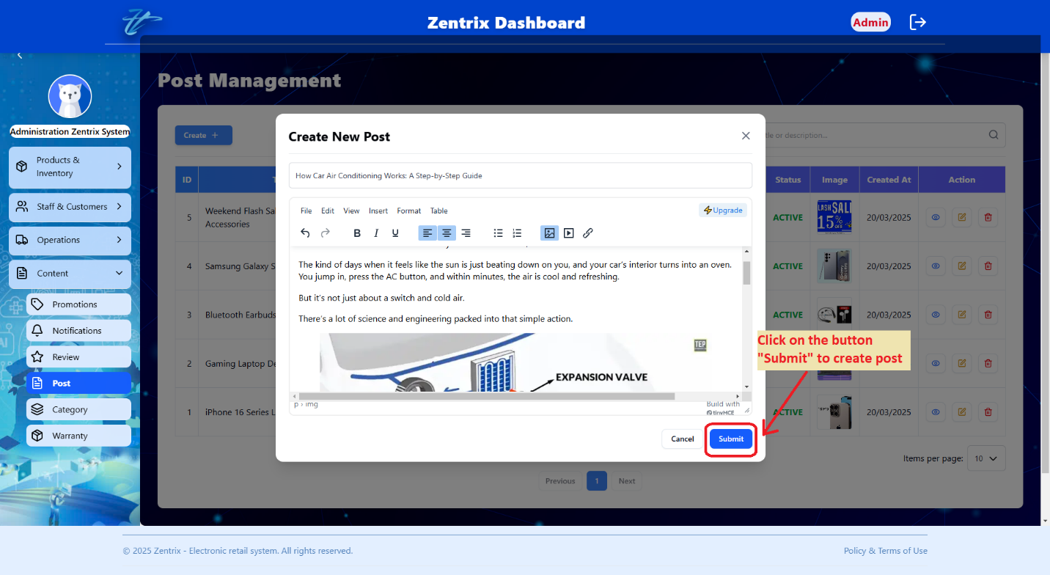

### View post detail

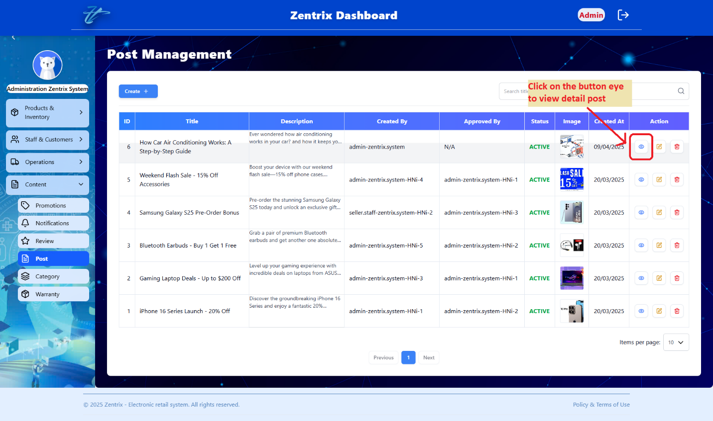

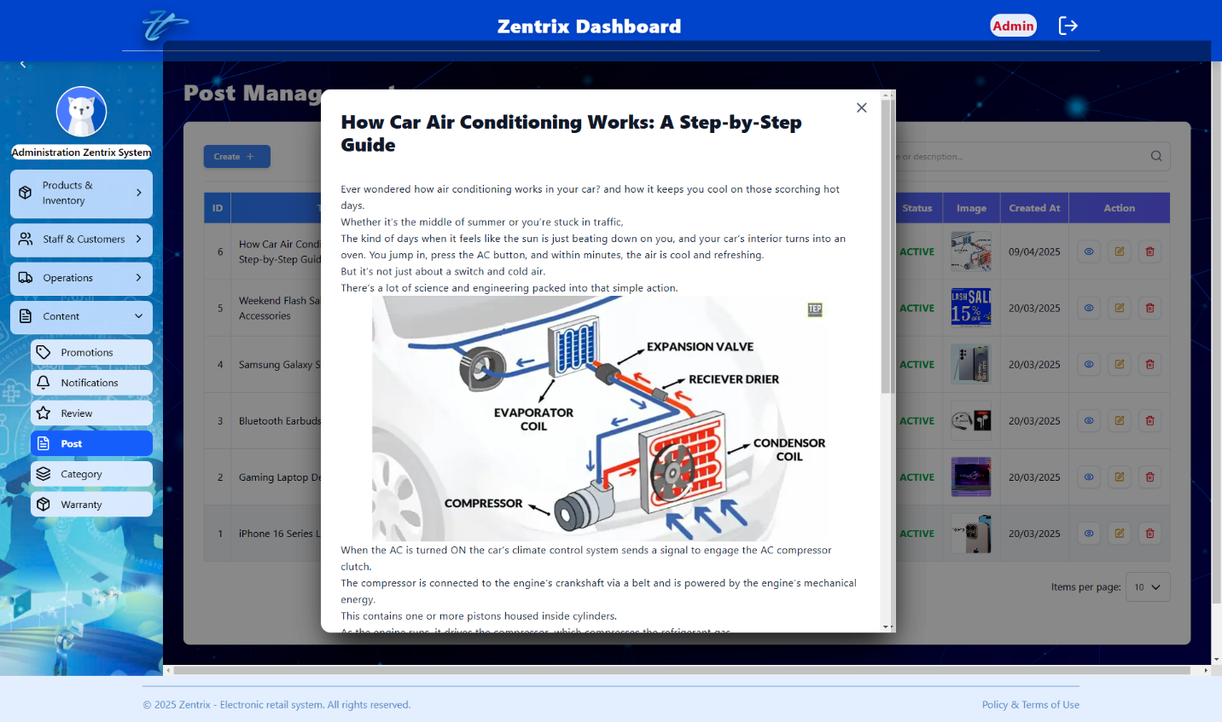

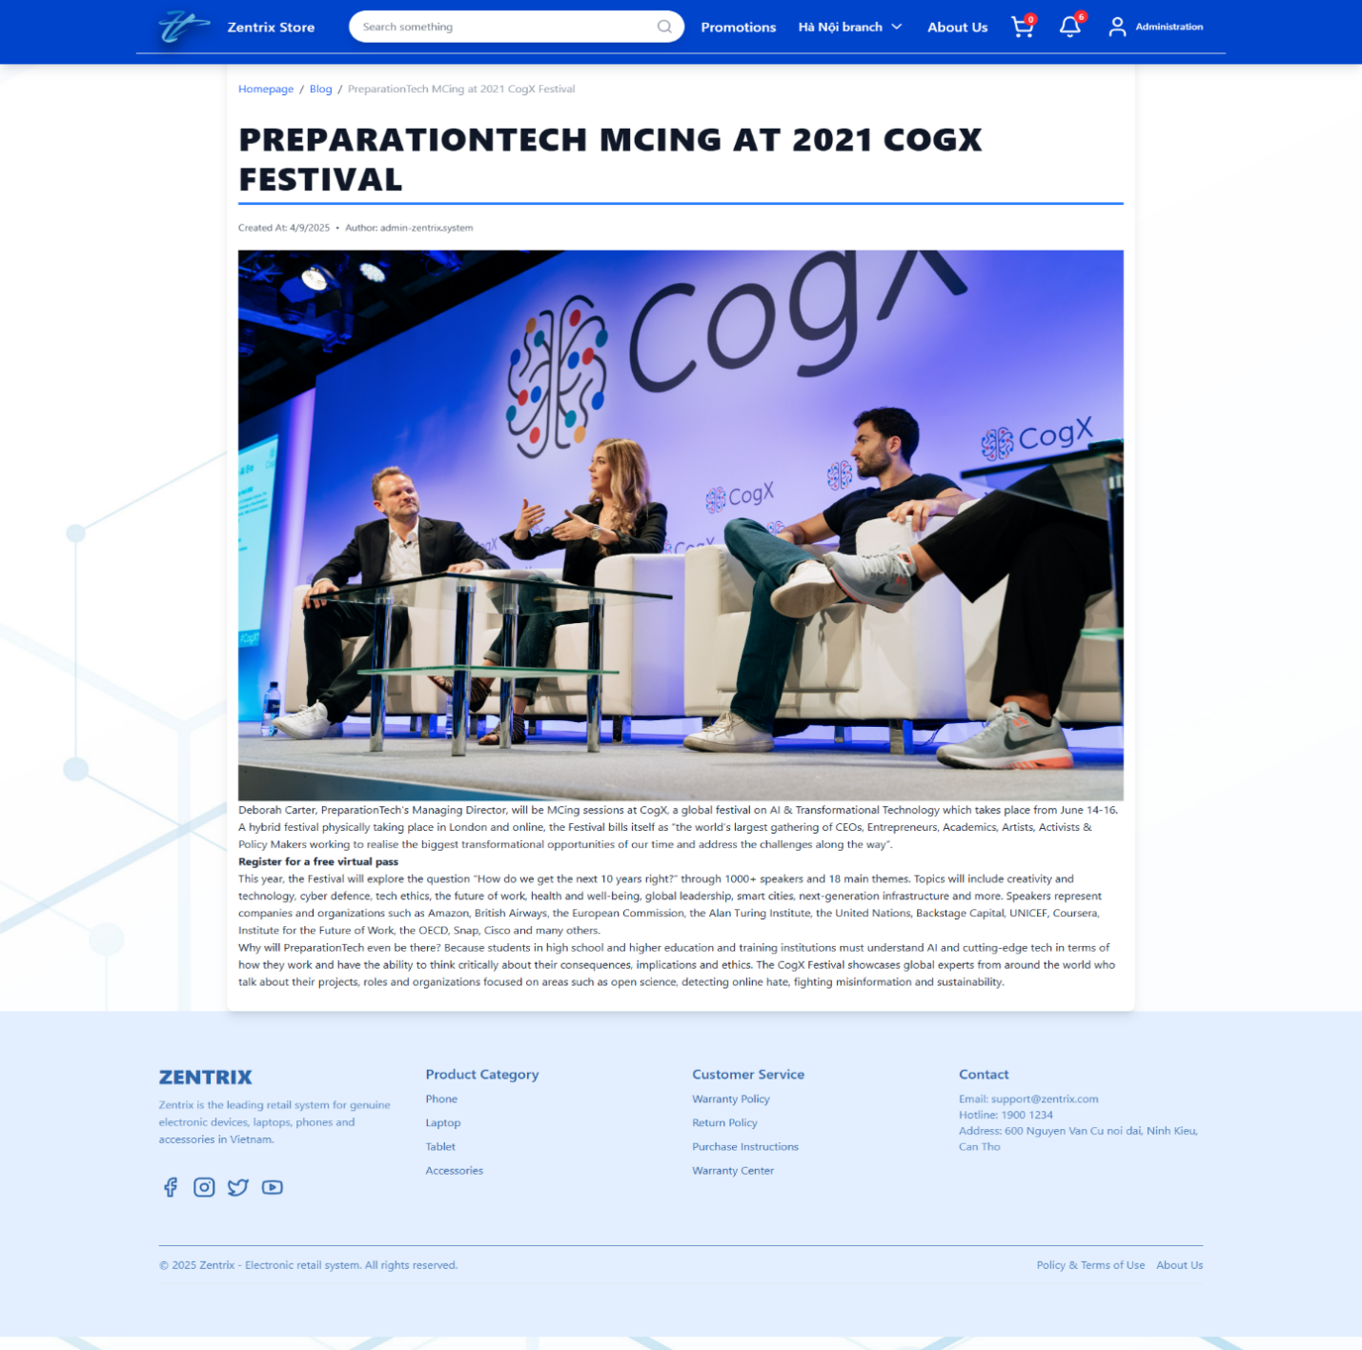

### Edit post

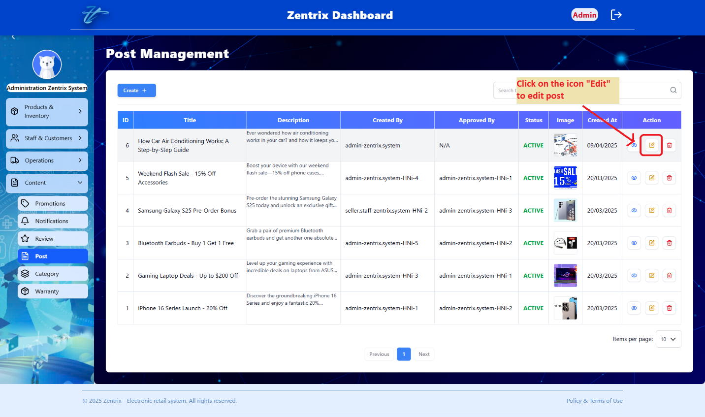

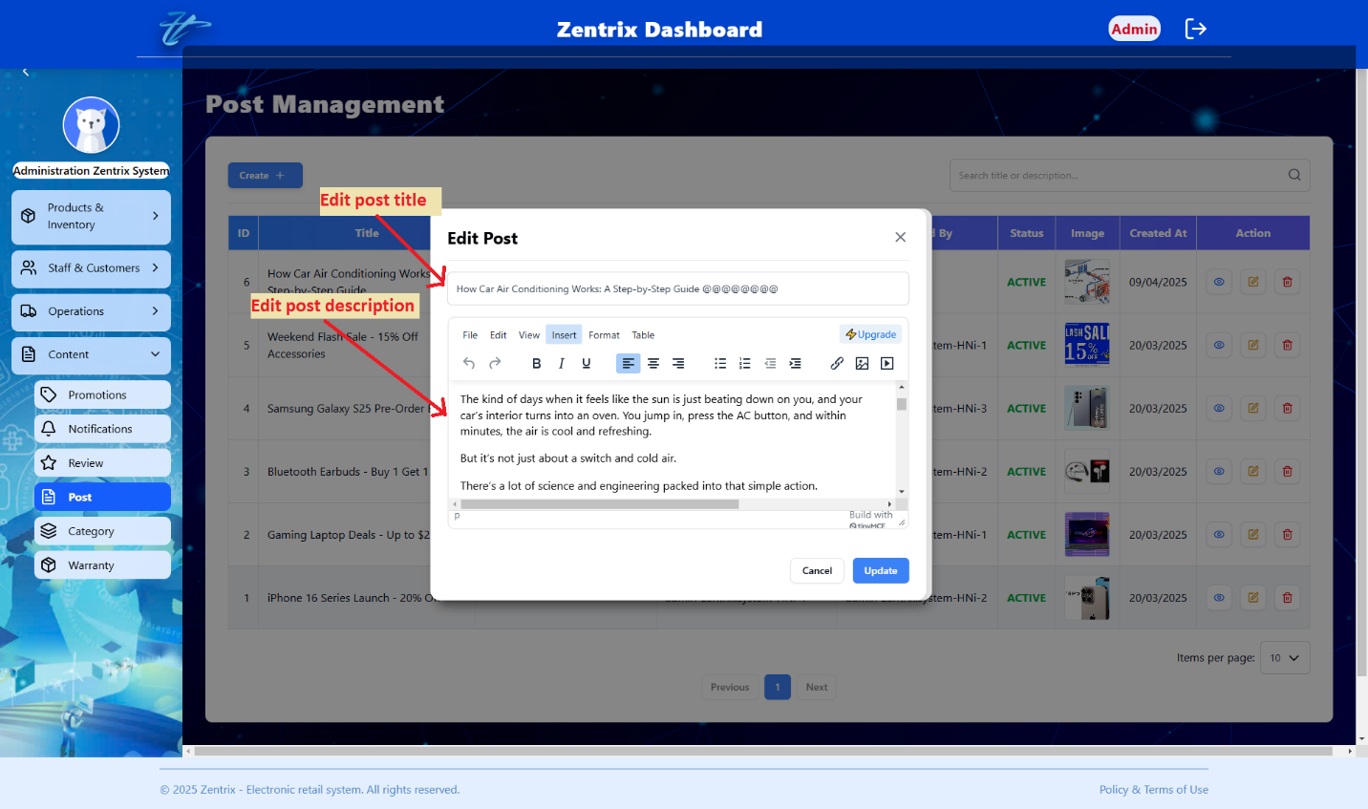

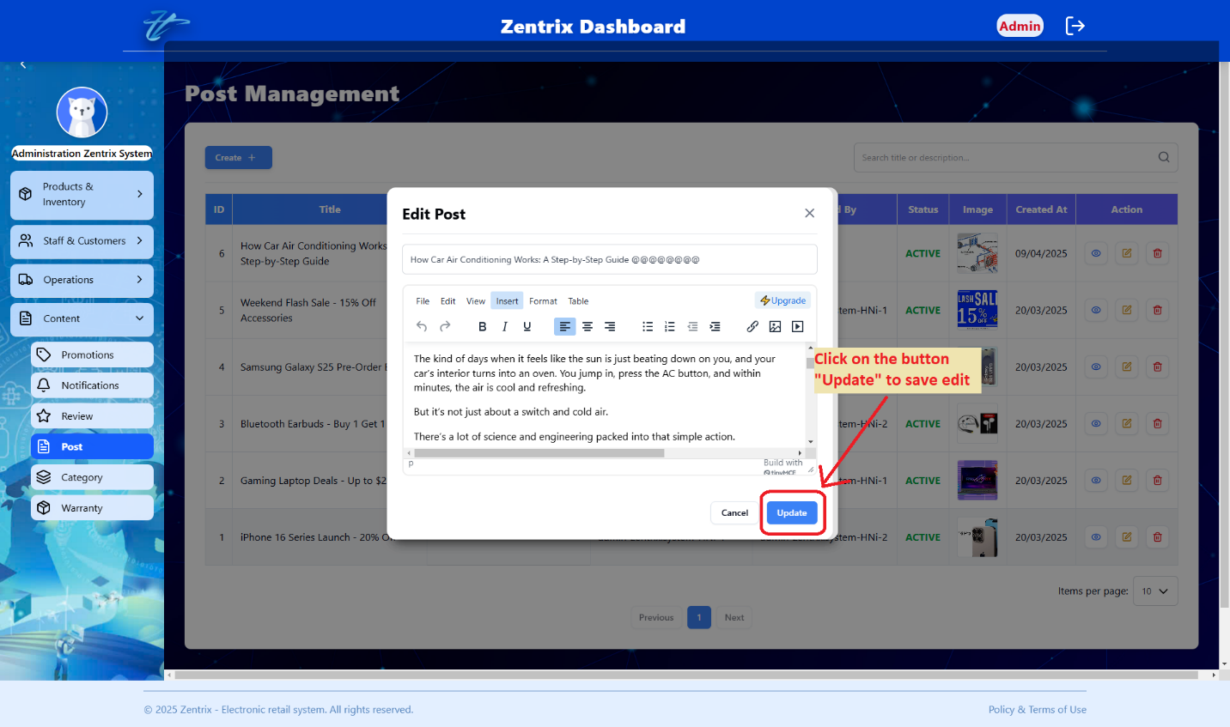

### Delete post

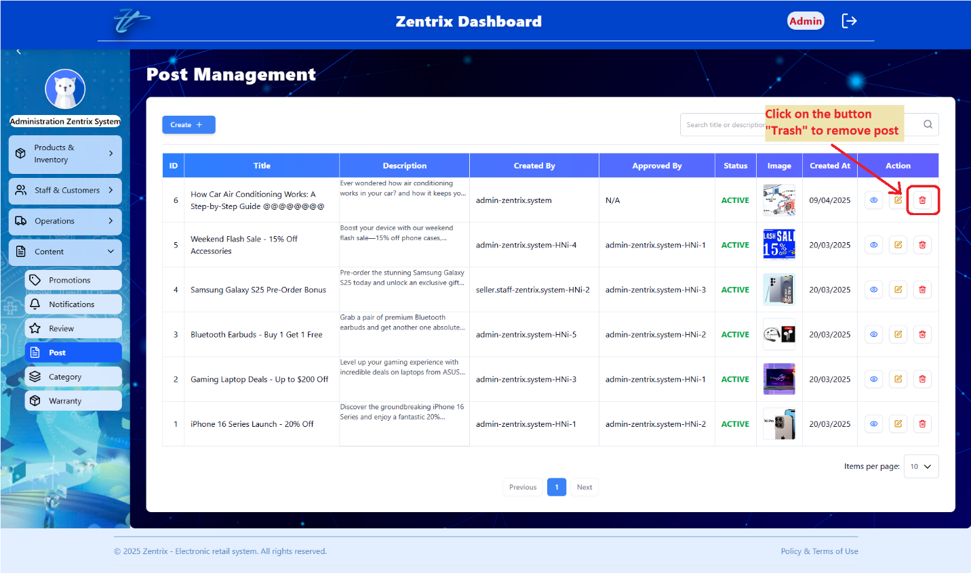

### Search post

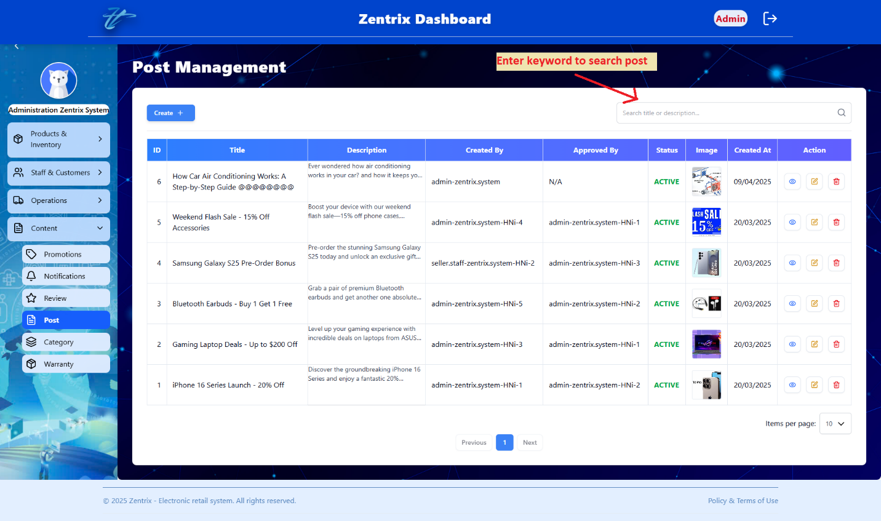

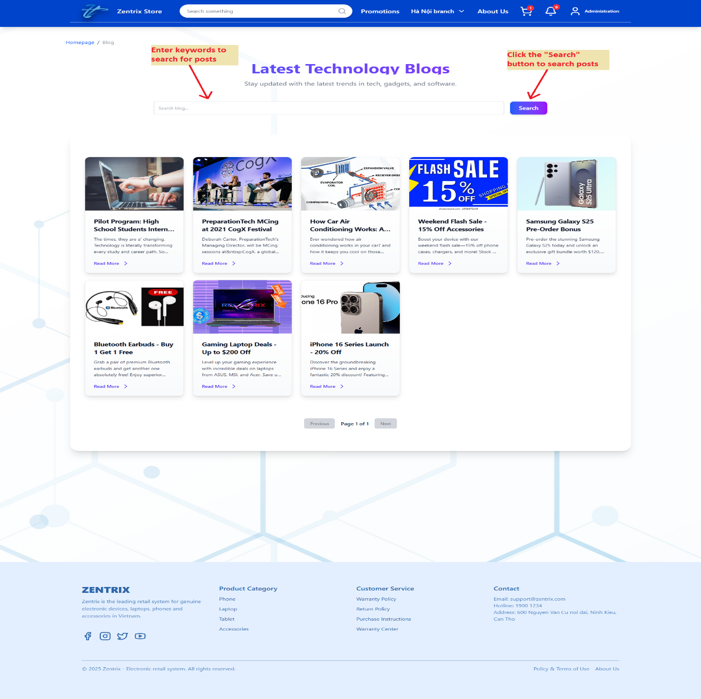

### View posts list

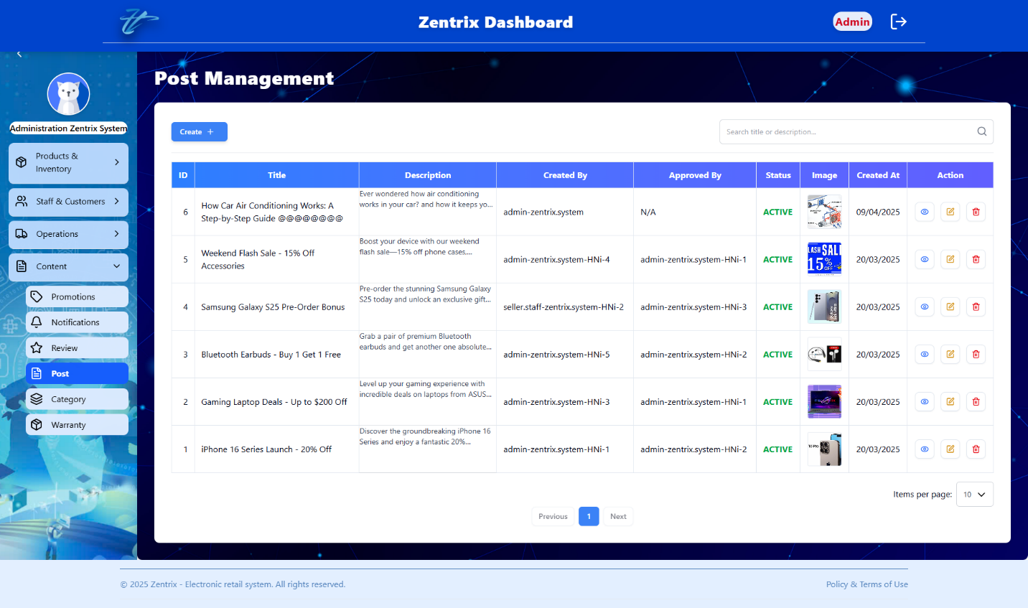

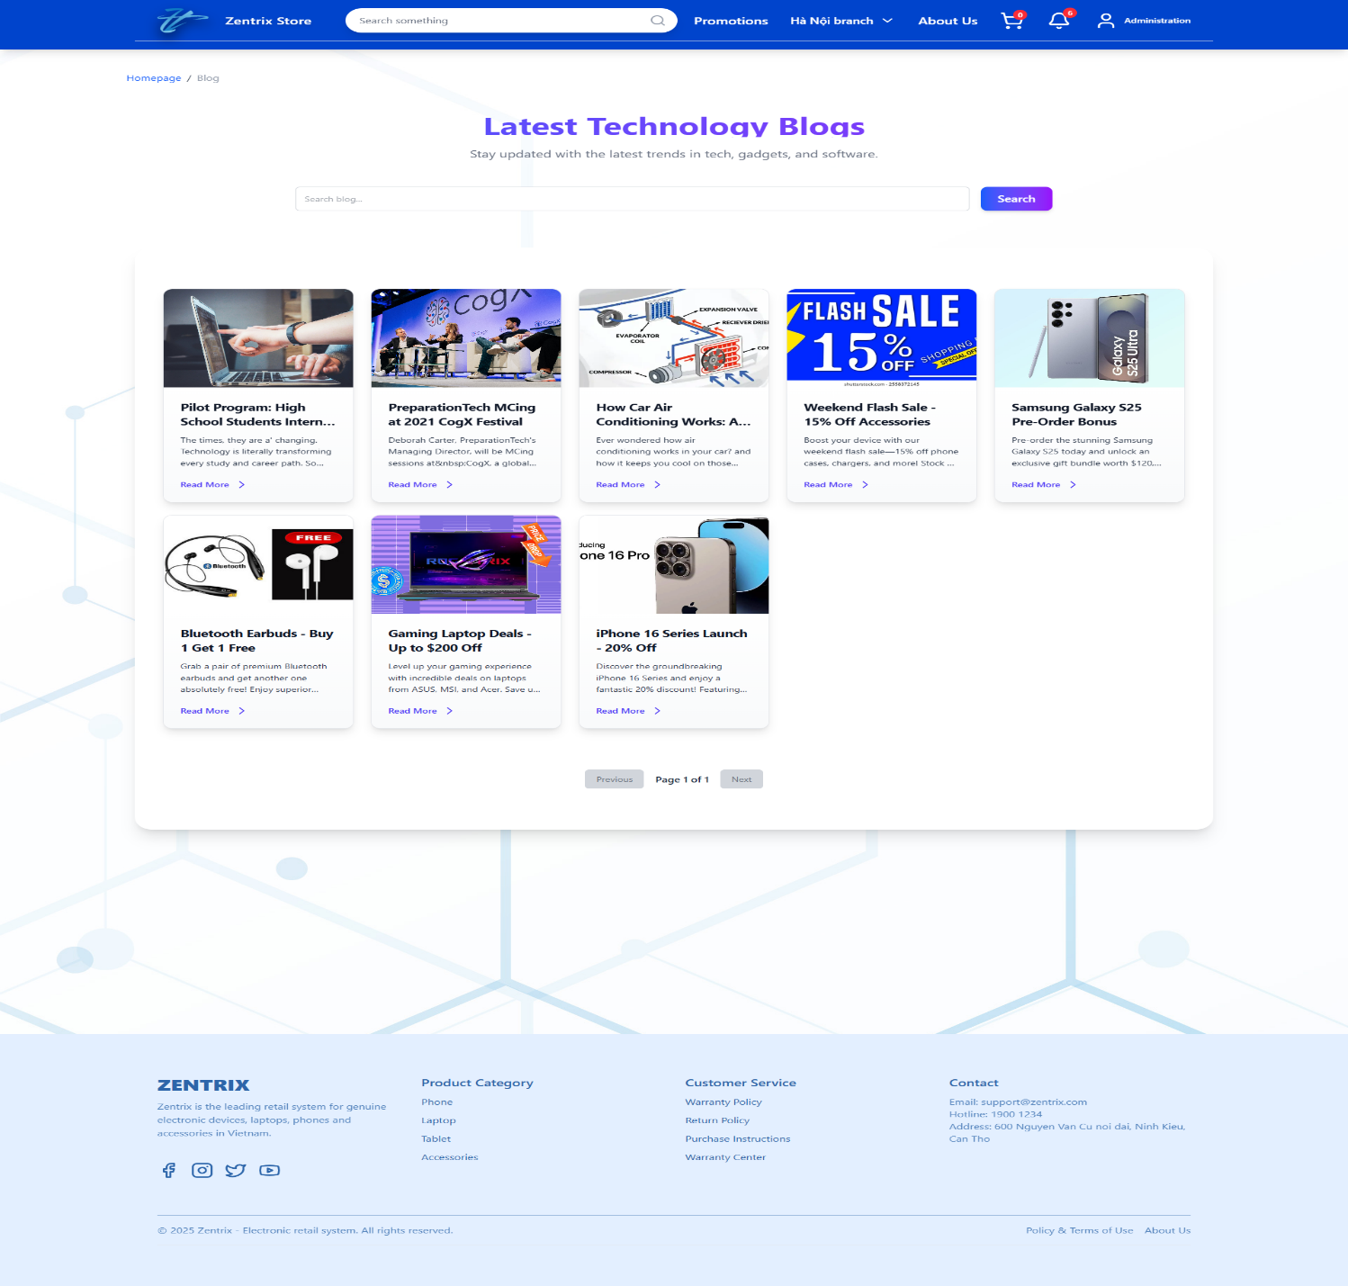

## MANAGE CATEGORIES

### Add category

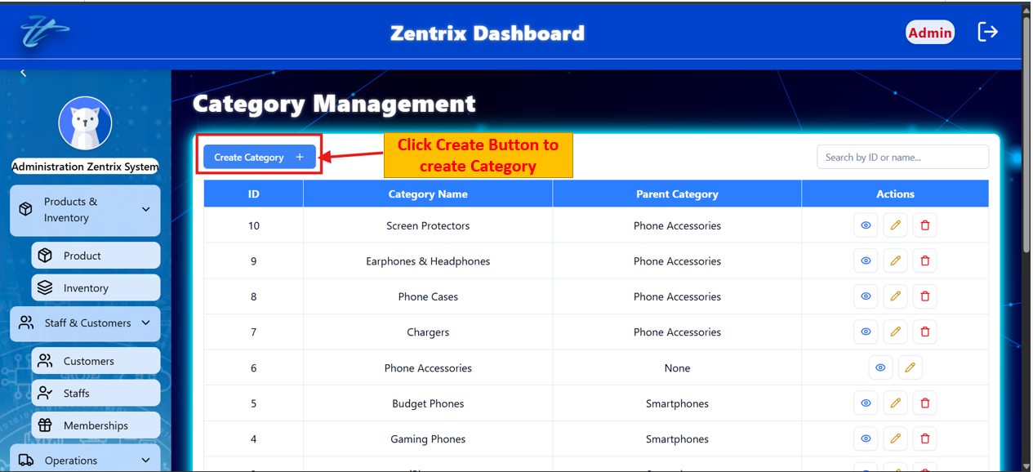

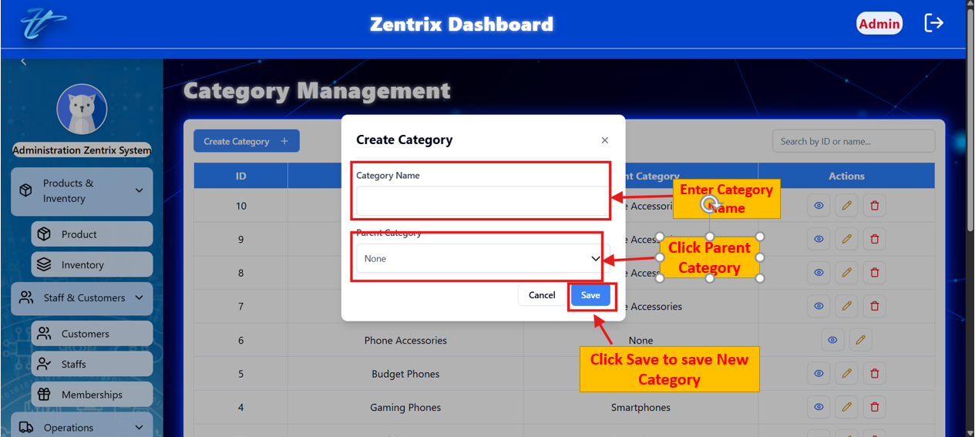

### View category detail

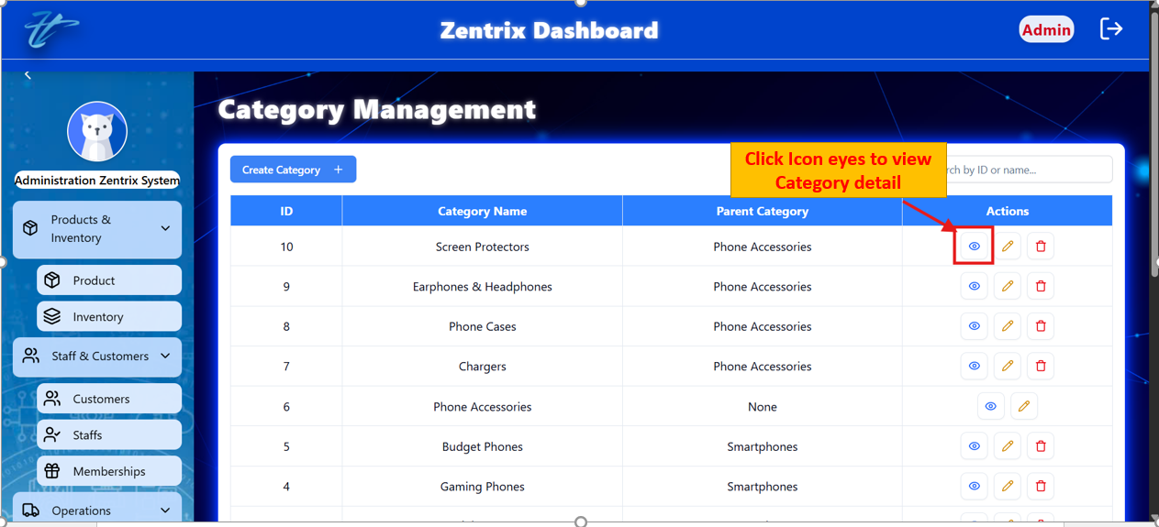

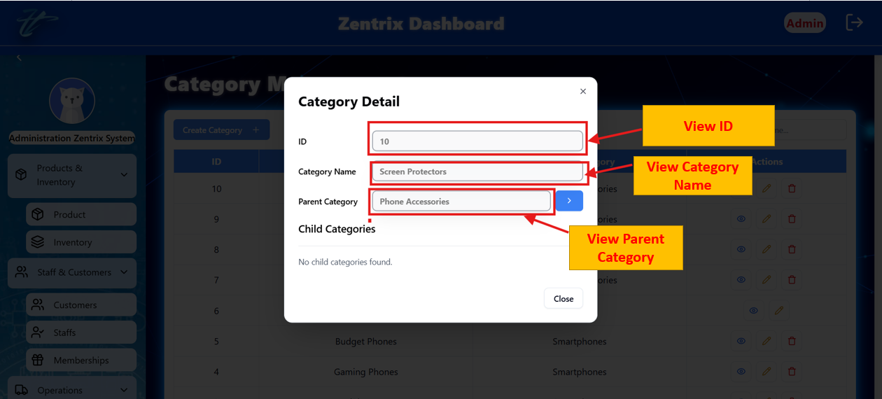

### Edit category

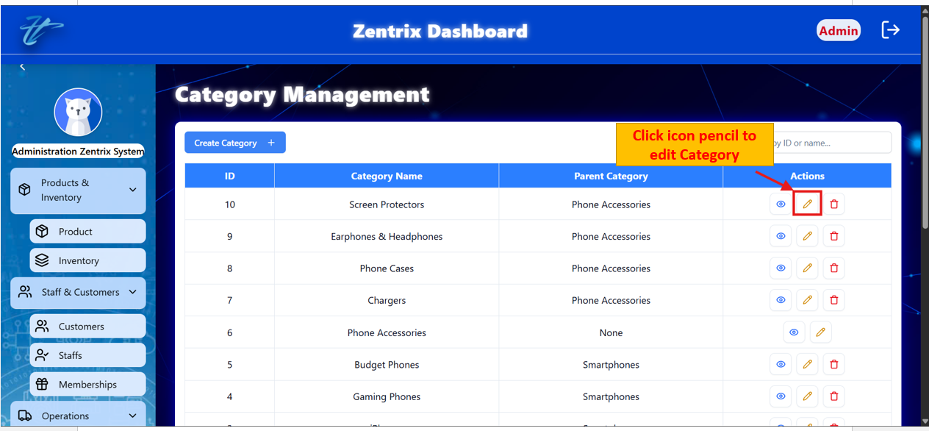

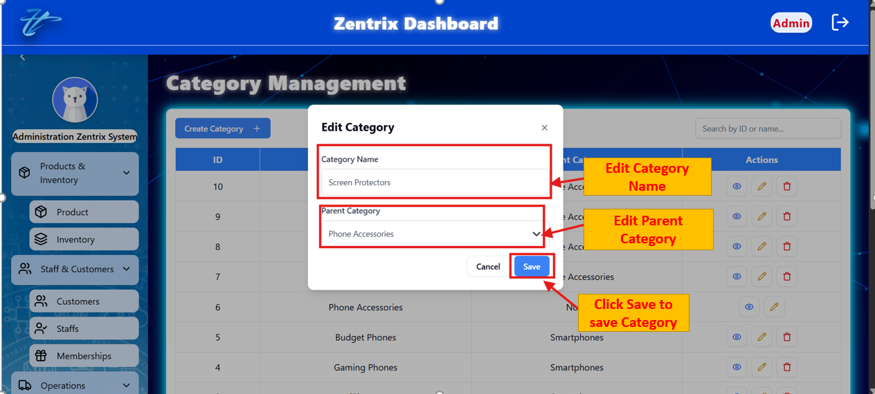

### Delete category

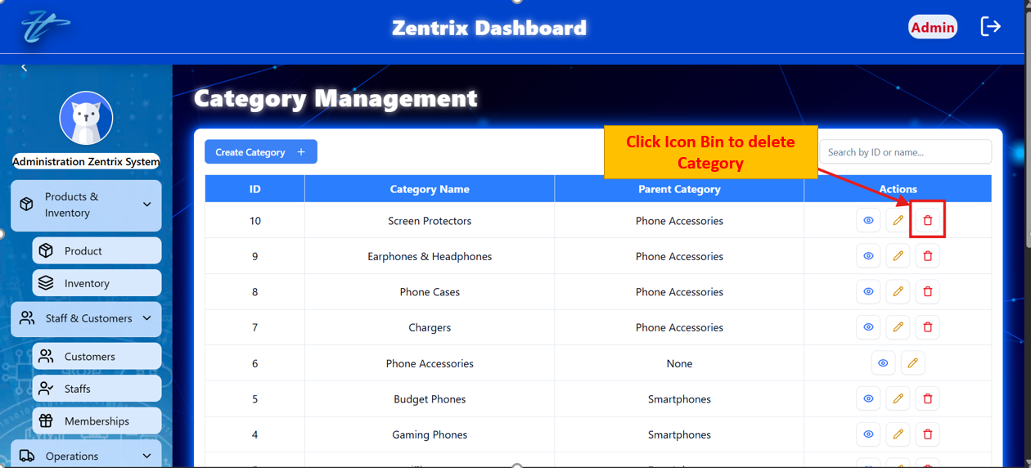



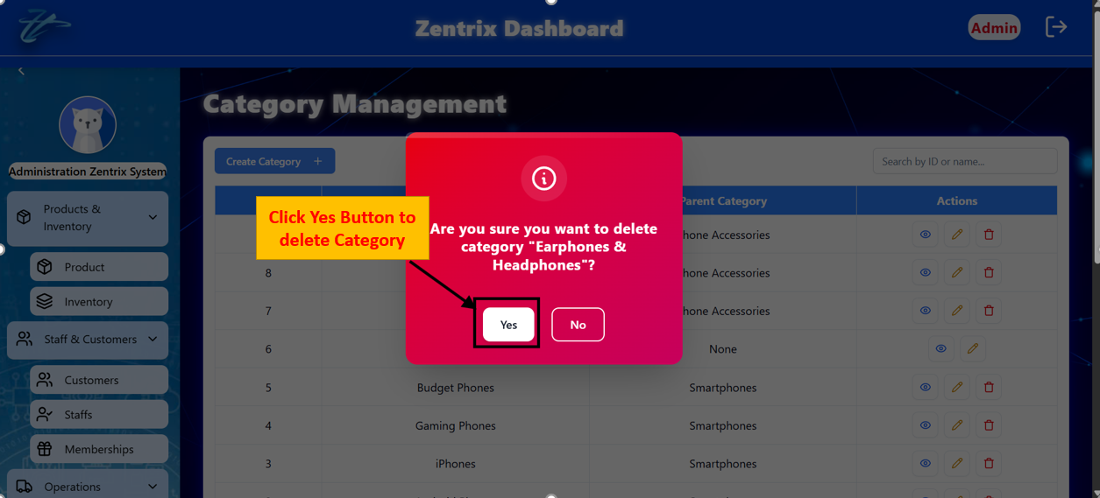

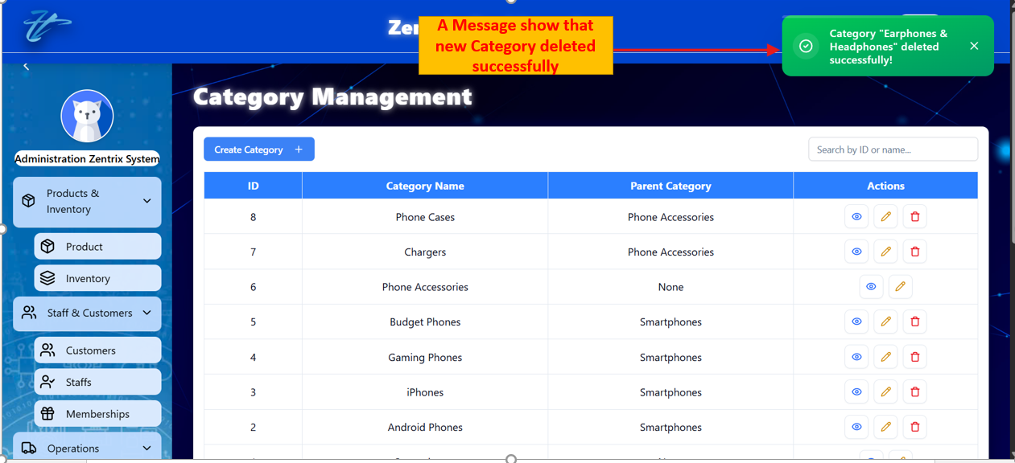

### Search category

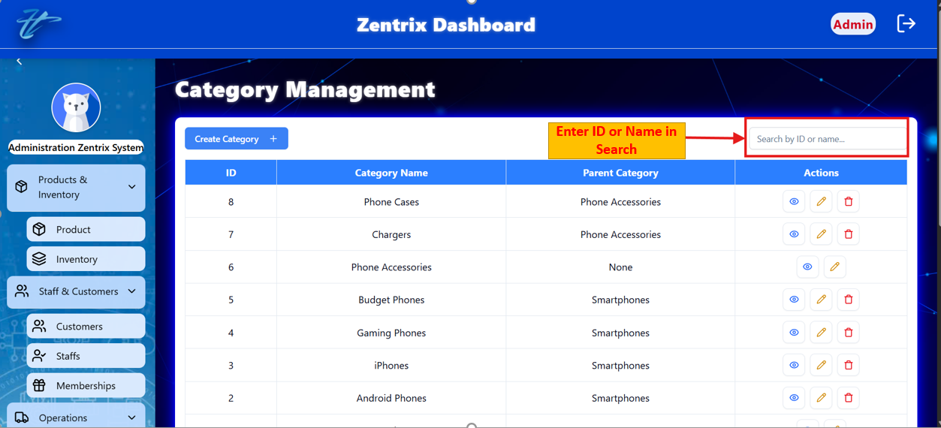

### View categories list

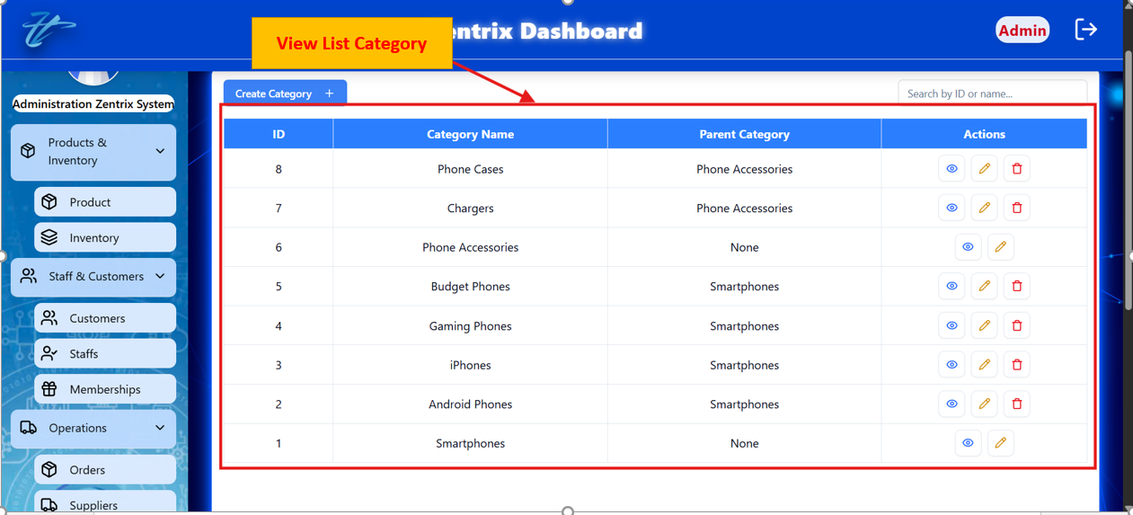

## MANAGE SUPPILERS

### Add supplier

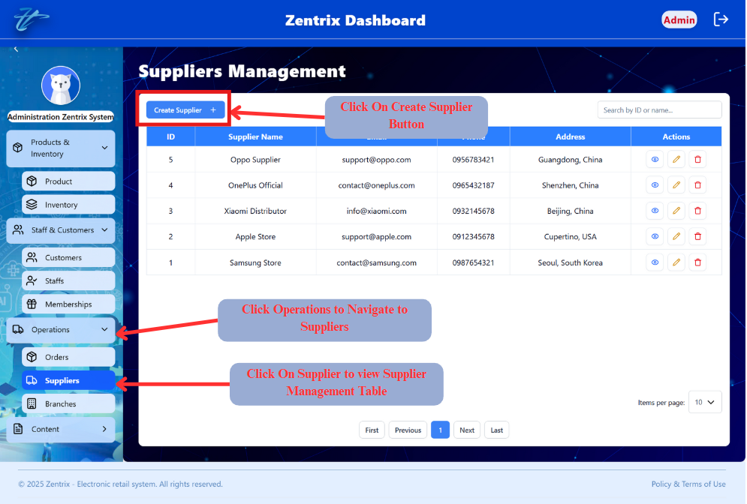

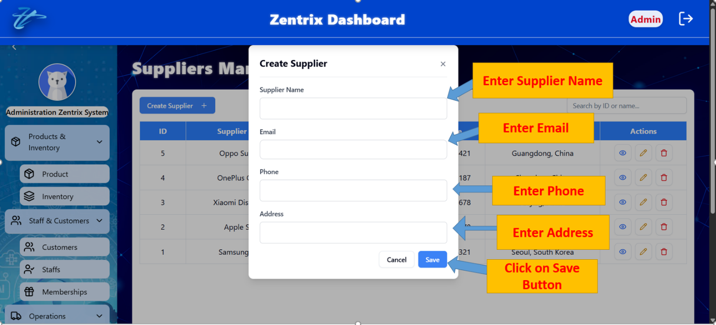

### View supplier detail

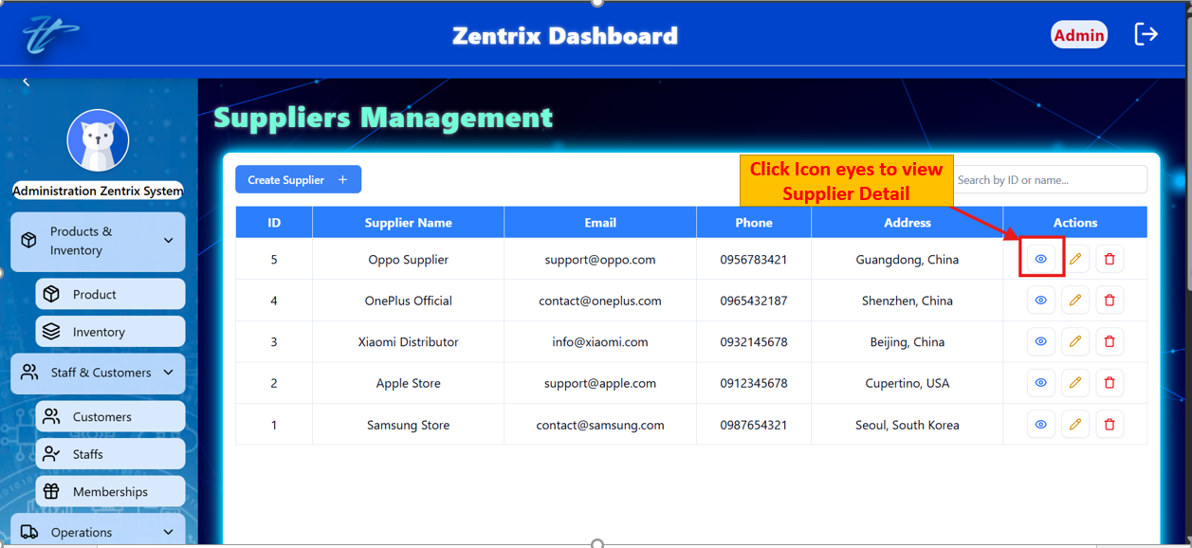

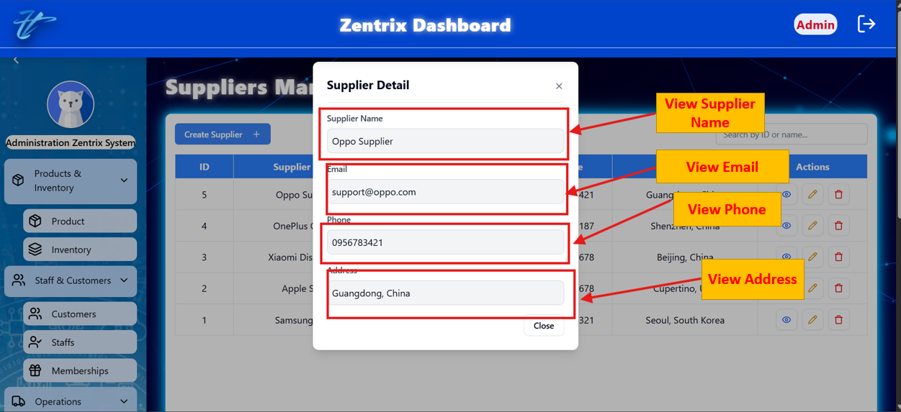

### Edit supplier

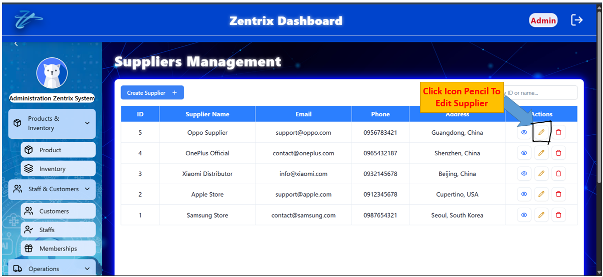

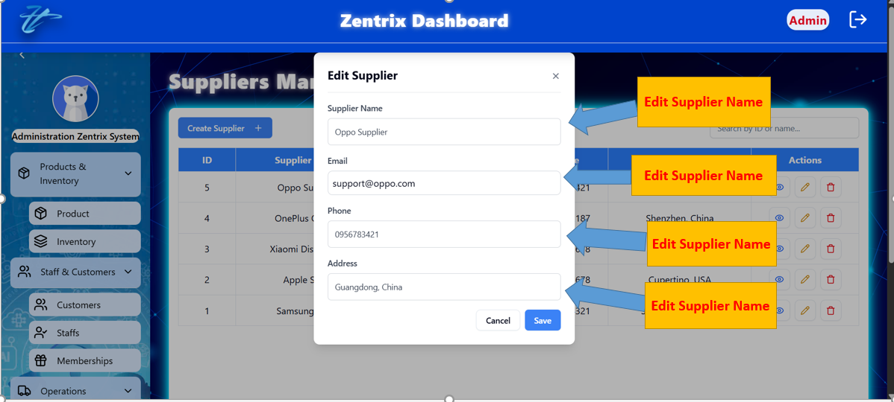

### Delete supplier

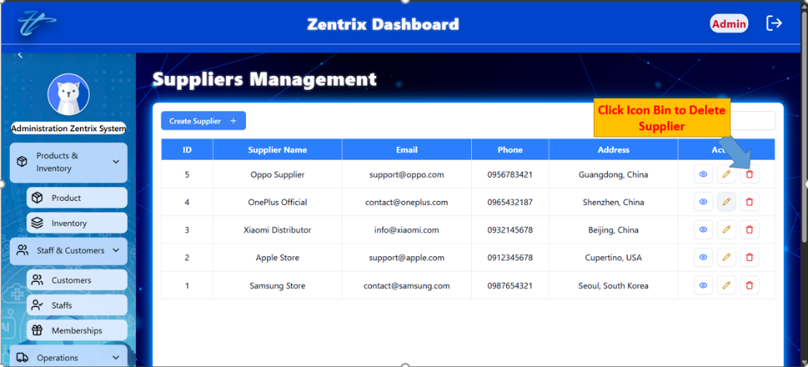

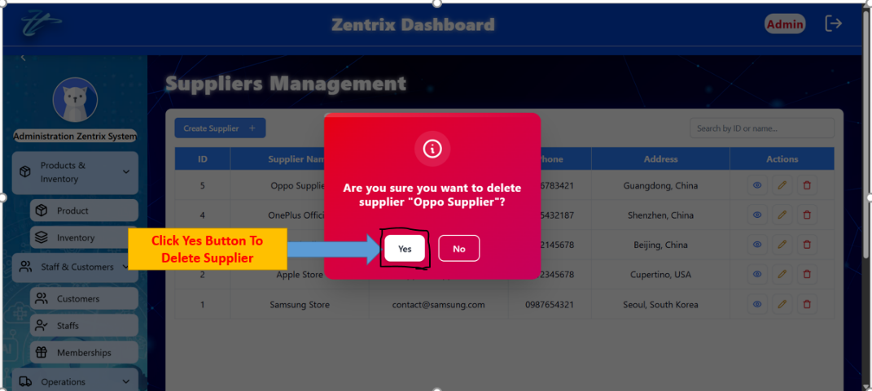

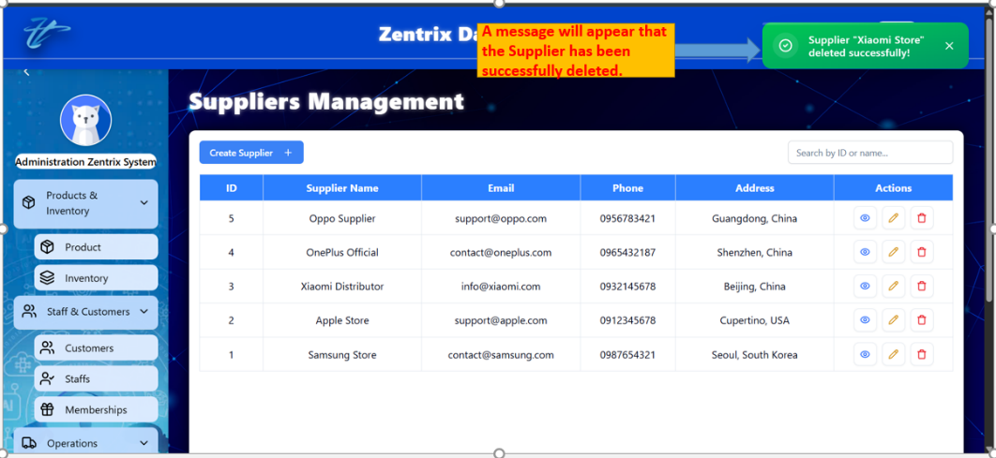

### Search supplier

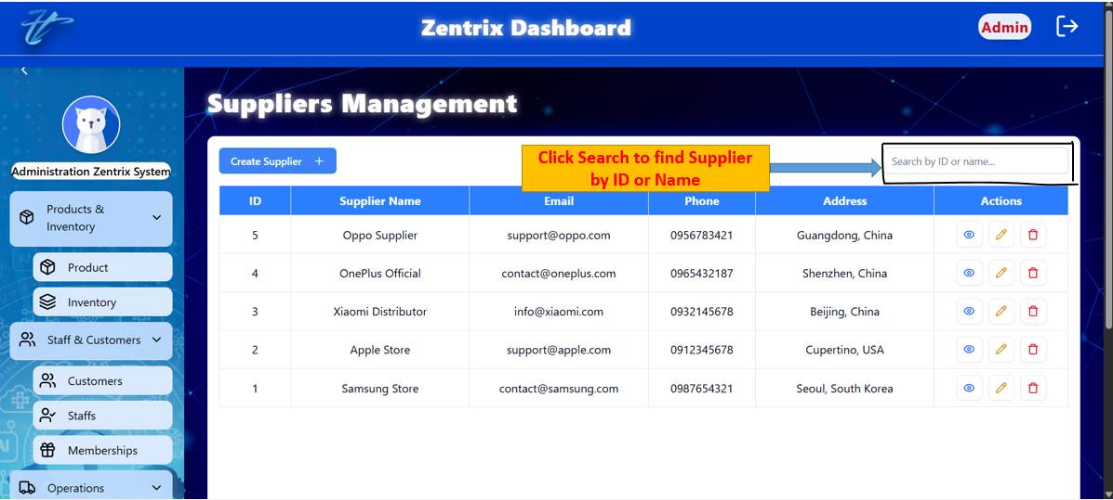

### View suppliers list

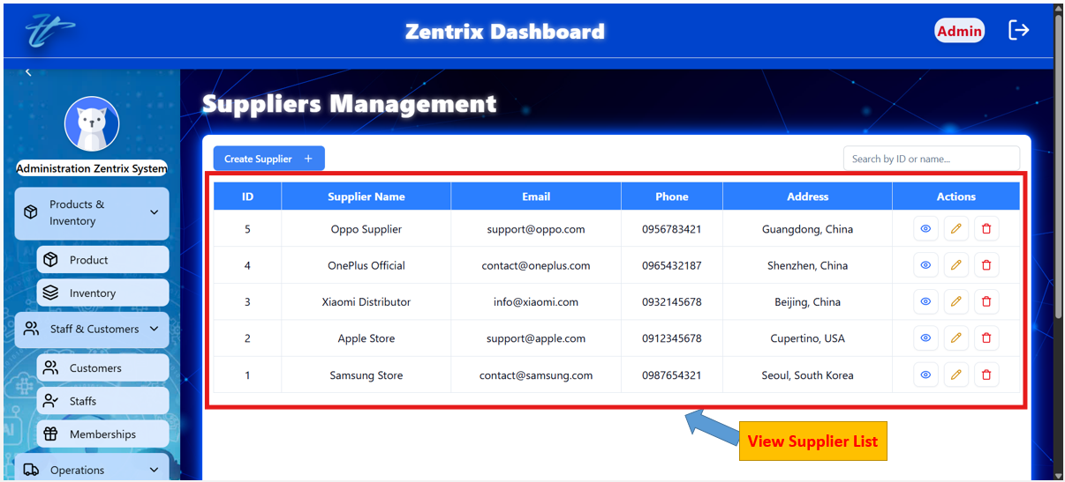

## MANAGE BRANCHES

### Add branch

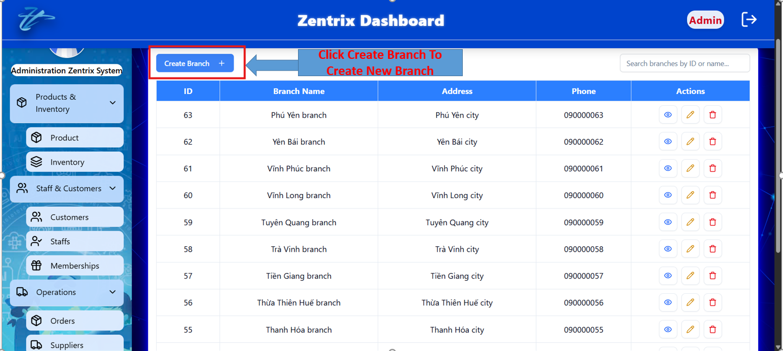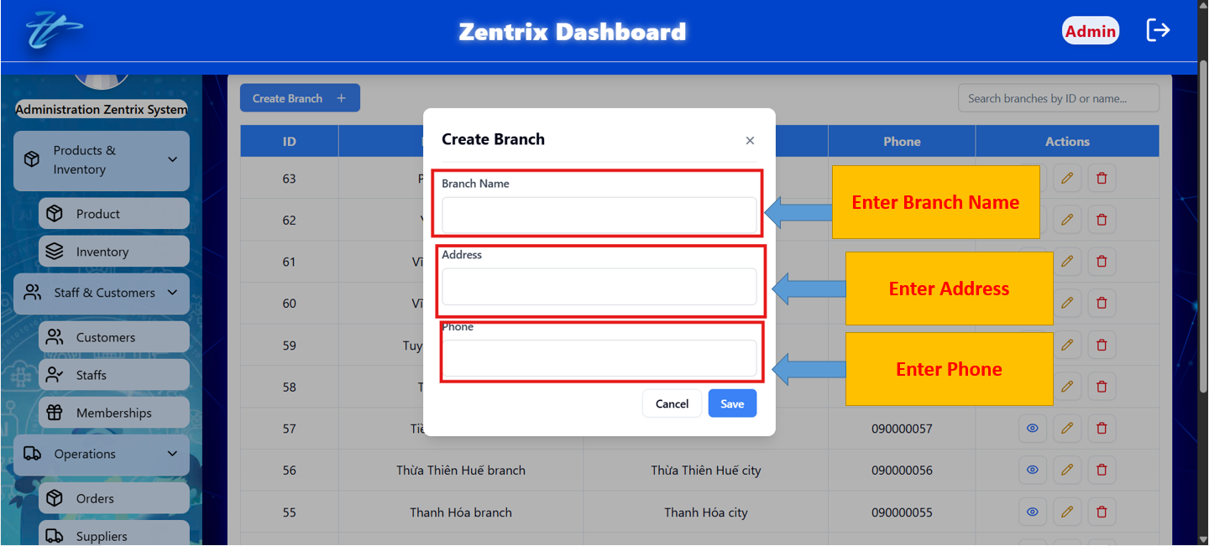

### View branch detail

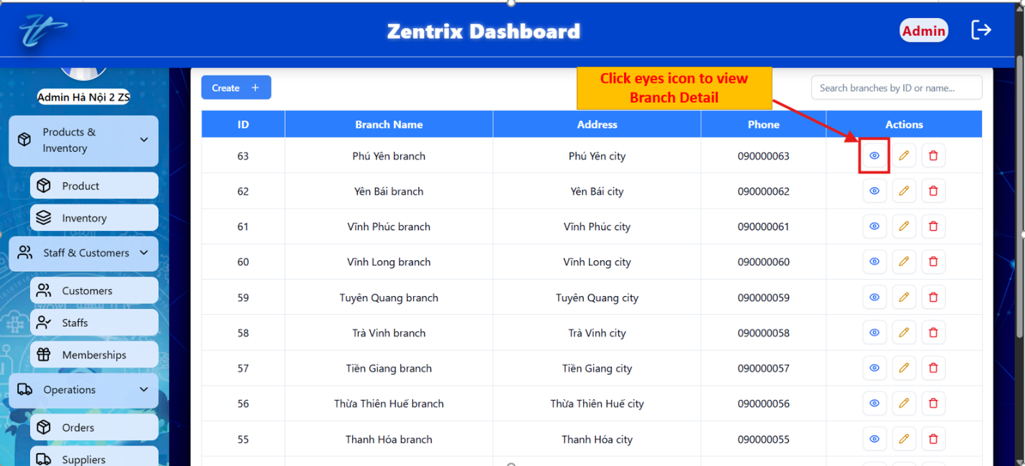

### View products detail in branch

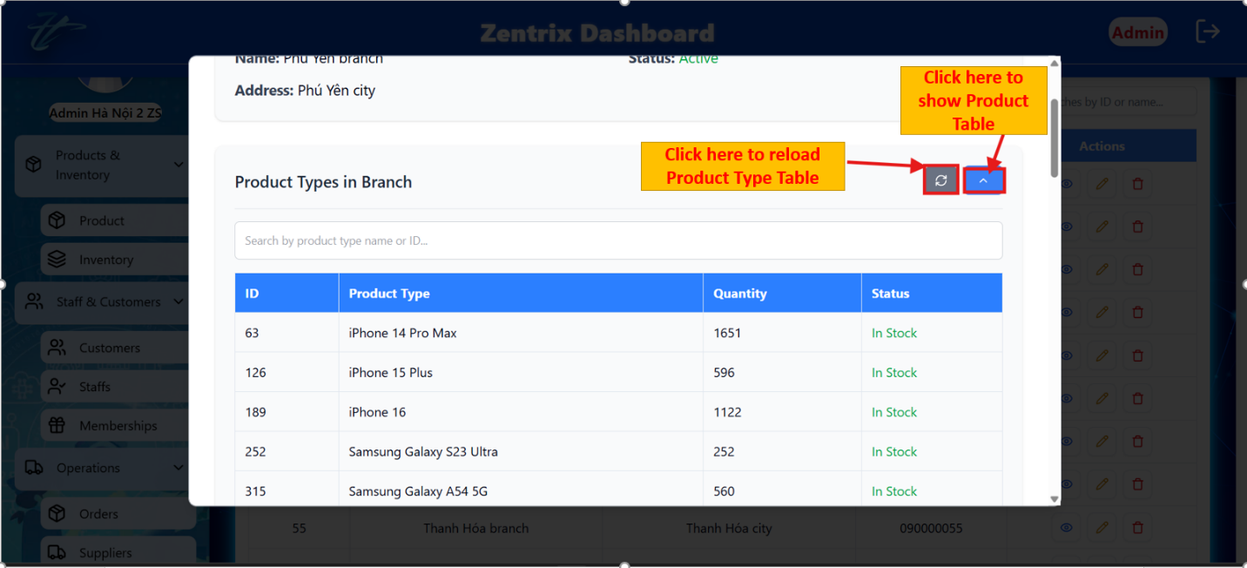

### Edit branch

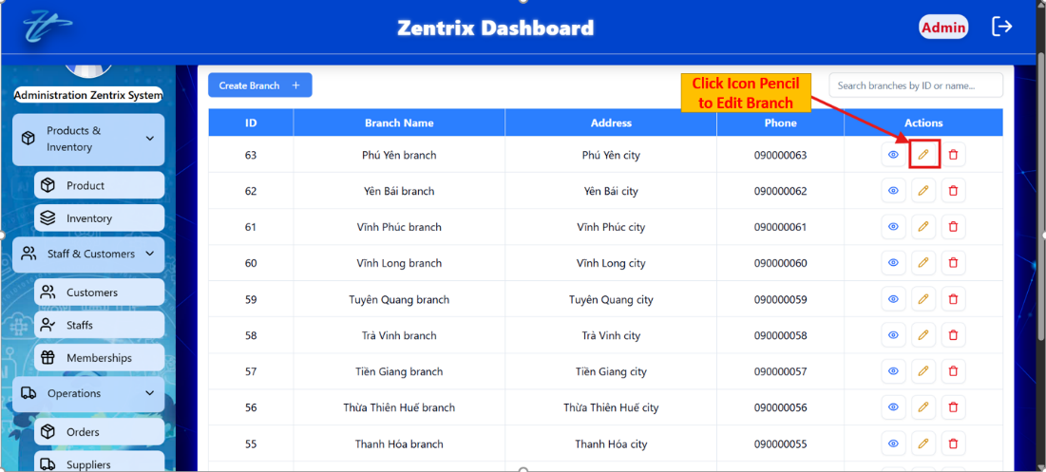

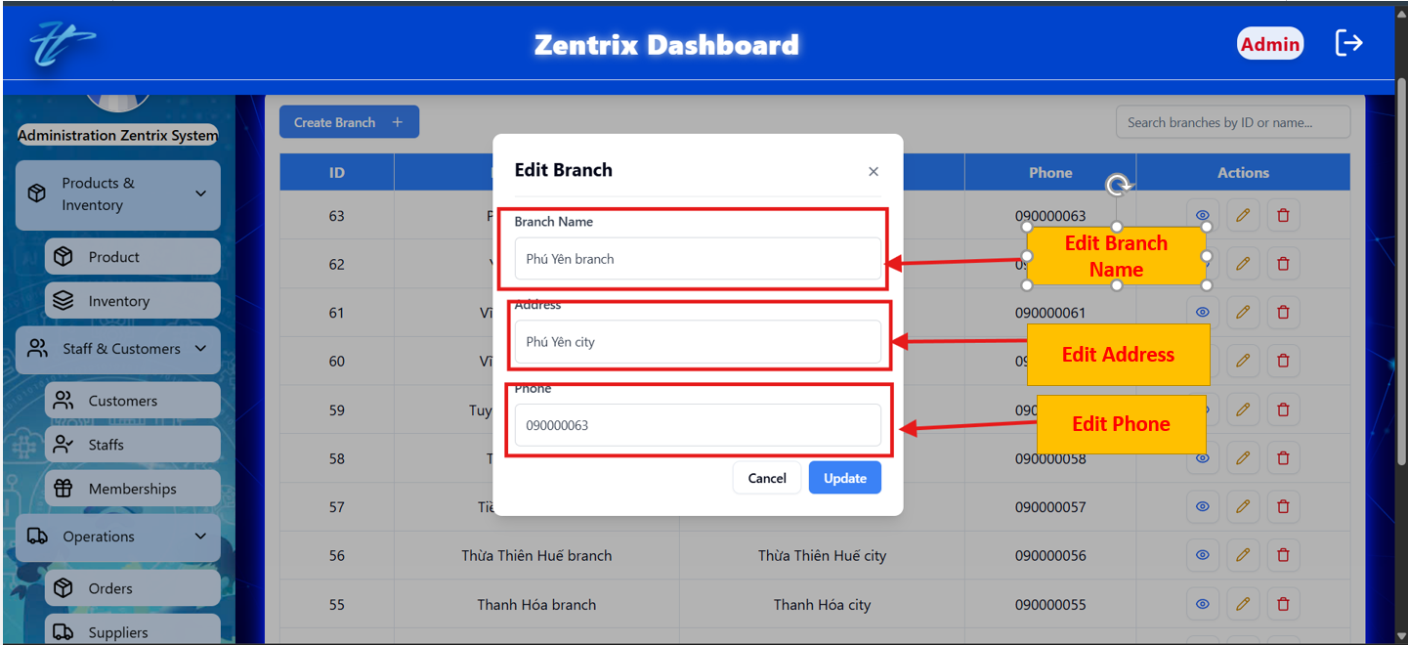

### Delete branch





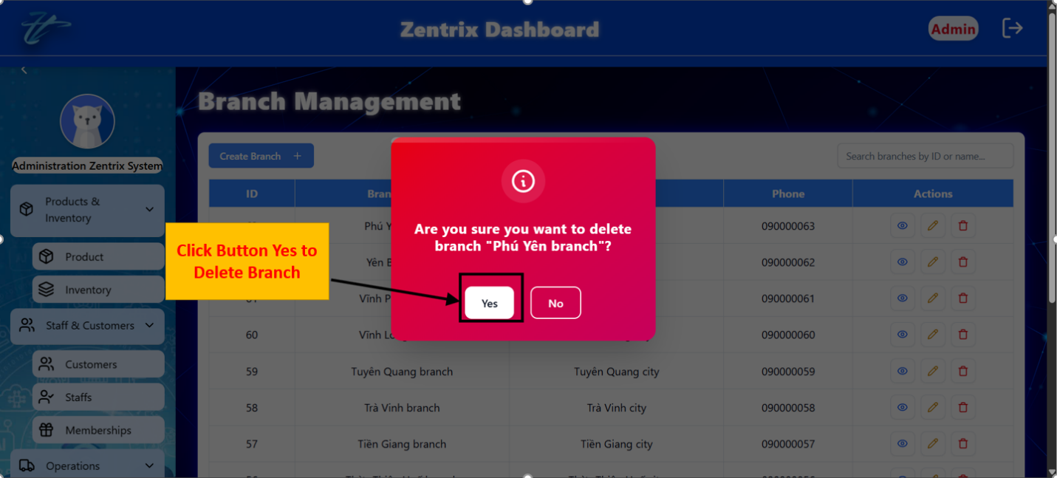

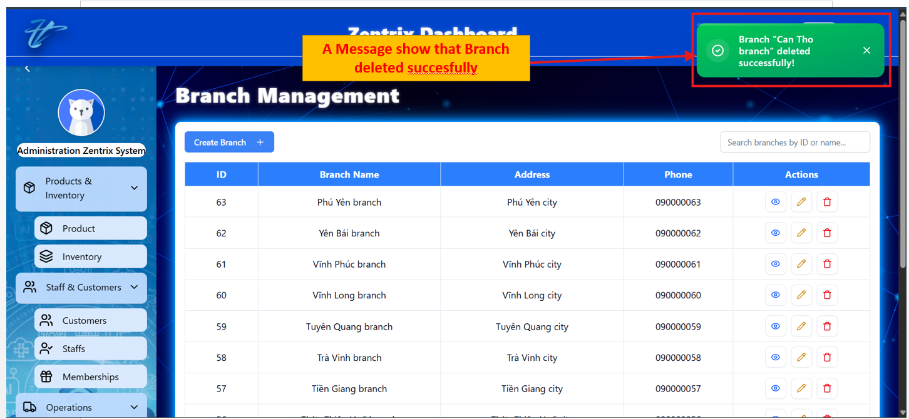

### Search branch

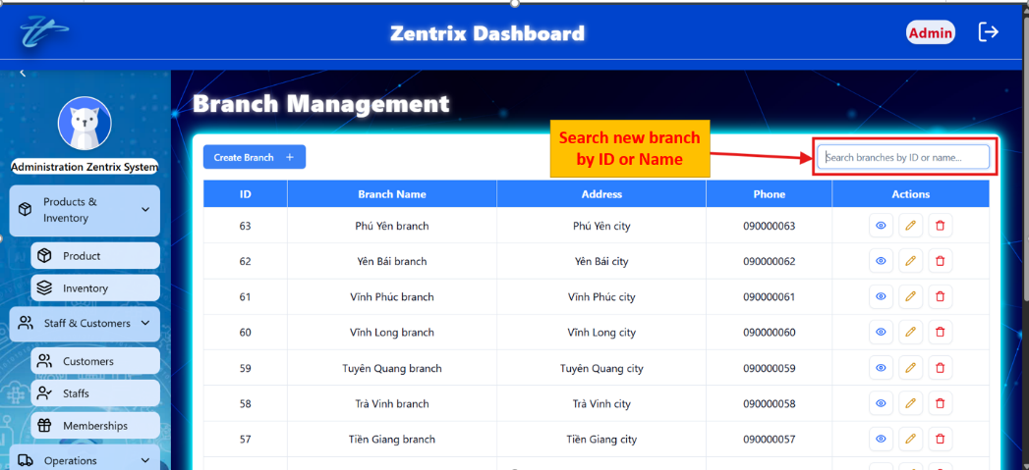

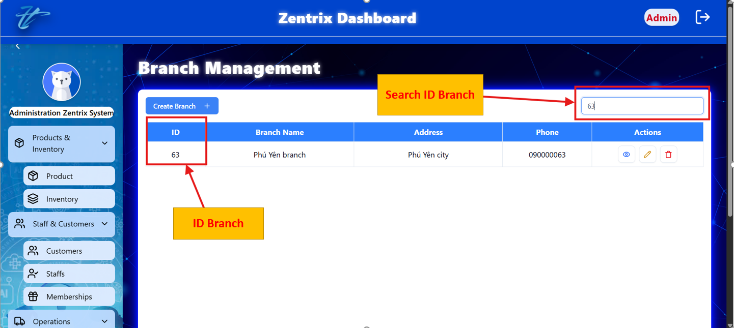

### View branches list

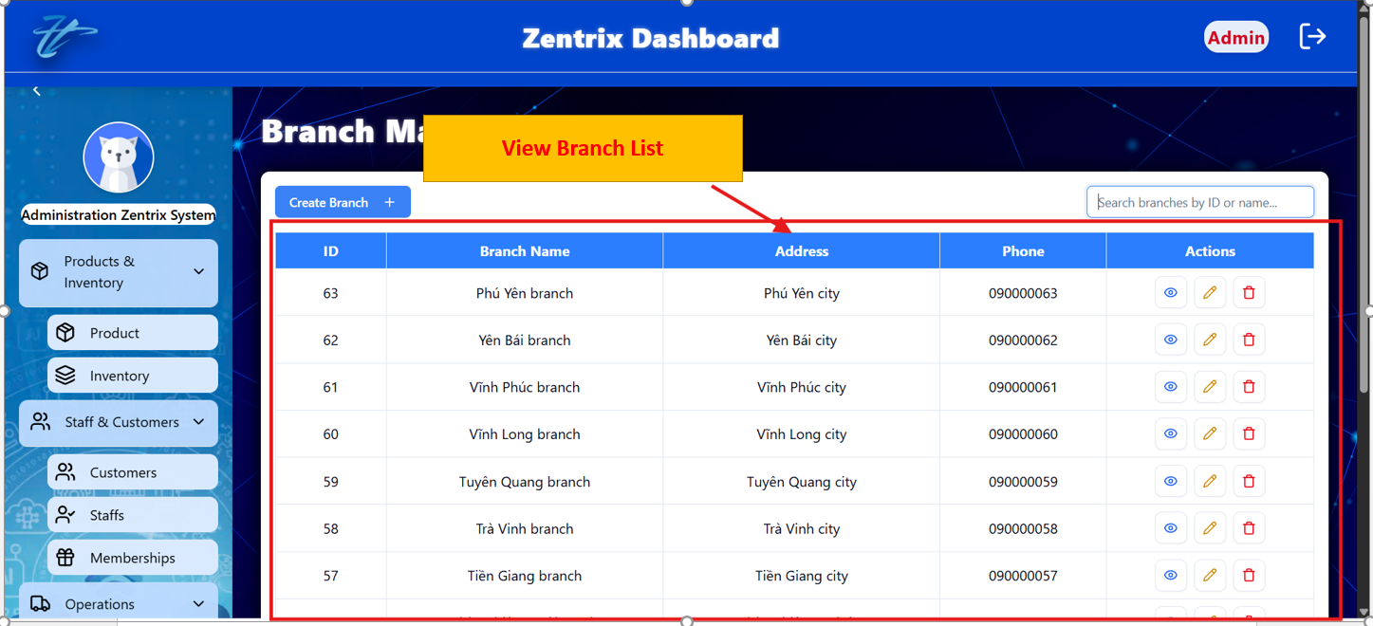

## COMPARE PRICE

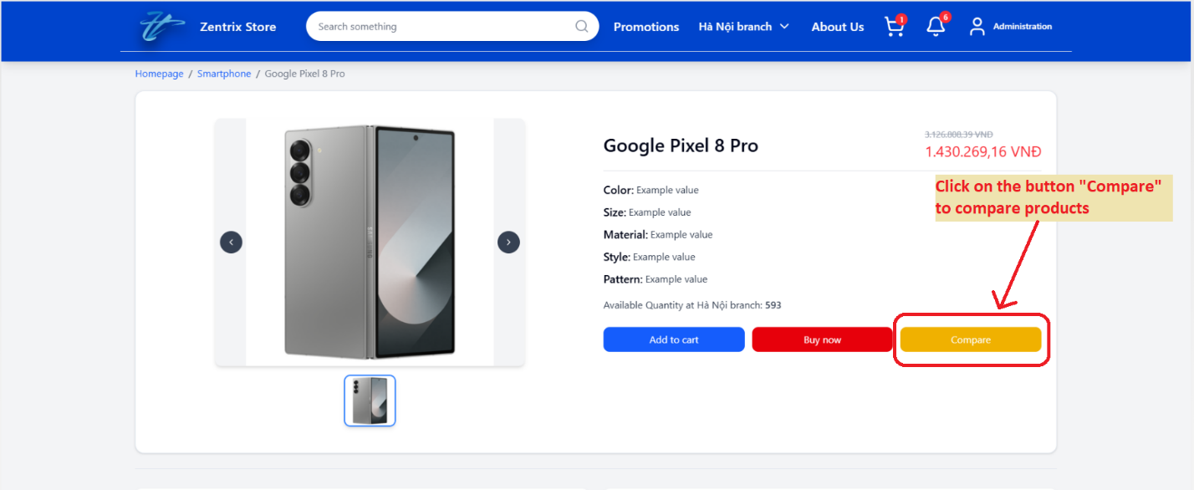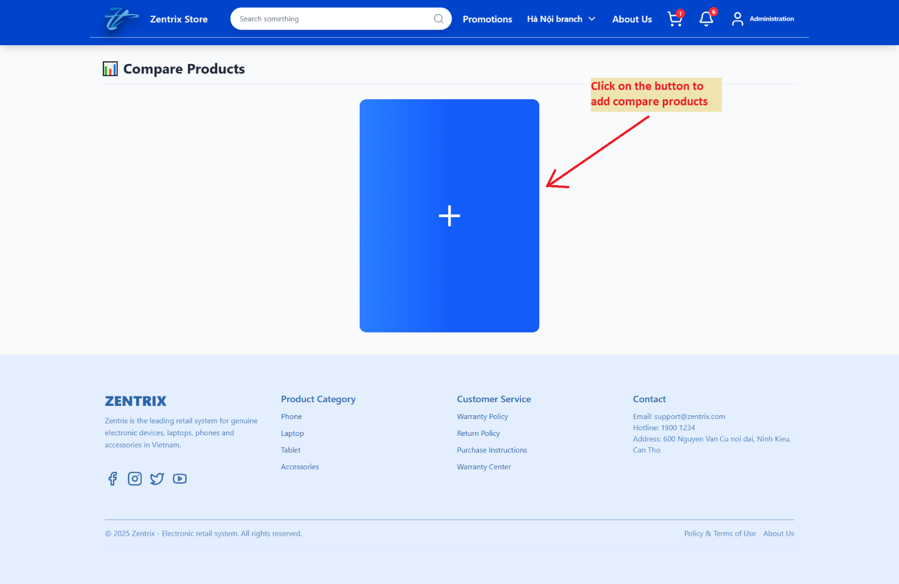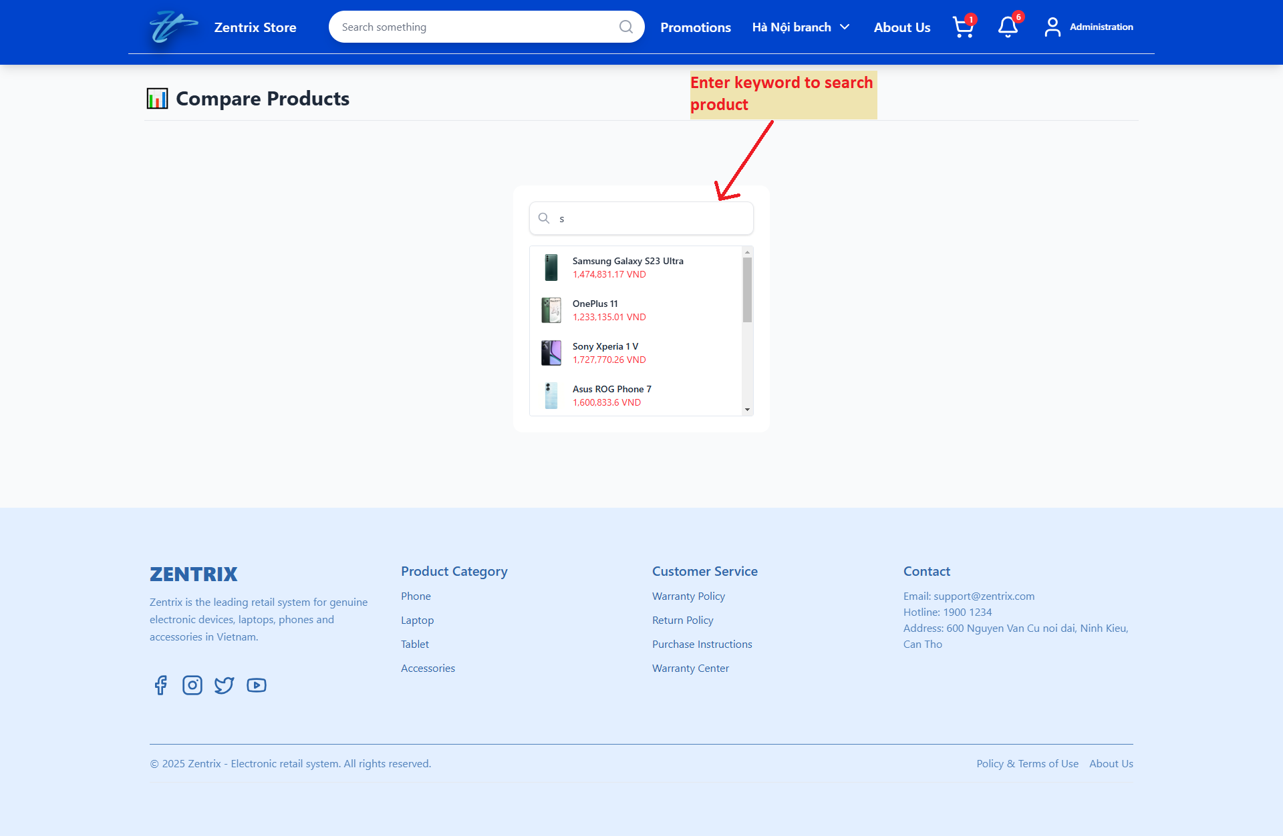

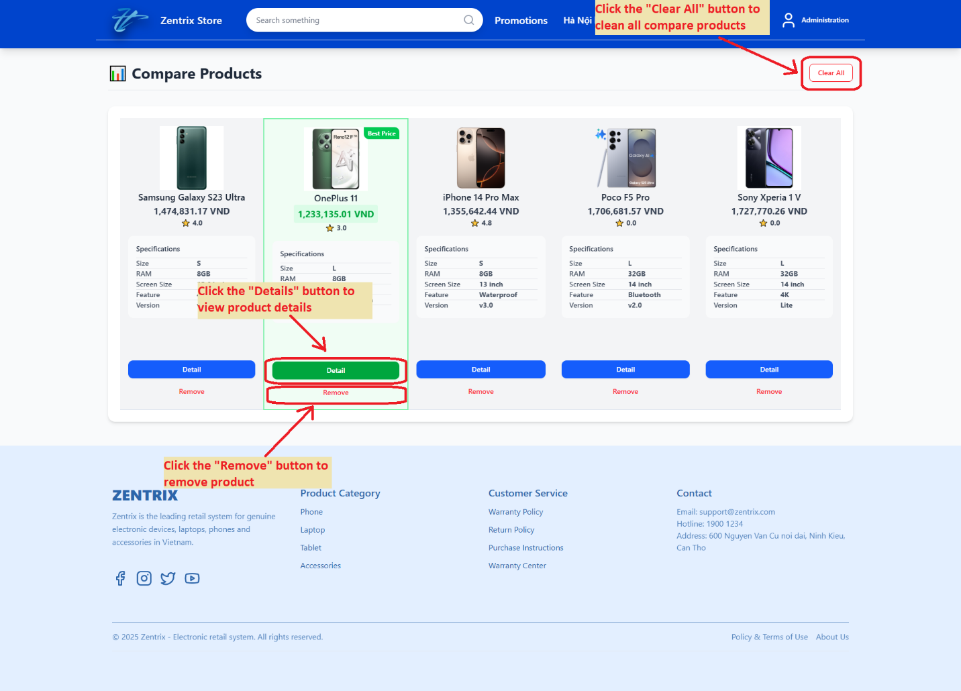

## INCOME STATISTIC

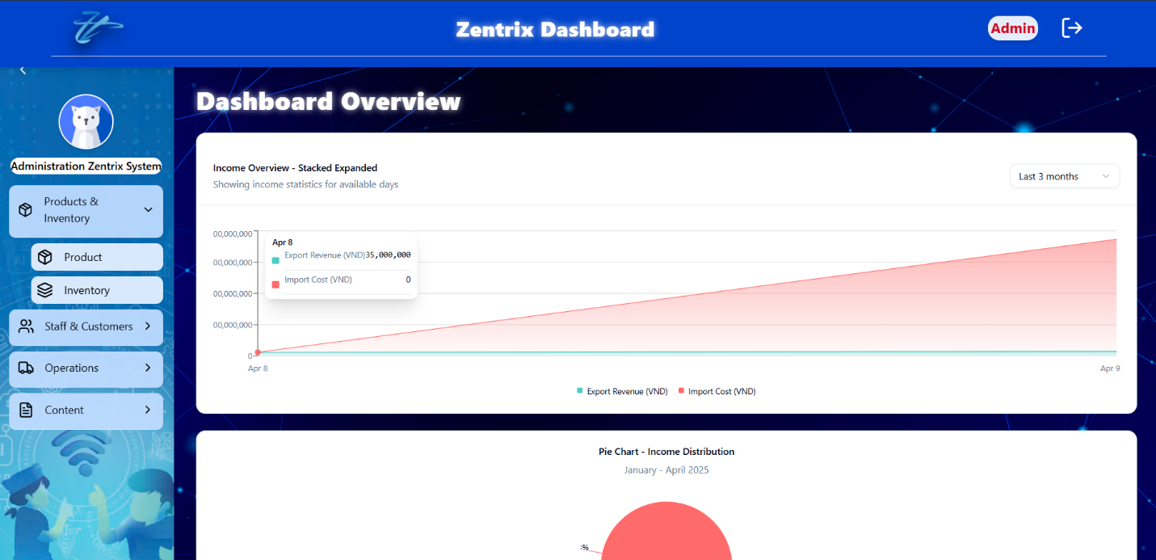

***---THE END---***